**Denys Stepanenko**

**Analysis of Shadows of Valor**

# Game Title: Shadows of Valor

## 1. About the Game

I'm creating ***Shadows of Valor***, a game that plunges players into a dark, mesmerizing world where light struggles to break through dense shadows. In this project, the player takes on the role of a brave knight who must navigate meticulously handcrafted levels filled with ancient secrets, hostile creatures, and treacherous traps. I designed the game with a heavy, moody atmosphere that challenges players to overcome both external foes and internal struggles.

The game’s visual and gameplay vision directly draws inspiration from influential titles. Its gothic 2D pixel art style and pervasive mood are heavily influenced by ***Blasphemous***, while the fast-paced, precision-based combat borrows mechanics from ***Dead Cells***. Additionally, ideas for level structure and interconnected design were inspired by the ***Castlevania* series**. This synthesis addresses a common challenge in hack-and-slash titles—balancing immersive ambiance with challenging, coherent gameplay—ensuring every element feels innovative yet rooted in classic design.

## 2. Who Will Play My Game?

I've built ***Shadows of Valor*** to appeal to a broad range of gamers. Casual players will be attracted by its accessible mechanics and immersive world, while hardcore enthusiasts will appreciate the deep, strategic combat and challenging encounters. Additionally, fans of action-adventure and RPG games will enjoy the gradual progression and rich historical tone integrated throughout the project.

As a single-player adventure, the game emphasizes focused exploration across diverse environments—from lush forests and perilous mountains to ancient ruins and cursed castles. The core gameplay revolves around precise, fast-paced combat where success depends on well-timed dodges and attacks against increasingly complex enemy patterns. Features like dynamic object spawning and a robust save/load system ensure that each level offers fresh challenges and that the player’s progress is seamlessly preserved.

## 

## 

## 

## 

## 

## 3. Game Mode & Technical Execution

I've structured the gameplay around precise, fast-paced combat where success hinges on well-timed dodges and attacks. The game introduces dynamic object spawning: each level is populated with randomly generated items, traps, and environmental hazards that keep every playthrough unpredictable. I also implemented a robust save/load system to ensure that the player's progress is reliably preserved, allowing the adventure to continue exactly where it left off.

Complementing the save system is the dynamic design of the levels. Randomized object spawning infuses each level with unpredictability by generating various items, traps, and environmental features on the fly while preserving the carefully designed layout’s intentions. These technical decisions address common challenges in modern hack-and-slash games, delivering an experience that bridges nostalgic aesthetics with modern gameplay innovations.

### 4 .Inspiration and Influences

**Castlevania: Symphony of the Night**

This iconic title has significantly influenced the level design and progression structure of ***Shadows of Valor***. The sprawling, interconnected environments of Symphony of the Night—with its hidden passages, secret rooms, and layered lore—demonstrate how exploration can be both rewarding and immersive. In our game, this approach inspires a world where each meticulously handcrafted level invites players to uncover secrets at every turn, reinforcing the atmosphere of mystery and discovery.

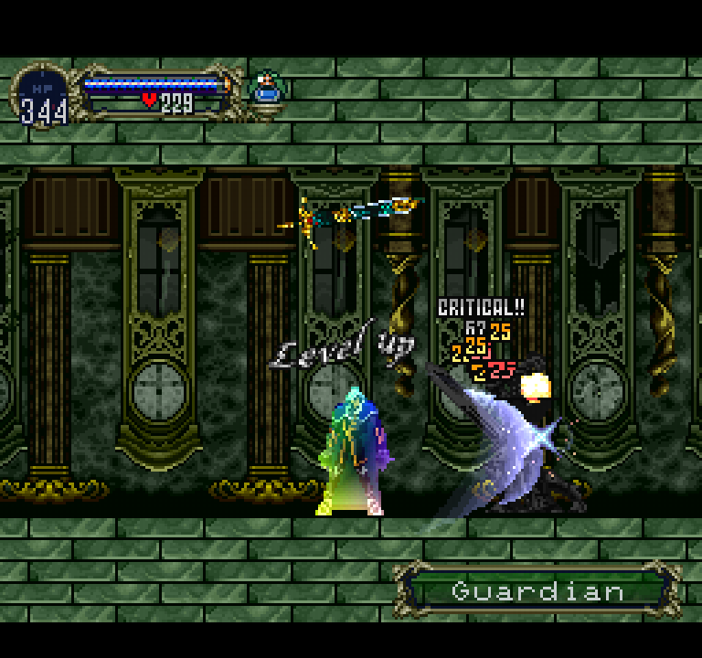

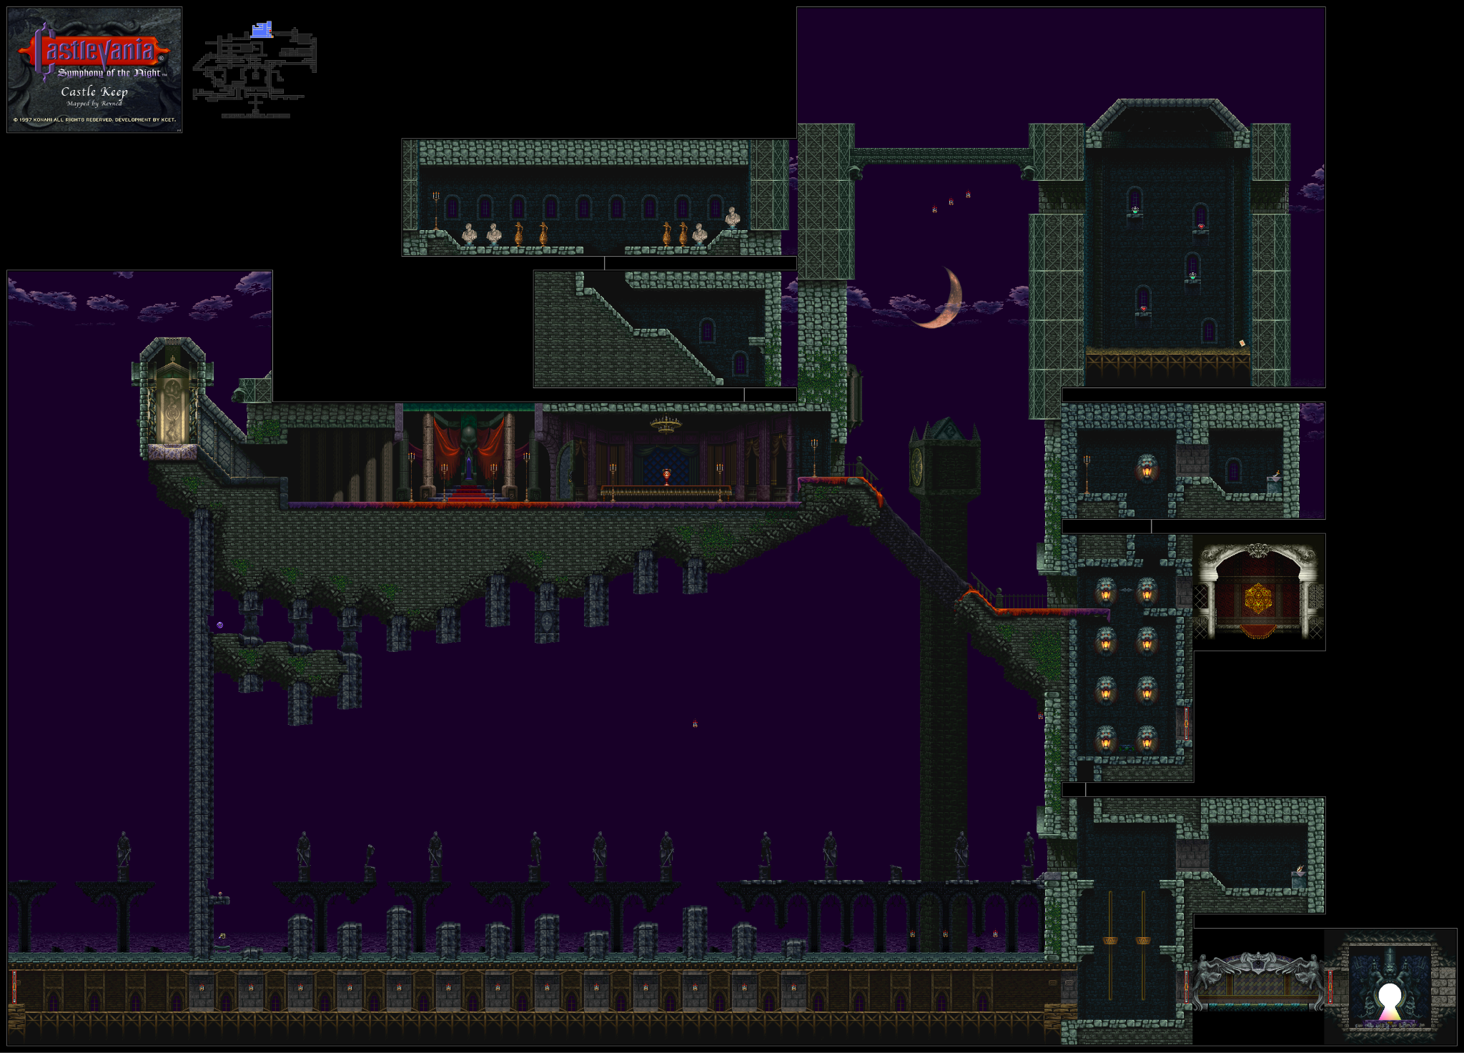

**Dead Cells** sets a benchmark for fluid, adrenaline-fueled gameplay. Its fast-paced, precision-based combat and the use of roguelike elements—like randomized enemy placements and procedural level variations—inject unpredictability into each run. ***Shadows of Valor*** adopts these elements by incorporating dynamic object spawning and challenging enemy patterns that demand timely dodges and attacks. This blend ensures that every session feels unique, continuously pushing players to adapt their strategies and master their skills.

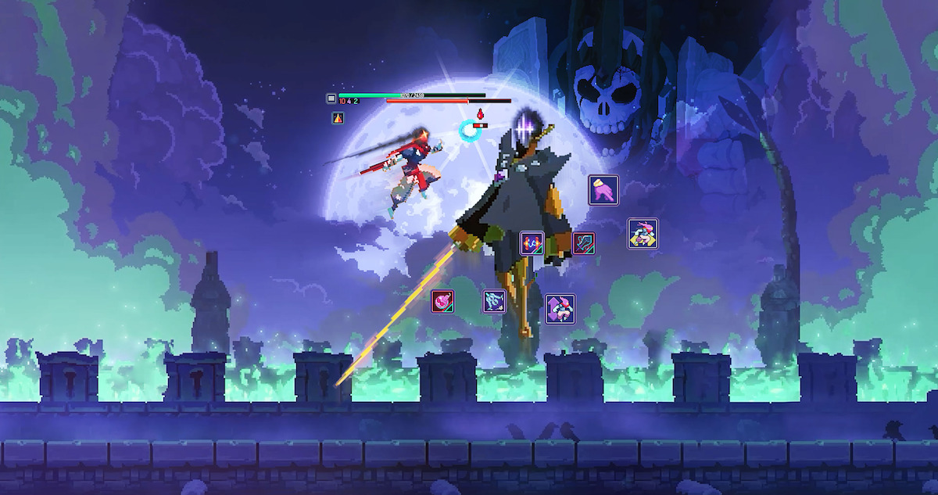

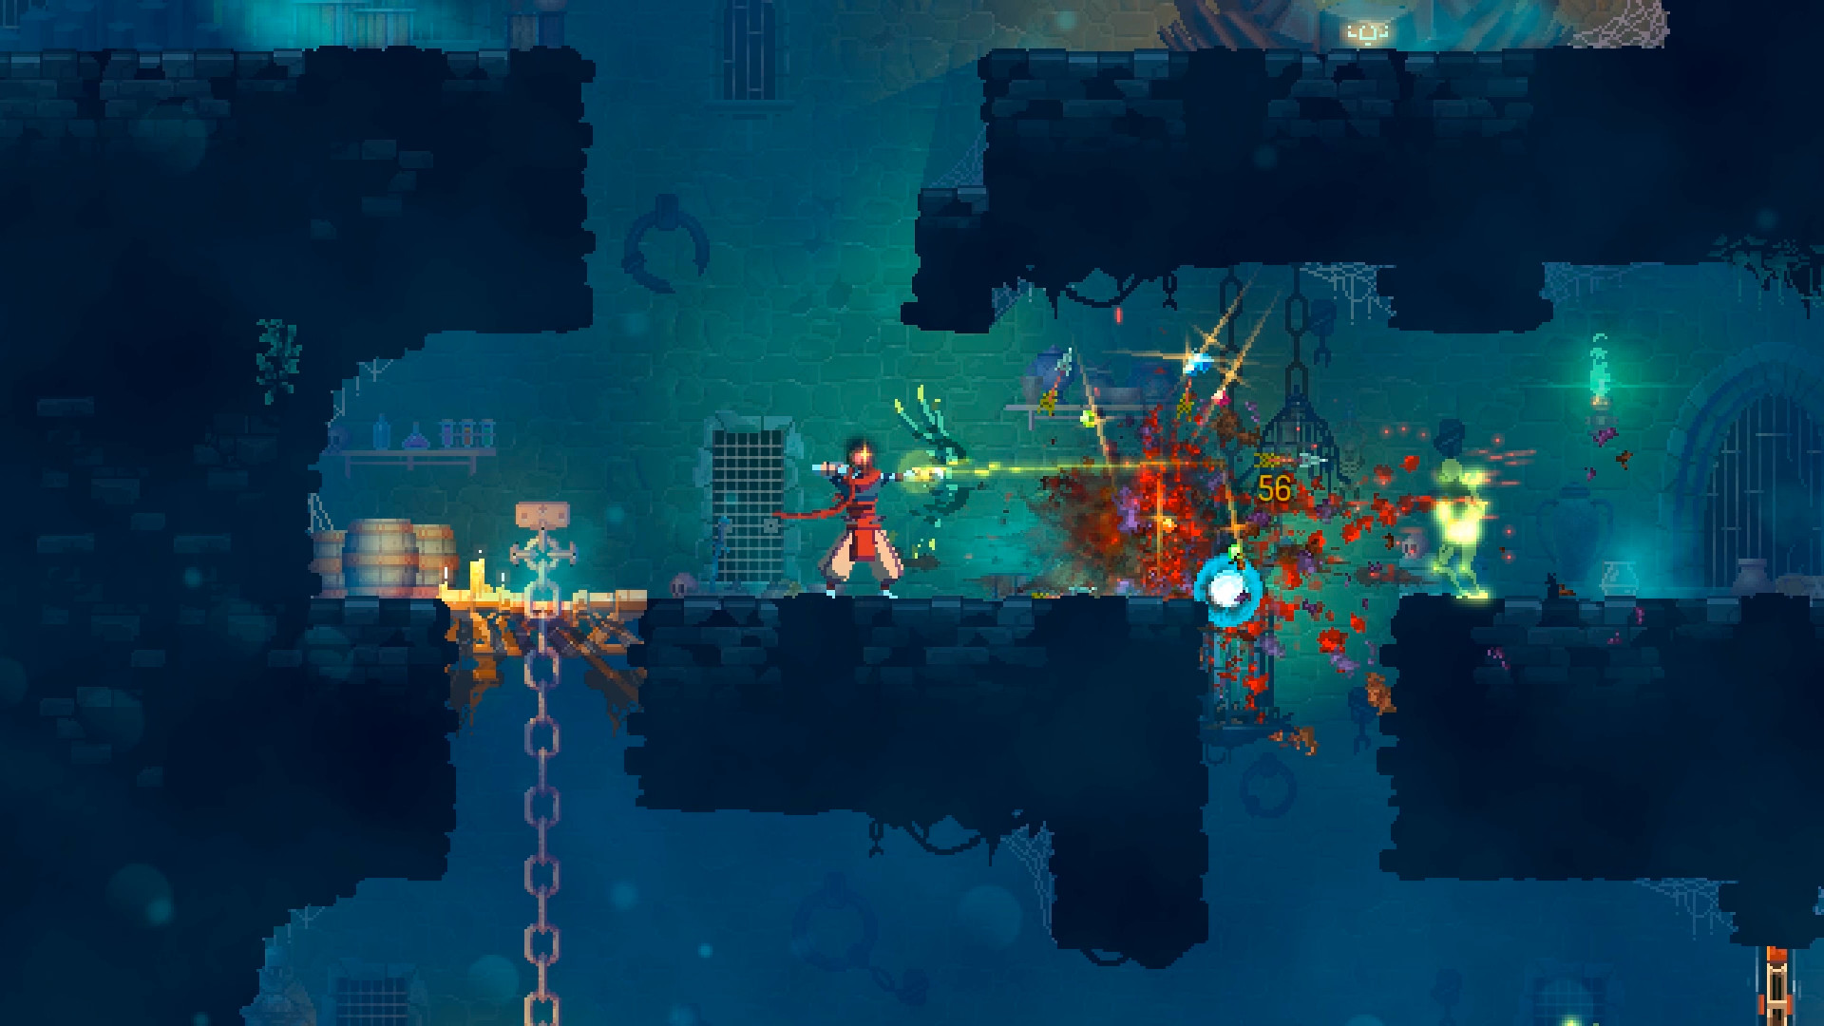

**Blasphemous** is celebrated for its deeply atmospheric tone, intricate lore, and richly detailed pixel art style. Instead of overt exposition, its story unfolds through evocative environmental cues and haunting visuals, creating an immersive world steeped in myth and mystery. This narrative technique has inspired us to infuse ***Shadows of Valor*** with subtle, environmental storytelling that enhances both mood and gameplay. Additionally, the challenging combat mechanics in Blasphemous—emphasizing skill and precise timing—align well with our own combat philosophy, ensuring that each battle is both visually engaging and demanding.

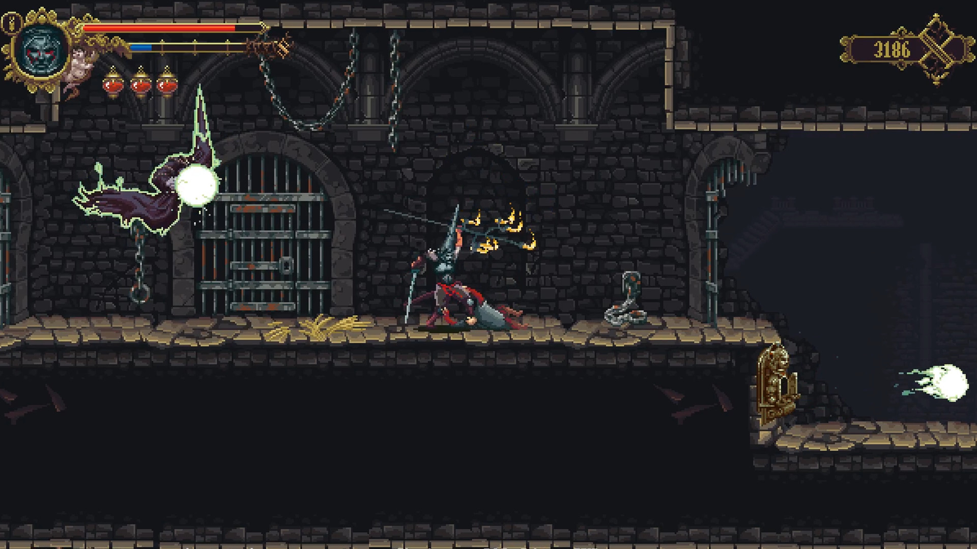

**5. Basic game mechanics and internal logic**

**Basic Game Mechanics and Internal Logic** I'm implementing core mechanics in *Shadows of Valor* inspired by titles like Dead Cells and Blasphemous. In my game, the player can move left and right, perform regular and double jumps, and slide to evade attacks. The combat system includes two types of attacks—a light attack and a heavy attack that deals double damage. Additional mechanics include:

* **Healing and Resource Management:** The player has three healing potions, which can be used by pressing the **E** key, and a healing statue that fully restores health when activated with the **X** key. The game also allows the player to pray to restore health (up to three times), with additional prayer required to reactivate healing afterward.
* **Enemy Behaviors:** Skeleton enemies follow patrol routines during which they rotate to face the player and calculate distances to determine whether to pursue. A spike trap present on certain levels damages the player, potentially causing instant death if activated without a shield.
* **Dynamic Object Spawning:** Various objects—from healing statues to simple stoves—are randomly spawned throughout levels, ensuring each playthrough offers unique challenges. All these mechanics are built on a scalable architecture that allows easy expansion and integration of new features without major revisions.

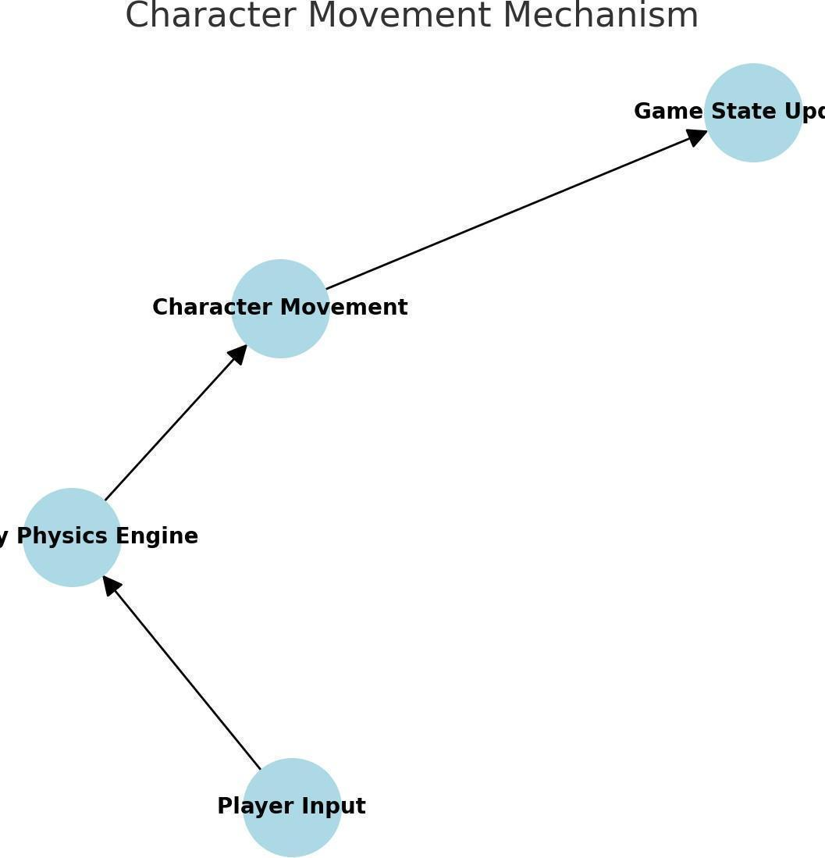

**Class Diagram**

Class Diagram – representing the structure of the game’s code and object hierarchy.

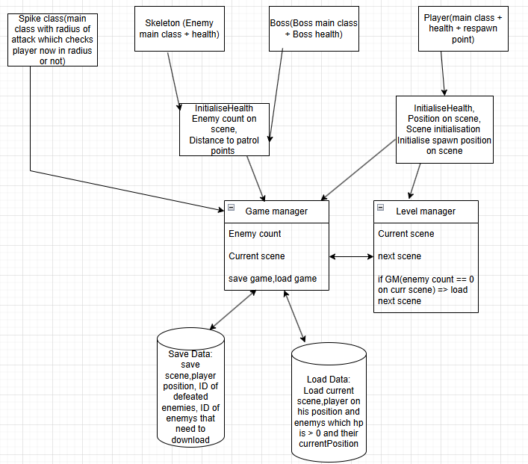

This class diagram provides an overview of key classes used in the game, showing relationships among player, enemy, and UI components to support robust coding practices.

## Example Mechanics Implementation:

### Weapon Mechanics

Explanation: In this example, the weapon mechanics are designed to provide stability and fluid combat for the player. The player is equipped with a single sword that offers two distinct attack types:

* Primary Attack: A standard light attack that allows quick strikes and facilitates movement.
* Secondary Attack: A heavier attack that deals increased damage and contributes to overall combat stability.

The code implementation (see attached screenshot) manages these two attack types by detecting specific input commands and then executing the appropriate combat routine. This dual-attack system ensures that the player can adapt their combat style depending on the situation, providing both speed and impact as needed.

**Player Attack Template (LMB = Attack1, RMB = Attack2)**

public class PlayerCombat : MonoBehaviour

{

public int lightAttackDamage = 10;

public int severeAttackDamage = 20;

public Animator animator;

private void Update()

{

if (Input.GetMouseButtonDown(0))

{

Attack(lightAttackDamage, "Attack1");

}

else if (Input.GetMouseButtonDown(1))

{

Attack(heavyAttackDamage, "Attack2");

}

}

private void Attack(int damage, string animationTrigger)

{

animator.SetTrigger(animationTrigger);

// Use raycast or trigger detection to apply damage

}

}

Description:

This code executes two different attacks — Attack1 (light) and Attack2 (heavy) by LMB/PCM click. Attacks activate the necessary animation and can be connected to hit mechanics via Raycast, OverlapBox or Trigger.

### Enemy Health Mechanic and State System:

## Explanation: The enemy health mechanic under testing is integrated with an AI state system that controls enemy behavior. The attached screenshot illustrates a finite state machine (FSM) with four key states for an enemy character:

## Idle: The enemy remains stationary, awaiting any stimulus.

## Walk: The enemy patrols its area, moving slowly or following a predefined path.

## Chasing: The enemy actively pursues the player when a threat is detected. This state triggers once the player comes within a certain range.

## Attack: The enemy directly engages the player in combat once it has closed the distance.

## This FSM setup not only allows the enemy to smoothly transition between states based on environmental triggers and player actions but also integrates with the enemy health mechanic. When the enemy receives damage, its state might transition (for instance, from Idle to Chasing), reflecting its readiness to react and engage the player accordingly.

## 

## The enemy health mechanic code:

**Health System Template (Player, Boss, Skeleton)**

public class Health : MonoBehaviour

{

public int maxHealth = 100;

public int currentHealth;

public event Action OnDeath;

private void Awake()

{

currentHealth = maxHealth;

}

public void TakeDamage(int amount)

{

currentHealth -= amount;

if (currentHealth <= 0)

{

currentHealth = 0;

die();

}

}

public void Heal(int amount)

{

currentHealth = Mathf.Min(currentHealth + amount, maxHealth);

}

private void Die()

{

OnDeath?.Invoke();

// Add death logic per entity (e.g., play animation, disable AI)

}

}

Description:

This template is used for the player, boss, and skeleton, and will be updated: animation calls, notification systems, recovery logic, and death triggers will be added. It is universal and flexibly connects to other systems through events (OnDeath).

**Player FSM:**

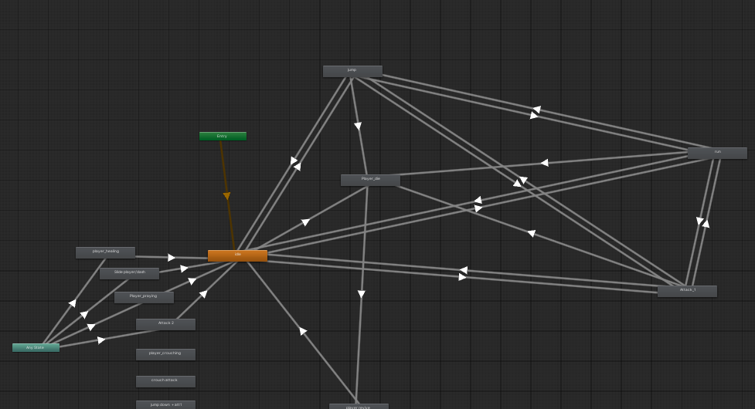

### Player FSM (Finite State Machine):

### The Player FSM manages all animation and behavior states the player transitions through during gameplay. It includes Idle (no input), Walking (movement), Jump (airborne), Attack1 and Attack2 (combat variations), Sliding (dodge or obstacle pass), Healing (health recovery), Pray (ritual or lore-related), Death (upon defeat), and Revive (resurrection). This structure ensures smooth transitions, prevents conflicts, and organizes logic clearly — supporting a wide range of mechanics from core movement to advanced interaction and combat behaviors.

**Boss FSM:**

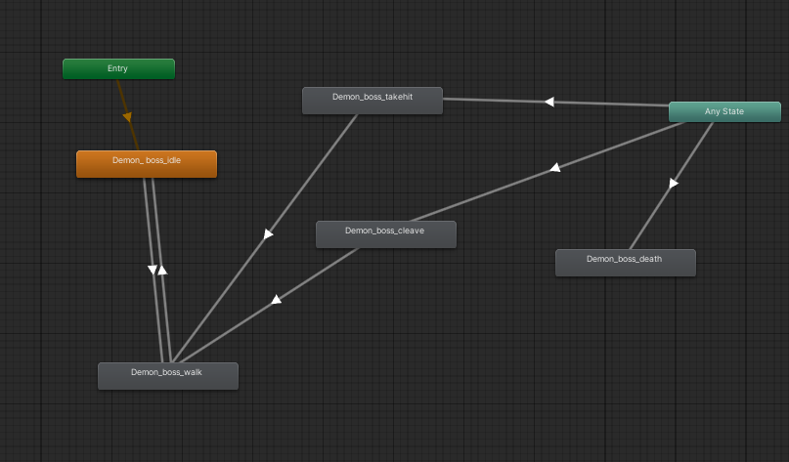

Boss FSM (Finite State Machine):

The Boss FSM defines the enemy boss's key behavior states shown in the diagram. These include Idle (passive/waiting), Walking (movement toward player), Cleave (attack animation), TakeHit (damage reaction), and Dead (final state after health reaches zero). Transitions are triggered by conditions like player distance, damage taken, or cooldowns. This FSM ensures predictable, expandable behavior and keeps each state modular and maintainable — allowing easy updates like adding new attacks or advanced boss logic later in development.

**Skeleton FSM:**

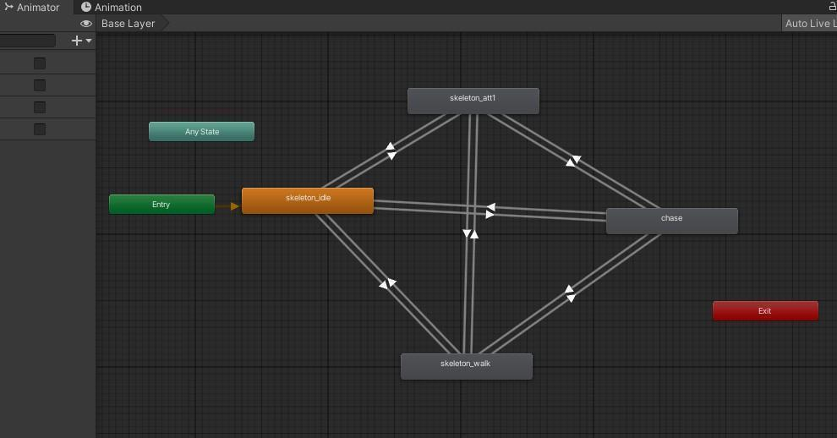

The screenshot displays four key states for the enemy character: "Idle," where the enemy is stationary and waiting; "Walk," where the enemy is moving around or patrolling the area; "Chasing," where the enemy is actively pursuing the player; and "Attack," where the enemy is directly engaging the player.

**Technologies, Architecture, and Tools** I'm developing ***Shadows of Valor*** in Unity using C# (with development in Visual Studio, .NET 9.0 Core) along with the Physics2D library and various UI and interface libraries. Unity’s robust frameworks underpin the game:

* **Physics Engine:** Enables realistic movement, collisions, and trigger events.
* **Animation System:** Using Animator Controllers, Blend Trees, and State Machines to create smooth, state-driven animations.
* **UI Toolkit:** Provides a clean, responsive interface through layered canvases and event-driven interactions.
* **C# Scripting:** Facilitates rapid prototyping, efficient game state management, and modular AI behaviors. The asset pipeline in Unity also organizes art, sound, scripts, and prefabs in a scalable structure, supporting version control and real-time updates for stable, continuous development.

**6. Data Persistence and Custom Save System** A key feature of ***Shadows of Valor*** is its custom save/load system, built on Unity’s JSON serialization. This system is designed to capture and persist all essential gameplay elements between sessions. When a player saves the game, the system records:

* **Player State:** The player's current position, current health, and the number of healing potions remaining.
* **Level State:** Detailed information about the current level, including the count of remaining enemies and the unique IDs of defeated enemies. This ensures that defeated enemies are not respawned upon loading.

Additionally, the **Level Manager** plays a crucial role in the game flow—monitoring the enemy count on the current level and automatically loading the next level once it reaches zero. The save system works in tandem with both the **Game Manager** and **Level Manager**: data from these modules is gathered and stored in a JSON file, which is then parsed during loading to accurately restore the game world exactly as it was at the time of the save. This modular approach simplifies debugging, supports future enhancements, and ensures compatibility with platform-specific storage solutions.

**How my JSON Save/Load system works with GameManager and LevelManager:**  
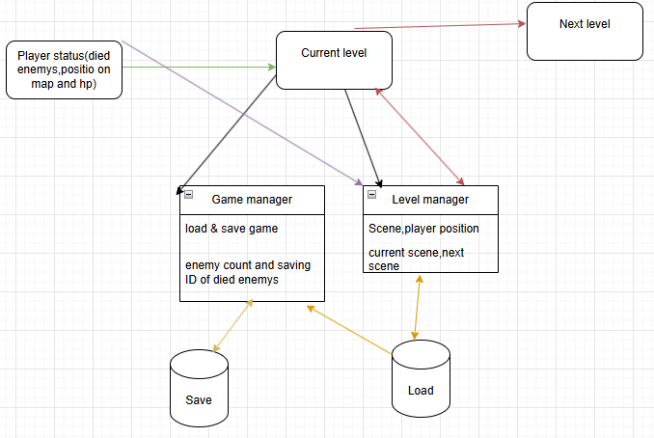

**How the JSON Save/Load System Works (Diagram Explanation):** Below the diagram, you'll see an illustration of the JSON Save/Load workflow. This schematic demonstrates how the system collects data from the Game Manager and Level Manager, stores key gameplay elements in a JSON file, and accurately restores the game state upon loading. This visual representation clarifies the interactions between the modules and highlights the robustness and modular nature of the data persistence system.

## 7. Analysis of Similar Games

### 1. Blasphemous

**Description: *Blasphemous*** stands out as a challenging platformer that integrates Metroidvania elements within a deeply symbolic narrative. Players control "The Penitent One" as they journey through a haunting world rich in cultural and religious references. The game features intricately detailed environments teeming with perilous enemies, hazardous obstacles, and lore waiting to be uncovered.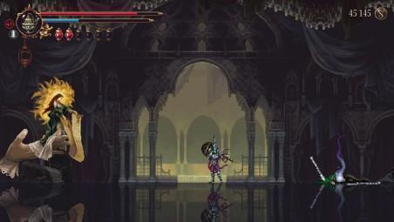

**Game Mechanics:**

* **Exploration:** Players thoroughly traverse interconnected environments, gaining new abilities that unlock previously inaccessible pathways, thereby creating a rewarding loop of discovery.
* **Combat:** The combat system is immediate and skill-based, relying on the player's precision and timing. With a wide variety of enemy types, players must continuously adapt their strategies to succeed.
* **Upgrades:** A diverse skill tree allows players to tailor their character’s abilities to match their individual play style, enhancing long-term satisfaction and progression.

**Context Diagram 1: Blasphemous**

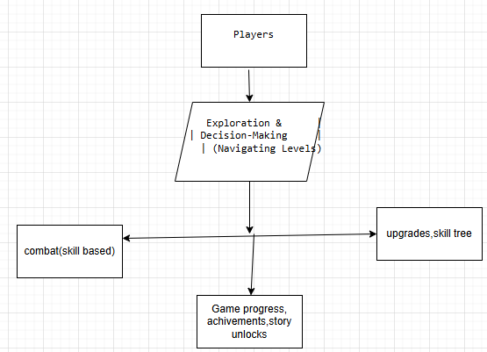

**Identified Problems:**

1. **Complex Navigation:** The intricate, interconnected paths can create confusion, making it challenging for players to backtrack or navigate efficiently through the expansive game world.
2. **Difficulty Spikes:** Sudden increases in challenge may lead to frustration, risking player disengagement during critical moments.

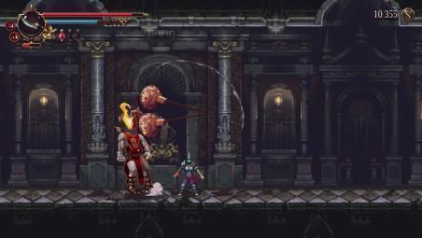

### 2. Dead Cells

**Description:** ***Dead Cells*** revolutionizes the action-platformer genre by combining roguelike mechanics with a Metroidvania-style exploration process. Players navigate through procedurally generated levels, facing challenging foes and environmental obstacles. At its core, the game focuses on skill-based combat, providing a diverse range of weapons and abilities that encourage experimentation with various playstyles.

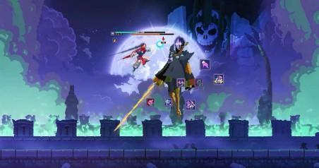

**Game Mechanics:**

* **Roguelike Elements:** Randomly generated level layouts and a permadeath mechanic require players to continuously adapt and improve their skills during each playthrough.
* **Level Design:** The interconnected world design encourages exploration; players must acquire specific upgrades to unlock previously hidden areas, reinforcing classic Metroidvania principles.
* **Combat Variety:** With an extensive selection of weapons and abilities, players can develop unique strategies that reward creative and adaptive combat approaches.

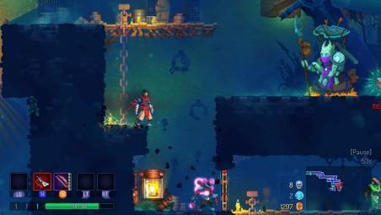

## Context Diagram 2: Dead Cells

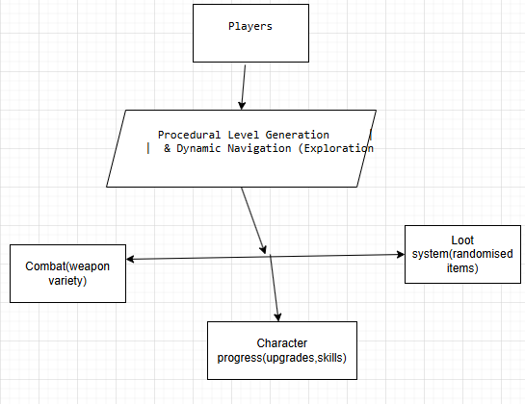

**Identified Problems:**

1. **Randomized Loot Frustration:** The inherent variability in loot can sometimes result in players acquiring items or weapons that do not align well with their play style or current needs, reducing overall enjoyment.
2. **Permadeath Disappointment:** Although permadeath adds tension, it can also lead to significant frustration if players feel that their long-term progress or achievements are abruptly lost after a prolonged session.

**3.Castlevania: Symphony of the Night**

**Description:** *Castlevania: Symphony of the Night* redefines the Metroidvania genre with its expansive, intricately interconnected castle. In this classic, players assume the role of Alucard and explore a sprawling, eerie fortress filled with hidden passages, secret rooms, and atmospheric environments. The game seamlessly blends exploration, challenging combat, and character progression, rewarding players with new abilities and upgrades as they uncover the castle's many mysteries.

**Game Mechanics:**

* **Exploration and Non-Linear Level Design:** The castle’s detailed layout encourages deep exploration. Players unlock new areas by acquiring abilities and keys, which grant access to regions that were previously unreachable. This creates a continuous cycle of discovery and progression.
* **Combat System:** The combat is skill-based and precise, featuring a mix of melee strikes, ranged attacks, and magical abilities. Players must adapt to varied enemy behaviors and boss mechanics—timing their moves carefully to overcome challenges.
* **Progression and Upgrades:** A robust upgrade system is integrated into the game, where collecting items, defeating bosses, and solving puzzles lead to enhancements in Alucard's attributes and weapons. This system reinforces a satisfying progression loop, where exploration and combat directly impact character development.

**Context Diagram for Castlevania: Symphony of the Night**

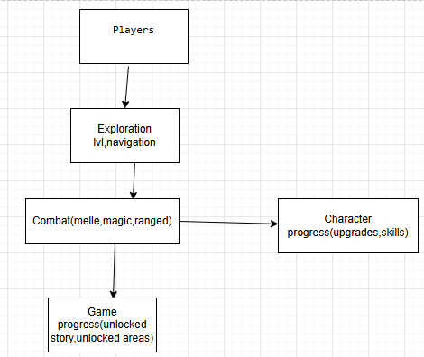

**Identified Problems for Castlevania: Symphony of the Night**

1. Complex Navigation: The sprawling, interconnected castle can be disorienting for players. The lack of clear, in-game directional cues means that players may often feel lost or confused, struggling to retrace their steps or find important paths among numerous hidden passages.
2. Inconsistent Difficulty Spikes: While the combat system is engaging, certain segments and boss encounters can present unexpected difficulty spikes. These abrupt increases in challenge can frustrate players, especially those who are still mastering the game's mechanics.
3. Pacing Issues: The non-linear exploration, though rewarding, sometimes leads to extended periods of backtracking. This can interrupt the overall momentum of gameplay, making the progression feel uneven and occasionally slowing down the pace in more extensive areas.

### Success Criteria (SMART Objectives)

### Gameplay Features

**Must have a game menu** The game must feature a fully functional main menu that allows the player to navigate key actions before entering gameplay. The menu includes the following options:

* **New Game** – Starts a new playthrough from Level 1 with default player stats.
* **Load Game** – Loads the player's last saved state from a JSON file, including health, position, and level state.
* **Settings** – Allows users to configure gameplay elements like music volume, screen resolution, and controls.
* **Exit** – Closes the application and returns the player to the desktop.

The menu is implemented using Unity UI, and button logic is controlled through C# scripts that connect menu interactions to in-game scene changes and system commands. These functions are critical to the game's usability and are among the first features available in the prototype.

### Dynamic Level Events

The game is structured around **three carefully designed levels**, each offering increasing complexity and intensity. These levels ensure pacing, skill progression, and gameplay variety:

* **Level 1 – Camp / Tutorial Zone** The first level serves as an **introduction to core mechanics**, including **movement**, **jumping**, **dashing**, and **healing using colbs**. The environment is more relaxed, allowing players to experiment and become comfortable with controls.
* **Level 2 – Intermediate Level** This level increases the challenge by introducing:  
  + **More enemies** with **higher damage output**
  + **Procedural generation** of certain elements to add unpredictability and replay value
  + Introduction of basic environmental hazards and more advanced platforming
* **Level 3 – Final Challenge** The final level features:  
  + **Moving platforms** to test timing and mobility
  + **Higher enemy density and aggression**
  + **Complex procedural level generation** (e.g., spawn positions for enemies and objects vary between playthroughs)
  + **The final boss battle**, acting as the ultimate test of the player’s skill

**Each level contains interactive and dynamic objects that enhance exploration and gameplay variety. These elements make each playthrough unique and unpredictable:**

* **Prayer Statue** – Appears randomly and allows the player to **restore health** and **refill healing colbs**, similar to the "Pray" mechanic in *Blasphemous*. It encourages exploration and offers a checkpoint-like feature for recovery.
* **Spike Traps** – Found in **Level 1 and Level 3**, these traps deal damage on contact and serve as environmental hazards. Players must time their movements carefully, especially during fights or platforming sections.
* **Random Object Spawning** – Procedural generation is used in **Levels 2 and 3** to spawn these interactive elements in new positions during each run, which increases replay value and keeps gameplay fresh.

**Metroidvania Style with Medieval Aesthetic** The game must integrate **Metroidvania elements** such as:

* Progression locked behind character abilities (e.g. slide, double jump).
* Procedural generation in Levels 2 and 3.

The **visual theme and mechanics** are directly inspired by:

* **Dead Cells** – Movement style (dash, double jump), fast-paced combat.
* **Blasphemous** – Healing system, prayer stations, dark aesthetic.
* **Castlevania: Symphony of the Night** – Medieval fantasy atmosphere and complex map design.

This style requires consistent visual and mechanical design that makes progression feel earned and interconnected.

User Experience

**Seamless Save/Load System** A polished save/load system is required. It will:

* **Save player state** to a local JSON file when the player chooses to save.
* Store current level, player HP, position, collected items, and number of enemies.
* **Load state** upon launching the game or selecting “Load Game,” recreating the scene exactly as the player left it.

This system ensures consistency, supports replayability, and demonstrates strong use of object serialization and file I/O management in C#.

### Conclusion

***Shadows of Valor*** is designed to be a standout single-player adventure that offers depth, challenge, and replayability. With its innovative blend of procedurally generated dungeons, dynamic combat, and a richly atmospheric world, the game invites players to experience an unpredictable yet strategically engaging journey.

Emphasizing technical stability, intuitive user experience, and continuous iteration through targeted playtesting, my development roadmap and clearly defined success criteria guarantee a high-quality final product**. *Shadows of Valor*** not only showcases robust game mechanics and a compelling narrative but also reflects my commitment to delivering a polished, immersive gaming experience that leaves a lasting impression on its audience.

**Final Project Design**

Shadows of Valor: Game Development and Narrative Exploration

## 1. Project Overview

### Description

***Shadows of Valor*** plunges players into a haunting world where light struggles to break through. In this project, players assume the role of a brave knight navigating diverse environments—from foreboding dungeons to enchanted forests—while uncovering mysterious lore, battling malevolent creatures, and avoiding treacherous traps. The interplay of oppressive shadows and dim lighting creates an immersive atmosphere that emphasizes the ever-present danger lurking around every corner.

### Context

This project underscores the importance of storytelling and atmospheric design in video games. ***Shadows of Valor*** balances thrilling exploration with a profound narrative aimed at engaging players on both emotional and intellectual levels. It aligns with the growing industry trend toward narrative-driven gaming experiences by integrating rich lore and dynamic gameplay.

### 2. Objectives

### Primary Objective

* Develop an engaging single-player adventure game that combines refined gameplay mechanics, strategic combat, and a rich narrative.

### Secondary Objectives

* Create diverse level designs that enhance gameplay and exploration.
* Develop a sophisticated AI system for dynamic enemy encounters.
* Craft a compelling narrative that resonates with players and promotes self-reflection on personal challenges.

### 3. Target Audience

* **Demographics:** Gamers aged 15–35 who enjoy action-adventure experiences focused on narrative, exploration, and gameplay challenges.
* **Needs Assessment:** Many players seek immersive experiences that provide both excitement and deep emotional engagement. This game meets that demand by intertwining engaging gameplay.

### 4. Project Scope

The scope of *Shadows of Valor* encompasses several key design elements:

* **Level Design:** Creation of immersive environments featuring thoughtful layouts, interactive elements, and deliberate aesthetics to enhance gameplay.
* **Character Development:** Design of compelling player and non-player characters, with a focus on appearance, abilities, backstory, and progression.
* **Enemy AI:** Implementation of sophisticated AI systems to produce varied and challenging enemy interactions that add strategic depth.
* **Visual Elements:** Production of high-quality graphics that underpin the game’s immersive atmosphere.

## 5. Methodology

An agile game development methodology is employed to drive iterative design and continuous feedback:

* **Agile Practices:** The project is broken down into manageable sprints, allowing regular progress assessments and rapid incorporation of playtester feedback. This drive for continuous iteration ensures ongoing refinement throughout development.
* **Data Collection:** Regular playtesting sessions, surveys, and interviews provide critical insights into gameplay mechanics, narrative flow, and player engagement, guiding incremental improvements.
* **Implementation Steps:**
  1. **Level Design & Environmental Art Creation:** Develop level layouts, design interactive elements, and build the visual world.
  2. **Character Models & Enemy AI Development:** Create player models, enemy characters, and implement dynamic AI behaviors.
  3. **Visual Assets:** Combine art to build a cohesive experience.
  4. **Playtesting & Iterative Refinement:** Use feedback to adjust gameplay, refine interfaces, and optimize performance.

### 

## 6. Resources Needed

* **Game Development Software:** Unity
* **Graphic Design Tools:** Photoshop (or similar)
* **Version Control Systems:** Git

### 7. Evaluation and Assessment

### Criteria for Success

* **Player Feedback:** High engagement, positive satisfaction scores, and observed improvement in completion rates based on user testing.
* **Engagement Metrics:** Quantitative data, such as time spent playing and frequency of in-game actions, will be tracked.
* **Completion Rates:** Measurable progress indicators obtained from playtesting sessions.

### Evaluation Methods

* **Surveys & Interviews:** Conduct post-playtest surveys and interviews to collect qualitative insights.
* **In-Game Analytics:** Monitor player behavior with analytics tools to capture quantitative performance data.

**8. Timeline**

**Milestones:**

* **Month 1: Finalize Game Concept and Narrative Outline During this phase, I focus on solidifying the core ideas of *Shadows of Valor*, including character development, setting, and overarching story. The narrative outline serves as a strategic roadmap for the project.**
* **Months 2–3: Level Design and Asset Creation In this period, I develop comprehensive level designs that include layout, mechanics, and obstacles. Simultaneously, I create and assemble all visual and audio assets (characters, environments, special effects) necessary for an immersive experience.**
* **Month 4: Enemy AI and Gameplay Mechanics Development The focus shifts to creating intelligent enemies that dynamically respond to player actions, alongside the implementation of essential gameplay mechanics such as physics, collision detection, and user interface elements.**
* **Month 5: Initial Playtesting and Feedback Collection Early versions of the game are put through extensive playtesting. This phase is dedicated to identifying issues in game mechanics, level navigation, and overall flow. Feedback from testers is then used to make informed adjustments.**
* **Month 6: Final Tweaks and Preparation for Launch In the final month, I refine the game based on playtesting feedback. This involves thorough testing, performance optimization, and quality assurance to ensure that the game meets all desired standards before release.**

**My Gantt Chart:**

**In this Gantt chart, you can see the structured workflow for creating my game, illustrating the timeline and progression through several key stages of development. Each stage builds on the previous one, ensuring a cohesive and organised approach to game creation.**

| Task | Start Date | End Date | Duration |
| --- | --- | --- | --- |
| Finalise game concept and narrative outline | Month 1 | Month 1 | 1 Month |
| Level design and asset creation | Month 2 | Month 3 | 2 Month |
| Develop enemy AI and gameplay mechanics | Month 4 | Month 4 | 1 Month |
| Initial playtesting and gathering feedback | Month 5 | Month 5 | 1 Month |
| Final adjustments and preparation for launch | Month 6 | Month 6 | 1 Month |

I have now developed enemy AI and gameplay mechanics for my game. This will allow me to create a more engaging and challenging experience for players.

## 9. Presentation Plan

* **Format:** Prepare a digital presentation that includes gameplay footage, concept art, and an overview of the narrative. The presentation will visually and verbally communicate the development process and design choices.
* **Audience Engagement:** Organize a live demo session where attendees can try out a level in real time. This interactive session will be followed by a Q&A segment, allowing for in-depth discussion of design decisions, future updates, and addressing any audience questions.

## 10. Appendices

**Additional Documentation: Include supplementary materials that support the design and development process, such as:**

* **Level Design Documentation:**

***Screenshots of Level Designs:***

* + - **Alpha: Initial playable versions showcasing basic layouts and interactive elements.**
    - **Final: Polished levels (Levels 1–3) with optimized graphics, refined enemy placements, and enhanced navigation.**

***Comparative Analysis:* A table or visual timeline summarizing key improvements (e.g., graphics enhancements, AI behavior modifications, refined navigation) between early prototypes and the final version**

**1st level prototype v0.2**

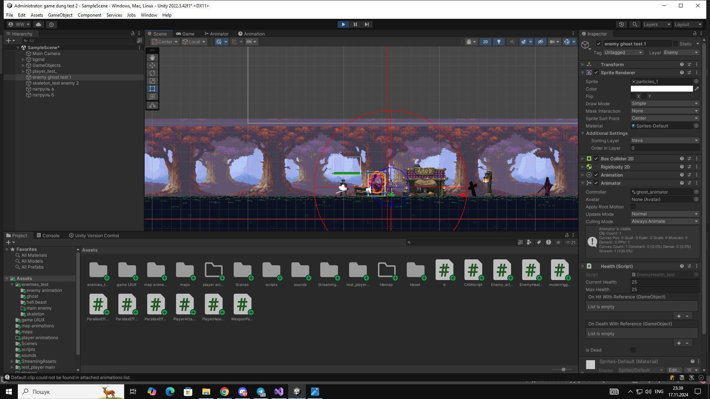

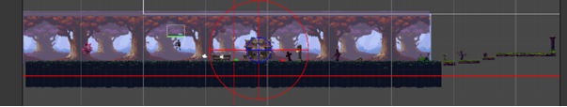

In this image, you can see my level prototype, which will allow me to check how to develop generative levels.

This prototype is an initial version of a level that will help me test and refine the algorithms and techniques used for generating levels dynamically. By experimenting with this prototype, I can better understand how different parameters and rules affect the layout and content of the levels. This iterative process is crucial for developing robust generative systems that can create diverse and interesting game levels automatically.

**Pre-Alpha v0.3 of 1st level:**

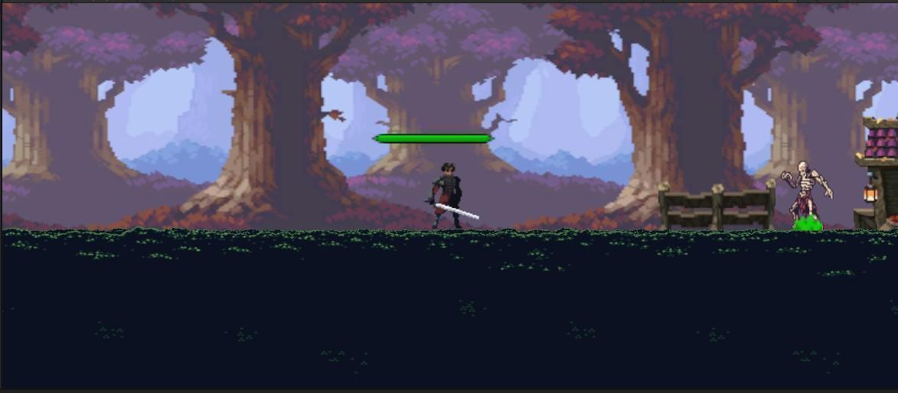

At this stage, the basic prototype of the first level was implemented. I was inspired by the style of Blasphemous and early versions of Castlevania to convey the atmosphere of a dark forest with elements of danger and uncertainty. The dark background, the simple level architecture and the first enemies — all this formed the basis of the future visual language of the game. This version did not yet contain detailed architecture or complex environments, but it set the right direction in terms of style and mood.

**1st level design:**

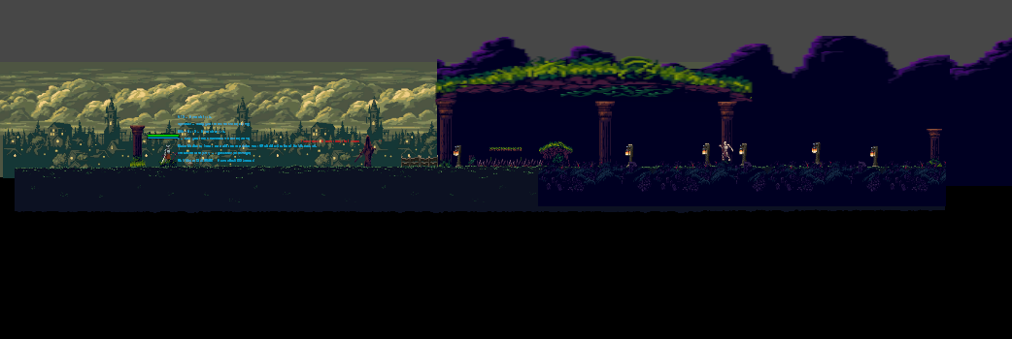

Here, the level has been significantly improved: added landscapes, new architecture, lighting effects and more detailed objects. The location is built with an emphasis on mysticism and natural elements - the player gets into the ruins, hidden in the middle of the forest. I decided to emphasize the atmosphere of abandonment and antiquity, creating a visual contrast between bright neon accents and dark foliage. The aesthetics directly refers to the Gothic motifs of Castlevania and the deep visual symbolism of Blasphemous.

**2nd level design:**

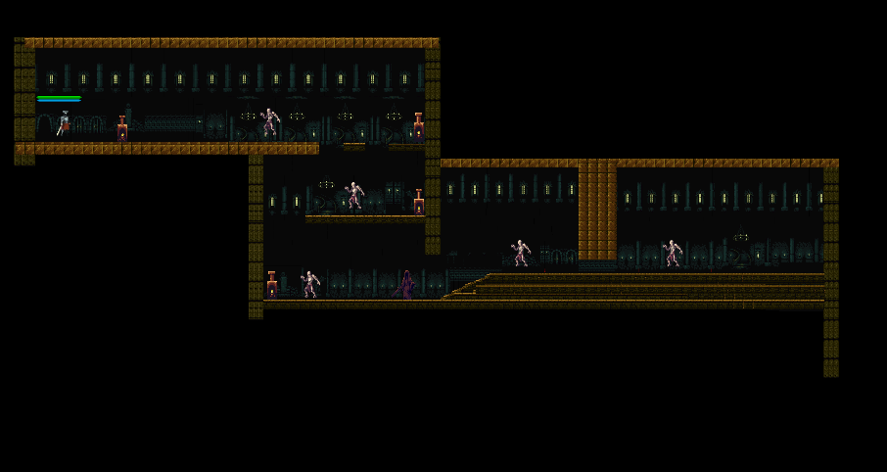

The second level takes the player to dungeons with more severe and industrial architecture. Yellow tones, darkness and narrow corridors prevail here. Visually, the level is created to cause a feeling of claustrophobia and constant danger. The mechanical level has become more complicated: more opponents, less room for maneuver. The design is based on dungeons from Blasphemous, where every corner can be a trap.

**3rd level(final) design:**

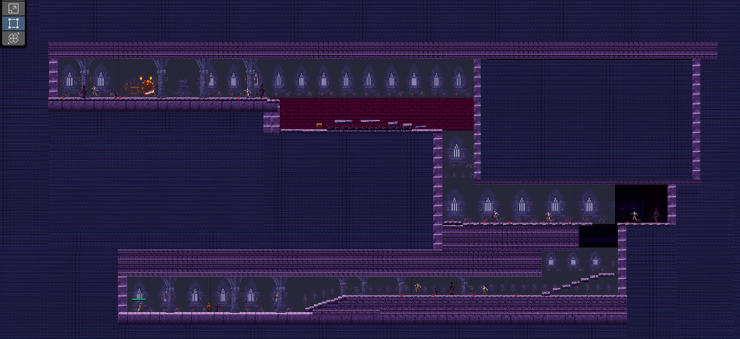

The final level is the culmination of the game's visual and thematic development. Dark purple tones, Gothic architecture, sharp contrasts and a clear structure of levels create the feeling of a sacred, but also sinister place. It is something between the catacombs and the temple - the last refuge of the enemies and the boss. The style emphasizes the importance of the final battle. Everything here should feel like the end of the road: beautiful and scary, epic and dark at the same time.

**Main Menu and Settings prototyping:**

**Menu:**

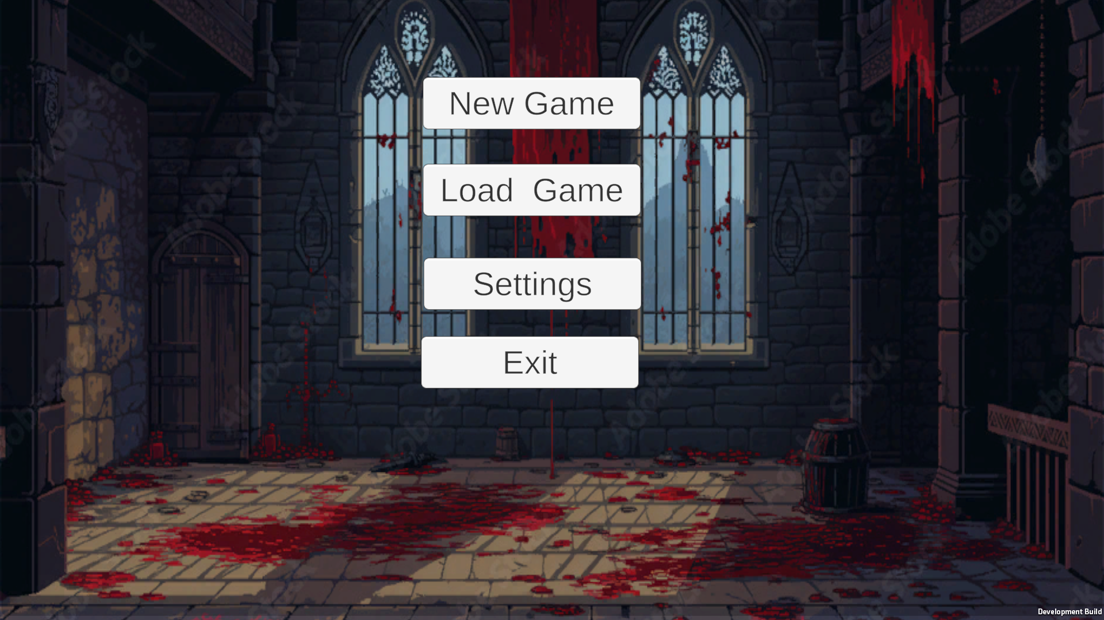

The Main Menu features a minimalistic design with a clean and user-friendly layout. The background is simple, and the buttons are styled in grey, making them easy to read and interact with. The menu includes the following options:

1. New Game:
   * Starts a brand-new game session. Selecting this will reset any progress and take you directly to the beginning of the game.
2. Load Game:
   * This option lets you continue from a previously saved game.
   * How it works: If no saved game exists, the system will automatically start a new game instead. However, if you have a saved game, it will load your most recent progress seamlessly.
3. Settings:
   * Opens the settings menu, where you can adjust game preferences like volume and view control instructions.
4. Exit:
   * Closes the game and returns you to your desktop or console interface.

The buttons are straightforward, and their functionality is designed to provide a smooth and intuitive experience for players.

**Settings:**

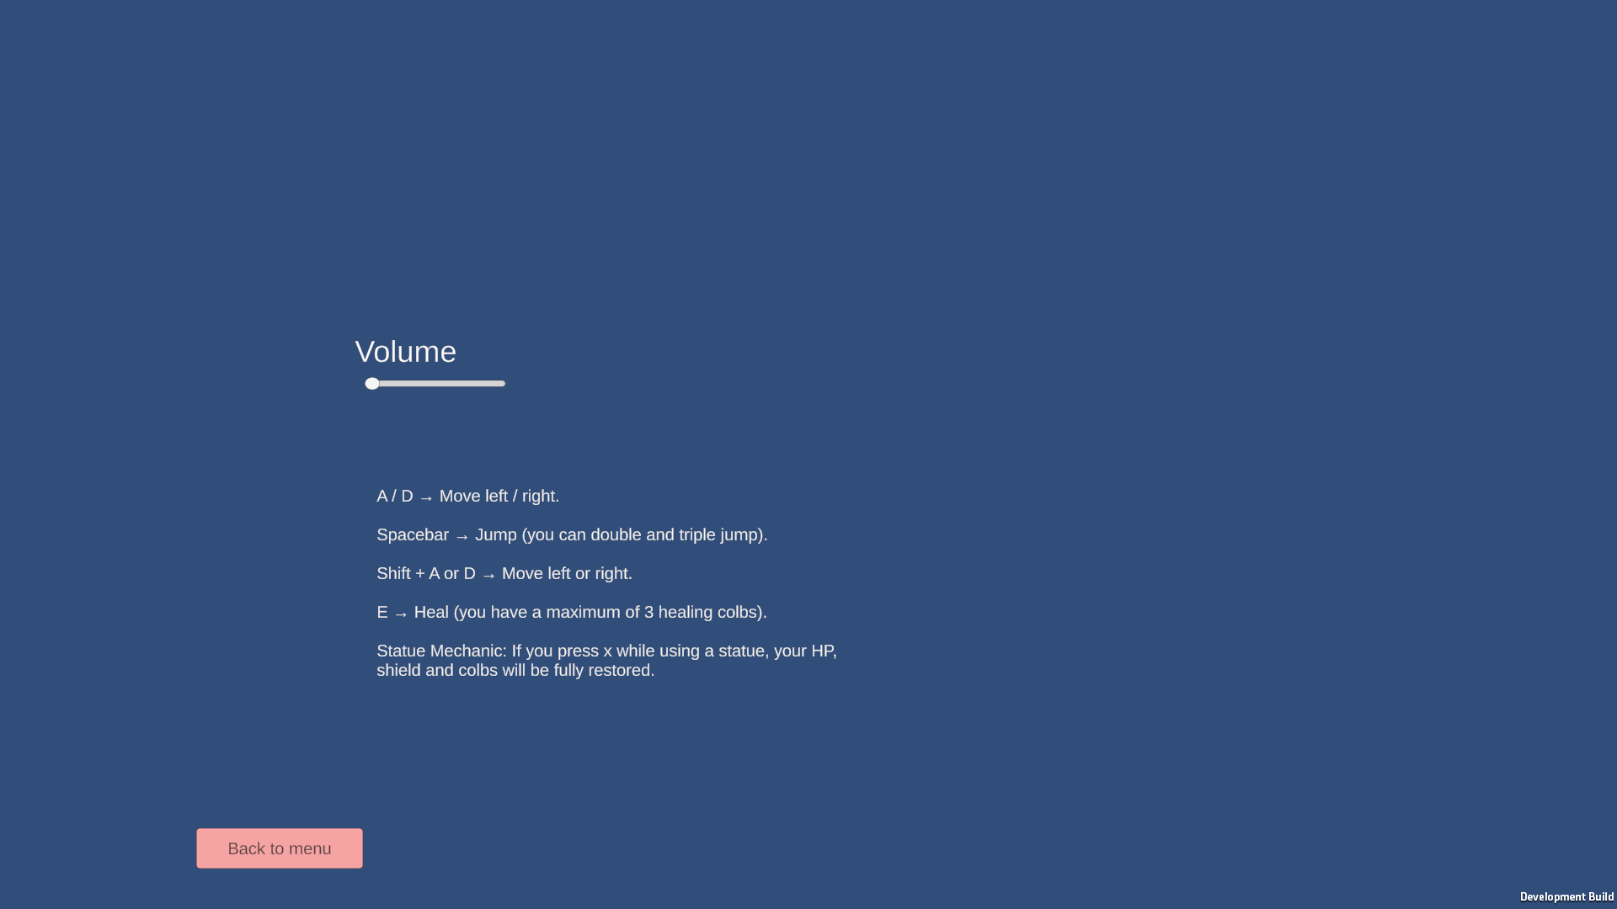

* The Settings Menu provides tools to customize your gameplay experience and access essential information about controls and gameplay mechanics. Here's what you’ll find:
* Exit to Menu:
  + Clicking this button will immediately return you to the main menu, allowing you to leave the settings without saving changes or continuing gameplay.
* Volume Slider:
  + Adjust the game's volume level from 0 (completely muted) to 100 (maximum volume). Simply drag the slider to your desired sound level, providing full control over the audio experience.
* Player Movement and Controls Information:
  + This section outlines the game's controls, helping players quickly familiarize themselves with gameplay mechanics. The following controls are explained:
    - Key A: Move left
    - Key D: Move right
    - Key Space: Jump
    - Key Shift + A/D: Slide to the left or right
    - Key E: Use healing colbs (to restore health)
    - Key X (near a prey statue): Pray at the statue
* The Settings Menu is thoughtfully designed to provide clarity and customization while keeping everything simple and accessible for players. The inclusion of detailed movement and control instructions ensures that players can easily learn how to interact with the game environment and perform actions effectively.

**Visual Flowcharts and Diagrams:**

**Game Entity Relationship Flowchart:** 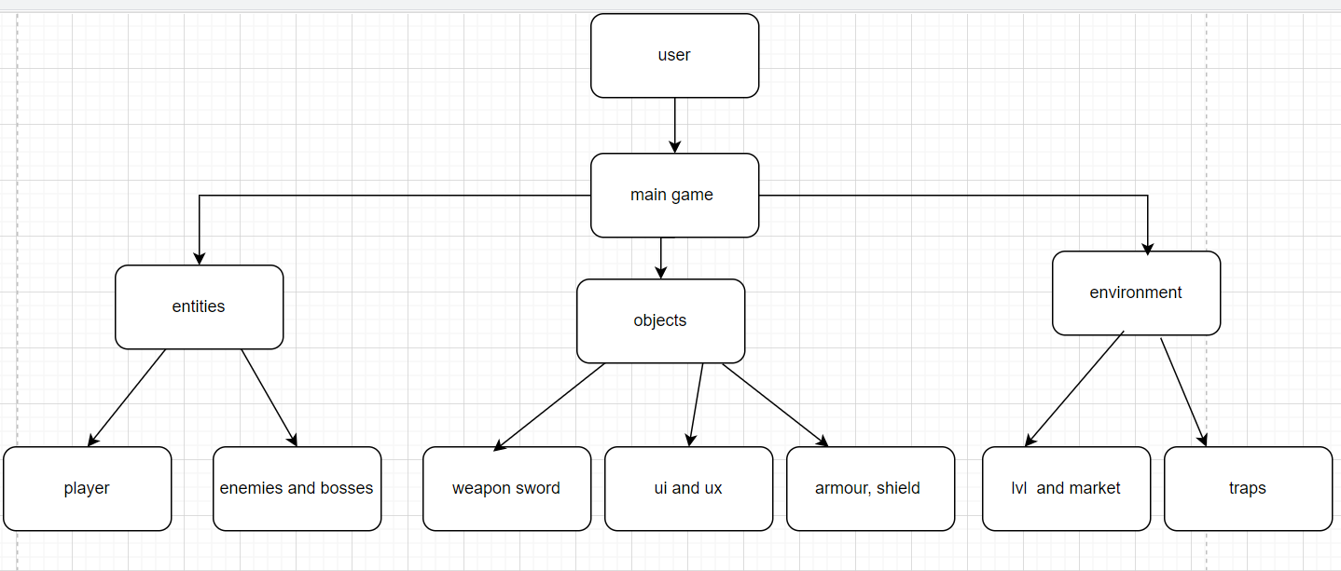

**Game Flowchart Explanation:**

The chart provides an overview of the main components and structure of the game. It starts with the initial entry point and branches out to various elements that make up the game. Here's a detailed breakdown of each section:

Entities:

- Description: Entities represent the characters and interactive elements within the game world. They are divided into different categories:

- Player: The main character controlled by the player. This entity interacts with the game environment and other entities, performing actions such as moving, attacking, and using items.

- Enemy: Characters or creatures that oppose the player. They add challenge and conflict to the game by engaging in combat or creating obstacles for the player.

Objects:

- Description: Objects are items that the player can interact with or use during the game. They can enhance the player's abilities or provide strategic advantages. The objects mentioned are:

- Weapon Sword: A type of weapon that the player can use to attack enemies. It represents melee combat capabilities and can vary in terms of damage and special abilities.

- UX/UI: User Experience and User Interface elements that provide visual feedback and controls for the player. These elements include health bars, menus, and buttons, making the game intuitive and user-friendly.

- Armor Shield: A defensive item that the player can use to protect themselves from enemy attacks. It can reduce damage taken and provide additional defensive capabilities.

Environment:

- Description: The environment encompasses the various settings and elements within the game world. These elements create the atmosphere and context for gameplay. The mentioned environment elements are:

- Traps: Hazardous elements designed to challenge the player. They can cause damage or impede progress, requiring the player to navigate carefully.

- Levels: Distinct stages or areas within the game. Each level presents unique challenges, objectives, and environments for the player to explore and conquer.

**Game In/Out Flowchart:**

This flowchart represents a comprehensive design for the functioning of a game system, breaking it into structured steps for smooth navigation and gameplay. The process begins at the start node, symbolizing the launch of the game. Players are then directed to the main menu, a central hub that offers essential options: Start Game, Load Game, Settings, or Exit. Each option is a gateway to specific functionalities—starting a new session, resuming progress through saved data, customizing gameplay settings like resolution and maximum FPS, or exiting the application entirely.

Upon selecting Start Game, the gameplay phase begins, where the system enters a loop to continuously check for player input. The game remains in a passive state if no input is detected, waiting for the player to take action. When input is received, the system evaluates the specific key pressed and triggers corresponding actions. Movement commands like A (move left) and D (move right) allow for basic navigation. Advanced inputs, such as Space for jumping, Shift for sliding or dashing, and Ctrl for crouching or attacking, offer players diverse ways to interact with the environment or engage with challenges.

These inputs lead to updates in the player state, dynamically altering the player's position, animations, or status in the game. After each input is processed and the player state is updated, the system evaluates the game state. This involves checking for conditions like the completion of objectives, player health, or external events that could end the session. If the game state remains active, the system loops back, allowing continuous gameplay. However, if the game state meets an ending condition (e.g., victory, defeat, or the player's choice to exit), the flow transitions to the end node, gracefully terminating the session.This structured flow ensures that the game is user-friendly, logical, and responsive. The seamless integration of menu navigation, input handling, and real-time updates provides a robust foundation for a compelling gaming experience.

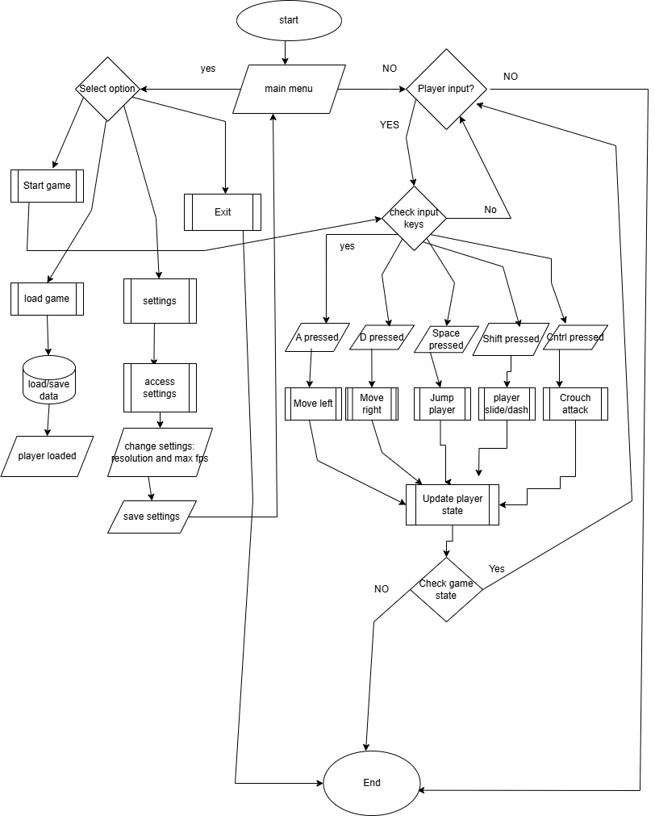

### 

### 

### 

**Game Loop & Player Interaction Diagram:**

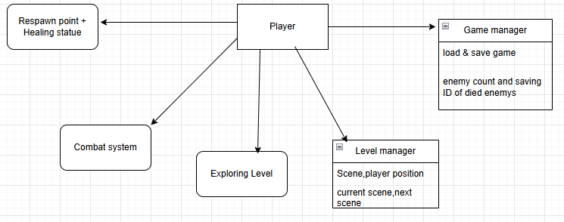

Diagram: Game Loop and Player Interaction

This context diagram illustrates the interaction between the Player and the core Game System. The system is divided into two primary gameplay mechanics:

- Combat: the player engages with enemies (e.g., skeletons with health bars and unique behaviors),

- Exploration: the player navigates levels, uses moving platforms, and searches for the exit portal.

This abstraction sets the foundation for understanding the flow of interaction and core systems in the game loop, which are later implemented via Unity scripts and prefab mechanics.

**Interface IHealth Diagram:**

This diagram outlines how health is managed for both the player and enemies, including the methods for taking damage and healing, ensuring consistent feedback within the game environment.

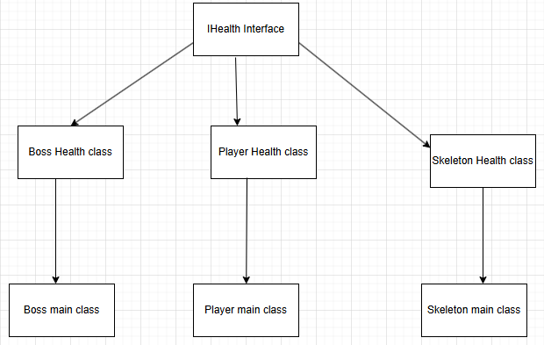

**Sequence diagram**

Sequence Diagram – depicting the order of interactions between objects during key game events.

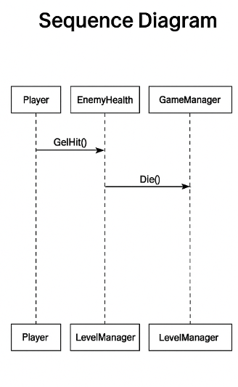

This sequence diagram shows the step-by-step flow of actions during important game events, such as an enemy encountering a player, ensuring that the game logic flows smoothly.

**Skeleton/Boss Behavior Diagram: Explaining state transitions when bosses or certain enemies detect the player.**

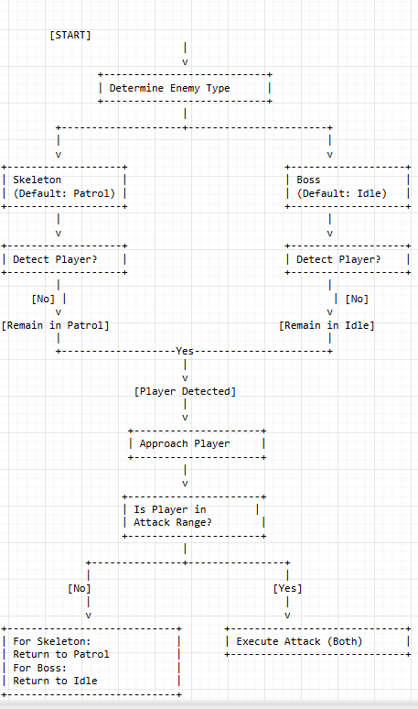

### Detailed Explanation

* Starting Point and Determination of Enemy Type:
  + The diagram begins with a START node.
  + A decision block ("Determine Enemy Type") is used to check if the enemy is a Skeleton or a Boss.
  + Skeleton: Its default state is Patrol, meaning it continuously moves around its designated area.
  + Boss: Its default state is Idle; the boss waits in place unless provoked.
* Player Detection:
  + Both enemy types evaluate whether they detect the player.
  + If the player is not detected:
    - The Skeleton remains in its Patrol state.
    - The Boss remains in its Idle state.
  + If the player is detected:
    - Both types transition to the "Approach Player" state.
* Approaching the Player and Checking Attack Range:
  + Once the player is detected, both the Skeleton and the Boss move toward the player.
  + They then evaluate whether the player is in attack range via a decision block ("Is Player in Attack Range?").
* Reaction Based on Player Proximity:
  + If the player is not in attack range:
    - Skeleton: Returns to its Patrol state, resuming active movement within its area.
    - Boss: Returns to its Idle state, waiting for the next opportunity.
  + If the player is in attack range:
    - Both the Skeleton and the Boss execute an attack.

**Class Diagram 2:**

Player Mechanics & Core Components

PlayerMovement

* Attributes: speed, jumpForce, maxJumps, groundCheck, rb, animator
* Methods: Move(), Jump(), Dash(), Flip(), HandleLanding()

PlayerHealth (Implements IHealth)

* Attributes: maxHealth, currentHealth
* Methods: TakeDamage(int amount), Heal(int amount), FullRestore(), Revive()

PlayerPrayer

* Attributes: prayerKey, prayerCooldown, canPray
* Methods: TryPray(), OnPrayerComplete(), ResetPrayerCooldown()

PlayerRespawn

* Attributes: respawnPoint, respawnDelay
* Methods: RespawnPlayer(), SetRespawnPoint(Vector3 newPosition)

PlayerCombat

* Attributes: attackDamage, attackRange, attackCooldown, enemyLayer
* Methods: Attack1(), Attack2(), OnDrawGizmosSelected()

PlayerColliderManager

* Attributes: boxCollider
* Methods: CheckCollision()

SlideMechanic

* Attributes: slideDuration, slideDistance, slideCooldown, maxSlides, slideKey
* Methods: Slide(), SlideCooldown(), RestoreSlides()

Enemy System & Boss Mechanics

Enemy (Base Class for AI)

* Attributes: health, damage, enemyID
* Methods: TakeDamage(int amount), Die(), Attack()

Boss (Inherits Enemy)

* Attributes: bossHealth, walkSpeed, attackDistance, attackDamage, detectionRadius
* Methods: StartAttack(), PerformAttack(), TriggerHit(), CheckForPlayer()

BossHealth (Implements IHealth)

* Attributes: maxHealth, currentHealth, healthBar, deathDelay
* Methods: TakeDamage(int amount), Heal(int amount), IsDead(), Die()

Skeleton (Inherits Enemy)

* Attributes: skeletonHealth, speed, patrolSpeed, chaseSpeed
* Methods: Patrol(), ChasePlayer(), Attack()

EnemyHealth (Implements IHealth)

* Attributes: maxHealth, currentHealth, deathDelay, healthBar
* Methods: TakeDamage(int amount), Die(), IsDead()

EnemyID

* Attributes: id
* Methods: GenerateID(), CheckIfKilled()

Game Management & Level Progression

GameManager

* Attributes: player, enemyCount, currentScene, savePath, killedEnemies
* Methods: SaveGame(), LoadGame(), EnemyDefeated(), MarkEnemyAsKilled()

LevelManager

* Attributes: currentLevel, maxLevels
* Methods: LoadNextLevel(), LoadLevel(int level), LoadMainMenu(), LoadEndScene()

LevelLoader

* Attributes: Instance
* Methods: LoadLevel(string sceneName), LoadAsynchronously()

ProceduralSpawner

* Attributes: spawnPoints, enemyPrefabs, spawnChance
* Methods: SpawnEnemiesProcedurally()

Statue

* Attributes: interactionRadius
* Methods: StartPrayer(System.Action onPrayerComplete), GetInteractionRadius()

Save System & Data Handling

SaveSystem

* Attributes: SavePath, KilledEnemiesPath
* Methods: DeleteSave(), SaveGame(), LoadGame(), MarkEnemyAsKilled()

SaveData

* Attributes: hp, position, scene

PlayerData

* Attributes: level, hp, currentScene

IHealth

* Methods: GetHit(int amount, GameObject sender)

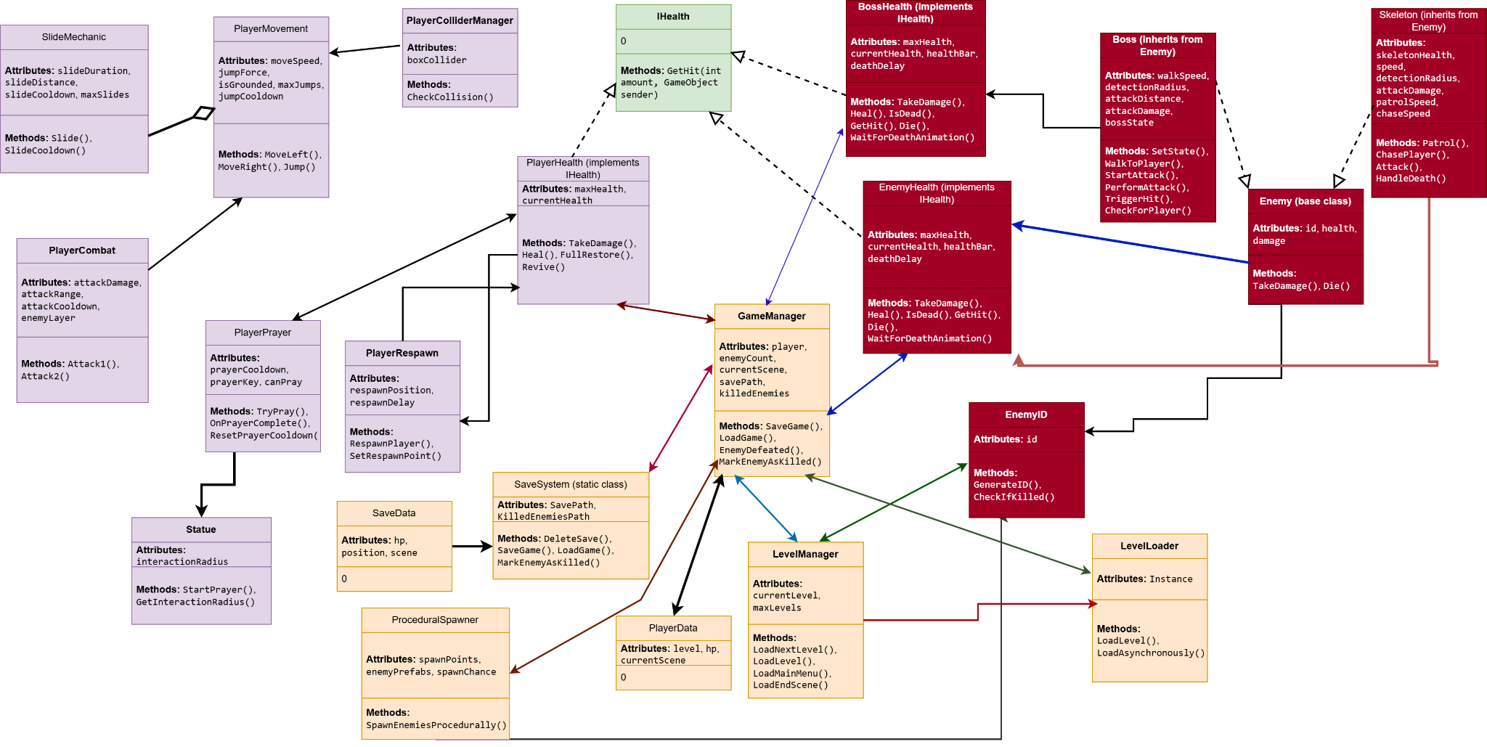

Player Mechanics & Core Components (Inheritance & Usage)

The PlayerMovement class is the central player controller, handling movement, jumping, and interactions with the environment. It **is associated** with PlayerHealth, which **implements** the IHealth interface, allowing standardized damage processing and healing. PlayerPrayer interacts with Statue, utilizing **association**, enabling the player to perform in-game prayers for full restoration. The PlayerRespawn class ensures the correct respawn logic, linking **directly** to PlayerHealth for health restoration on death. PlayerCombat **interacts** with IHealth, making it capable of affecting enemies' health values. PlayerColliderManager is responsible for **collision detection** using BoxCollider2D, allowing precise environmental interactions. The SlideMechanic class is **aggregated** with PlayerMovement, meaning it enhances movement but can exist independently.

Enemy System & Boss Mechanics (Inheritance & Usage)

The **foundation of all enemy behaviors** is the Enemy class, serving as a **base** for both Boss and Skeleton. Both EnemyHealth and BossHealth **inherit** from IHealth, ensuring all entities follow a **consistent health management pattern**. Each enemy possesses a **unique identifier** (EnemyID), allowing GameManager to track eliminated foes. Boss extends Enemy and contains **custom attack patterns, movement logic, and AI transitions**, making boss fights feel immersive. It holds BossHealth as a **composition**, meaning the boss **cannot exist independently without its health component**. Skeleton follows a similar structure, inheriting Enemy and relying on EnemyHealth for **combat durability and AI-driven attack sequences**. These components **collectively enable reactive enemy behaviors**, ensuring dynamic combat scenarios.

Game Management & Level Progression (Inheritance & Usage)

GameManager is the **central authority** for tracking enemy interactions, level progression, and saved game states. It **aggregates** LevelManager and **associates** with LevelLoader for **efficient level transitions**. ProceduralSpawner is linked with EnemyID, ensuring **each generated enemy has a unique identifier** that persists across sessions. Additionally, Statue ties directly into PlayerPrayer, allowing **structured player-environment interactions** based on specific conditions. These mechanics collectively maintain **fluid level transitions, progression tracking, and responsive gameplay** while ensuring that **game states adapt dynamically**.

Save System & Data Handling (Inheritance & Usage)

Persistence in the game is fully managed by SaveSystem, which is **composed within** GameManager, meaning GameManager **cannot function without it**. It maintains core game states via SaveData, which **associates** with PlayerData, allowing **player stats (level, health, and position) to persist** across game sessions. The IHealth interface is **implemented** by PlayerHealth, BossHealth, and EnemyHealth, creating a **unified health management structure** that ensures consistent behavior for all entities. This system **cohesively binds data tracking, health monitoring, and session persistence**, guaranteeing a **smooth gameplay experience** even after multiple restarts.

## Identification of Algorithms and Runtime Systems in Enemy Management

## 1. Enemy Health System — Logic and Usage

## Each enemy in the game is controlled by the ``EnemyHealth'' component, which contains:

## Current and maximum health (`CurrentHP`, `MaxHP`)

## Status flag (`alive`)

## Unique `enemyID' (set manually or automatically when spawning)

## Algorithm when receiving damage:

## ```csharp

## public void TakeDamage(int damage) {

## CurrentHP -= damage;

## if (CurrentHP <= 0 && alive) {

## alive = false;

## die();

## }

## }

## ```

## Method `Die()`:

## Raises the death event via a delegate

## Adds the enemy's ID to the ``HashSet'' of those killed

## Runs a `Coroutine` with a delay to remove from the scene

## 2. Saving and loading enemies

## Serialization of enemy status via `List<EnemyData>`

## ```

## [System.Serializable]

## public class EnemyData {

## public string ID;

## public int currentHP;

## public Vector3 position;

## }

## ```

## When saving:

## ```csharp

## List<EnemyData> savedEnemies = new List<EnemyData>();

## foreach (Enemy e in FindObjectsOfType<Enemy>()) {

## savedEnemies.Add(new EnemyData {

## ID = e.ID,

## currentHP = e.CurrentHP,

## position = e.transform.position

## });

## }

## string json = JsonUtility.ToJson(new EnemyDataWrapper(savedEnemies));

## ```

## Why `List'?

## Unity **natively serializes `List<T>`**, which excludes the use of third-party serializers.

## With 10–40 enemies **search through `List.Contains` does not create bottlenecks**.

## Ease of data recovery when booting.

## 3. HashSet<string> — Tracking of killed enemies in runtime

## ```csharp

## private HashSet<string> killedEnemyIDs = new HashSet<string>();

## void OnEnemyKilled(string id) {

## killedEnemyIDs.Add(id);

## }

## ```

## Why HashSet and not List?

## O(1) search time — instant check to see if the enemy has already been killed.

## Duplicates are excluded - one ID cannot be added twice.

## 4. Delegates and Event-Driven Design

## Instead of hard connections between classes, a centralized `EventBus` is used:

## ```csharp

## public static class EventBus {

## public static Action<string> OnEnemyKilled;

## }

## ```

## Usage:

## ```csharp

## // Inside EnemyHealth

## if (OnEnemyKilled != null)

## EventBus.OnEnemyKilled.Invoke(ID);

## ```

## Advantages:

## Weak connection: UI, SaveSystem and other modules subscribe to the event without knowing about the enemy directly.

## Flexibility: easily enable or disable event listeners.

## 5. UnityEvent for editor integration and UI

## ```csharp

## [SerializeField] private UnityEvent onDeath;

## void Die() {

## onDeath?.Invoke();

## }

## ```

## UnityEvent allows you to visually sign methods in the editor, which is convenient for linking animations, sounds and effects without code.

## 6. Coroutine — delay before removing the enemy

## After the death of the enemy, you need to play the animation, wait for its completion, and **only then delete the object**:

## ```csharp

## private IEnumerator DeathSequence() {

## PlayDeathAnimation();

## yield return new WaitForSeconds(2f);

## Destroy(gameObject);

## }

## ```

## Advantages:

## Allows you to accurately manage time

## Easily build visual sequences

## Does not block the main flow of the game

## 7. async/await — delays outside of MonoBehaviour (for example, when switching between scenes)

## ```csharp

## public async void LoadSceneWithDelay(string sceneName) {

## await Task.Delay(2000);

## SceneManager.LoadScene(sceneName);

## }

## ```

## When to use:

## To manage delays **outside MonoBehaviour

## In services and systems where ``Coroutine'' is not available

## For **cleaner and readable code**, especially in service classes

## 8. Loading enemies

## Pseudocode:

## ```pseudo

## for each enemy in scene:

## if enemy.ID in killedEnemyIDs:

## destroy(enemy)

## ```

## Explanation:

## After loading the level — the ID of each enemy is checked against the `HashSet` of killed enemies

## If the enemy is killed — he is removed so that the player does not encounter him again

## This is **player progress based on events, not hard variables

## JSON example of a serialized enemy:

## ```json

## {

## "id": "skeleton_01",

## "type": "skeleton",

## "health": 0,

## "alive": false

## }

## ```

**9) Procedural generation of dynamically generated objects (levels 2–3)**

In levels 2 and 3 I implemented partial procedural generation of objects (enemies, chests, healing statues). Instead of manual installation, objects will dynamically spawn at randomized points or according to patterns.

Idea:

To make the levels more replayable and alive, to create a sense of diversity and adaptation to game conditions (for example, increasing the difficulty closer to the boss).

What is generated:

Environment objects (decorations, lamps, effects)

Spawning of Healing statues in some positions on the map

Pseudocode of generation:

```pseudo

for each spawnPoint in level.spawnPoints:

if randomChance <threshold:

prefab = getRandomPrefabFromCategory("Enemy")

spawn(prefab, spawnPoint)

```

Example implementation in C#:

```csharp

[SerializeField] private List<Transform> spawnPoints;

[SerializeField] private GameObject[] enemyPrefabs;

void Start() {

SpawnEnemiesProcedurally();

}

void SpawnEnemiesProcedurally() {

foreach (Transform point in spawnPoints) {

float chance = Random.Range(0f, 1f);

if (chance < 0.6f) { // 60% chance to launch enemy

GameObject prefab = enemyPrefabs[Random.Range(0, enemyPrefabs.Length)];

Instantiate(prefab, point.position, Quaternion.identity);

}

}

}

```

Explanation:

* `spawnPoints` — pre-marked points (e.g., empty GameObjects on the scene)

* `enemyPrefabs` — an array of enemies that can be spawned

* `Random.Range` — used to select a prefab and probability

* `Instantiate()` — a standard Unity function for creating an object from a prefab

Why it is effective:

Allows you to easily scale the level by simply adding points

Increases replayability without manually editing the scene

Simplifies balancing (through probability parameters)

Can be adapted to game conditions (e.g., difficulty or player progress)

Extension possibilities:

Generation using `ScriptableObject` templates for different biolanguages

Connection of a seed system for reproducible generation

Adaptive selection of enemies depending on the player's level

In conclusion:

Procedural generation at levels 2–3 is used for dynamic placement of game objects, using:

Pre-marked spawn points

Enemy prefabs

Probabilistic selection logic

Standard `Instantiate()` mechanics

This makes levels lively, unpredictable, and fits perfectly with the rest of the project architecture (event model, saves, enemies with IDs, etc.).

## 

**My Difficulties in Developing Systems and Mechanics:**

One of the most challenging parts during development was creating a shared healing system that works for both the skeleton enemies and the boss. Designing proper logic and synchronization took time and many iterations.

I spent almost two months working on the skeleton patrol system — it was hard to make their movement and behavior feel natural while avoiding bugs and unexpected behavior.  
 The boss system took me around 1.5 months, especially due to the unique mechanics like damage animations, attacks, and transition states.

Fixing bugs related to the player’s shield system, double attacks, and sliding mechanics was another major task. I wanted these elements to work in harmony, and it required careful state control and testing.

The GameManager, LevelManager, and LoadSystem took around 1.5 months to build properly. One big issue I faced was missing or incorrect file paths, which sometimes caused the entire game to crash — tracking these down and fixing them was tedious but critical.

It was also mentally challenging to come up with architecture ideas. Eventually, I decided that the boss and skeleton would share a core enemy script, but skeletons would have patrolling AI, and bosses would have damage animations instead. That separation helped me modularize the logic and reduce redundancy.

The idea of double jumps with stamina came from *Hollow Knight* — I really liked how that mechanic pushed movement creativity.  
 The shield regeneration mechanic for the player was inspired by action-RPGs with upgradeable shield bars (similar to souls-like titles).

Implementing the prayer mechanic from *Blasphemous* and the healing colbs from ***Dead Cells*** was also tough — I wasn’t sure how to trigger or animate those systems at first. But after testing and some placeholder logic, I made it work within my engine.

Level design-wise, I took inspiration from ***Castlevania***, especially in how they built tunnels and path transitions, and the dark and moody atmosphere came from *Blasphemous*.  
 I tried to merge both styles while keeping the design flexible for gameplay.

Due to time limits, I couldn’t implement crouch mechanics and crouch attacks — the slide system already worked great, especially for Level 2’s layout, so I decided not to force in unnecessary features.

Lastly, fixing bugs became a regular part of development. I understood where most bugs came from, so I could patch them fast. In total, I spent around 5 days polishing everything to make sure the final game had zero critical bugs.

**EnemyHealth screenshot:**

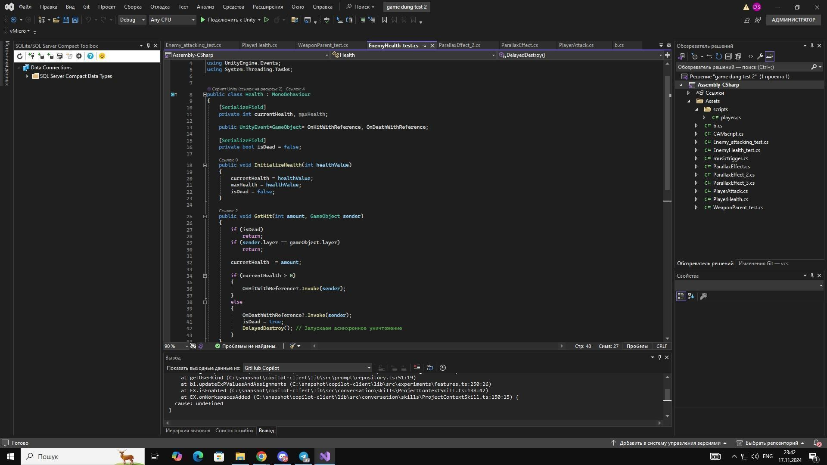

**In this example, the enemy health mechanic that is currently being tested in the game.**

## 

## 

## 

## 

## 

## 

## 

## 

## 

## 

## 

## 

## 

## 

## 

## 

## 

## 

#### 2. Weapon System — Player Attacks and Damage Logic

The Weapon script allows the player to perform two types of attacks:

* **Left Click (LMB)** → Attack 1
* **Right Click (RMB)** → Attack 2

**Logic flow:**

* Attacks are triggered based on player input.
* If the cooldown timer allows, an animation is played, and the attack is executed.
* The weapon uses collision (Raycast or OverlapBox) to detect enemies.
* On hit, it calls enemy.GetComponent<EnemyHealth>().TakeDamage(damage) to reduce the enemy’s HP.

**Integration with EnemyHealth:**

* When an enemy is hit and dies, their state is updated in the JSON.
* The alive flag becomes false, and they are skipped during the next load.

## Weapon mechanics code:

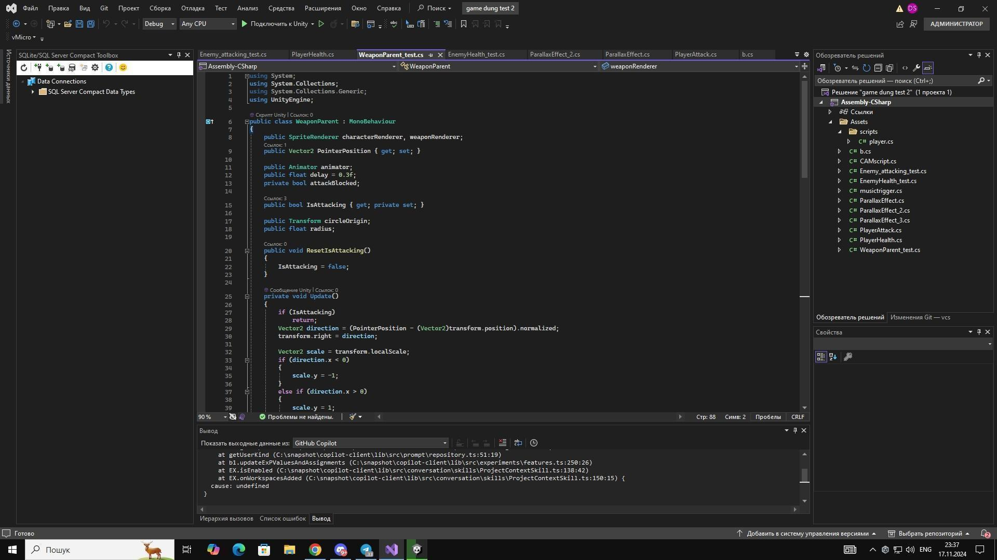

**In this example, weapon mechanics, the player has 1 sword and 2 attacks for movement and stability in the game.**

**UI(User Interface):**

**In game player UI:**

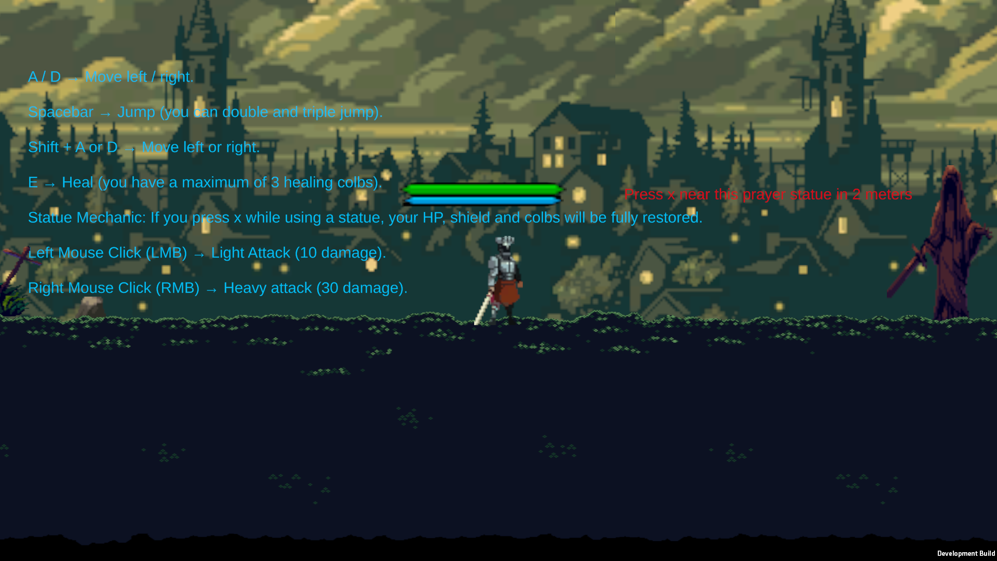

**The Player UI is designed to provide critical information about the player's current status during gameplay. Here's a breakdown of the main elements:**

* 1. **Health Bar:**
     + **Displays the player's current health. As the player takes damage, the bar decreases. This gives the player a clear visual cue about how much health they have left.**
  2. **Shield Bar:**
     + **Indicates the player's shield status. The shield absorbs damage before health is affected (if the game uses such a mechanic). Like the health bar, the shield bar decreases when the shield is used to block or absorb attacks.**

**My final solution:**

In this section, you will find screenshots from my game that demonstrate several key mechanics and show how the levels look from the player’s perspective.

Below the images, I’ve included the full project code, organized into sections. The most important scripts are highlighted with explanations to help you understand their purpose and how they work in the game.

**My screenshots of some parts of my game-gameplay:**

**Attack 1 picture:**

**Description:**

**The player initiates the first sword attack animation. The enemy in front is targeted, and the attack animation is clearly visible with the sword extended forward.**  
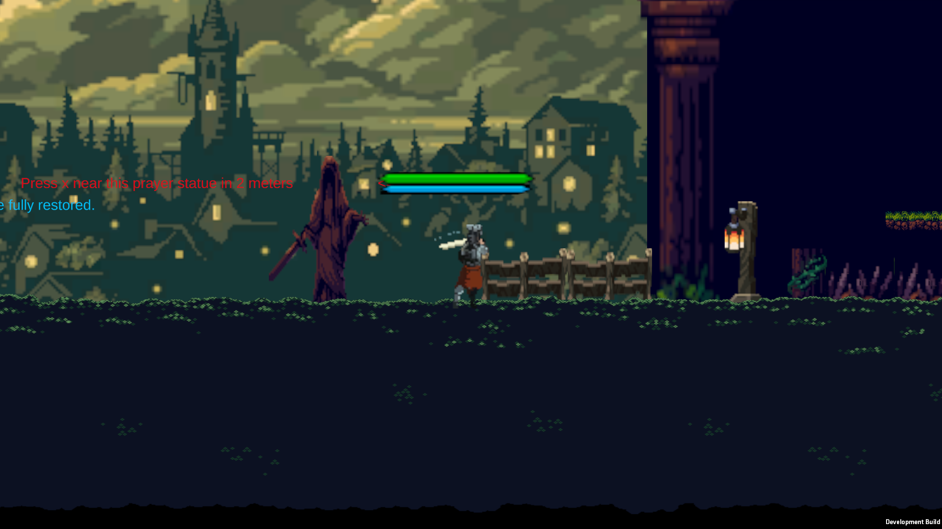

**Attack 2 picture:**

**Description:  
 The player follows up with a second attack in the combo sequence. The animation shows continuation from the first attack, with a fluid combat motion. The sword hits the enemy again.**

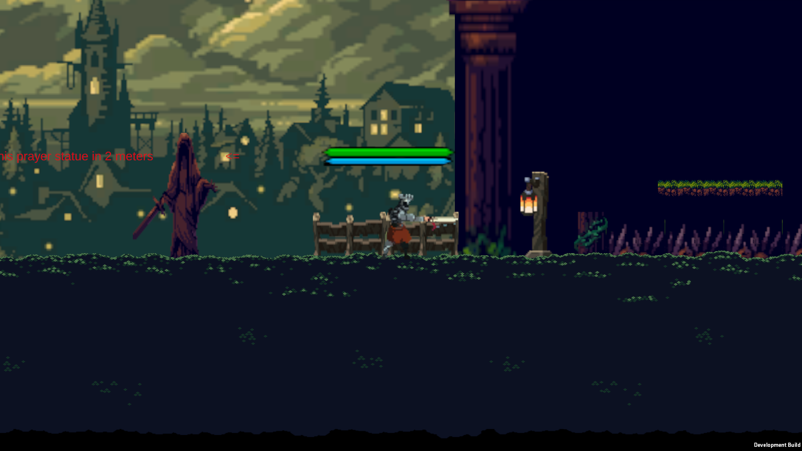

**Jumping with animation picture:**

**Description:**

**The player character is mid-air in a jump with the jump animation active. This scene shows the jump mechanics and smooth transition from grounded to airborne state.**

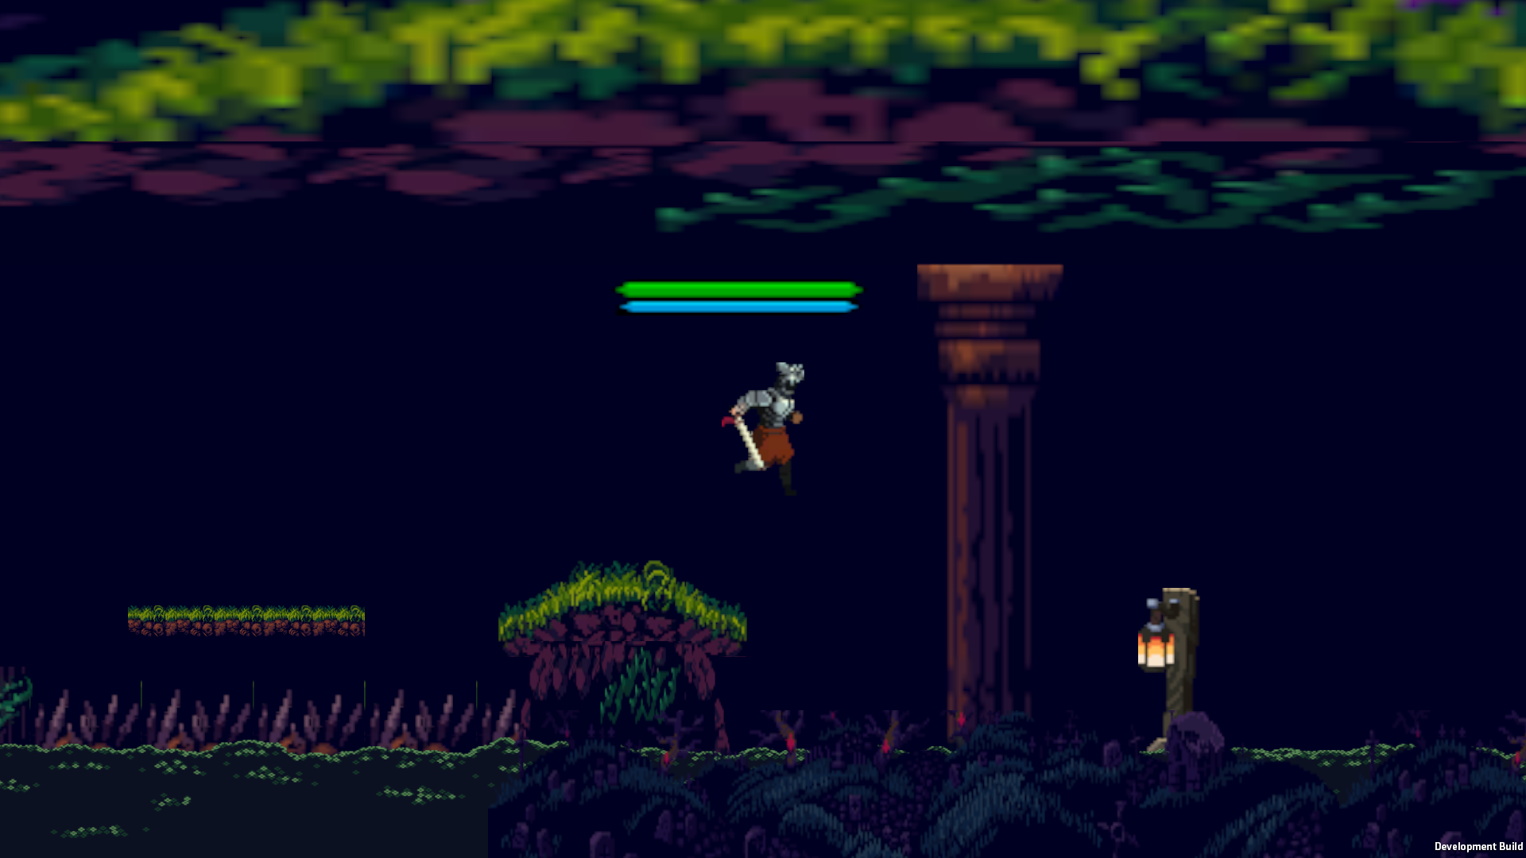

**Fighting with skeleton on 1st level picture:**

**Description:**

**The player is engaging in combat with a skeleton enemy on the first level. The player is performing a melee attack while the enemy prepares to retaliate. Shows how combat mechanics are implemented on basic enemies.**

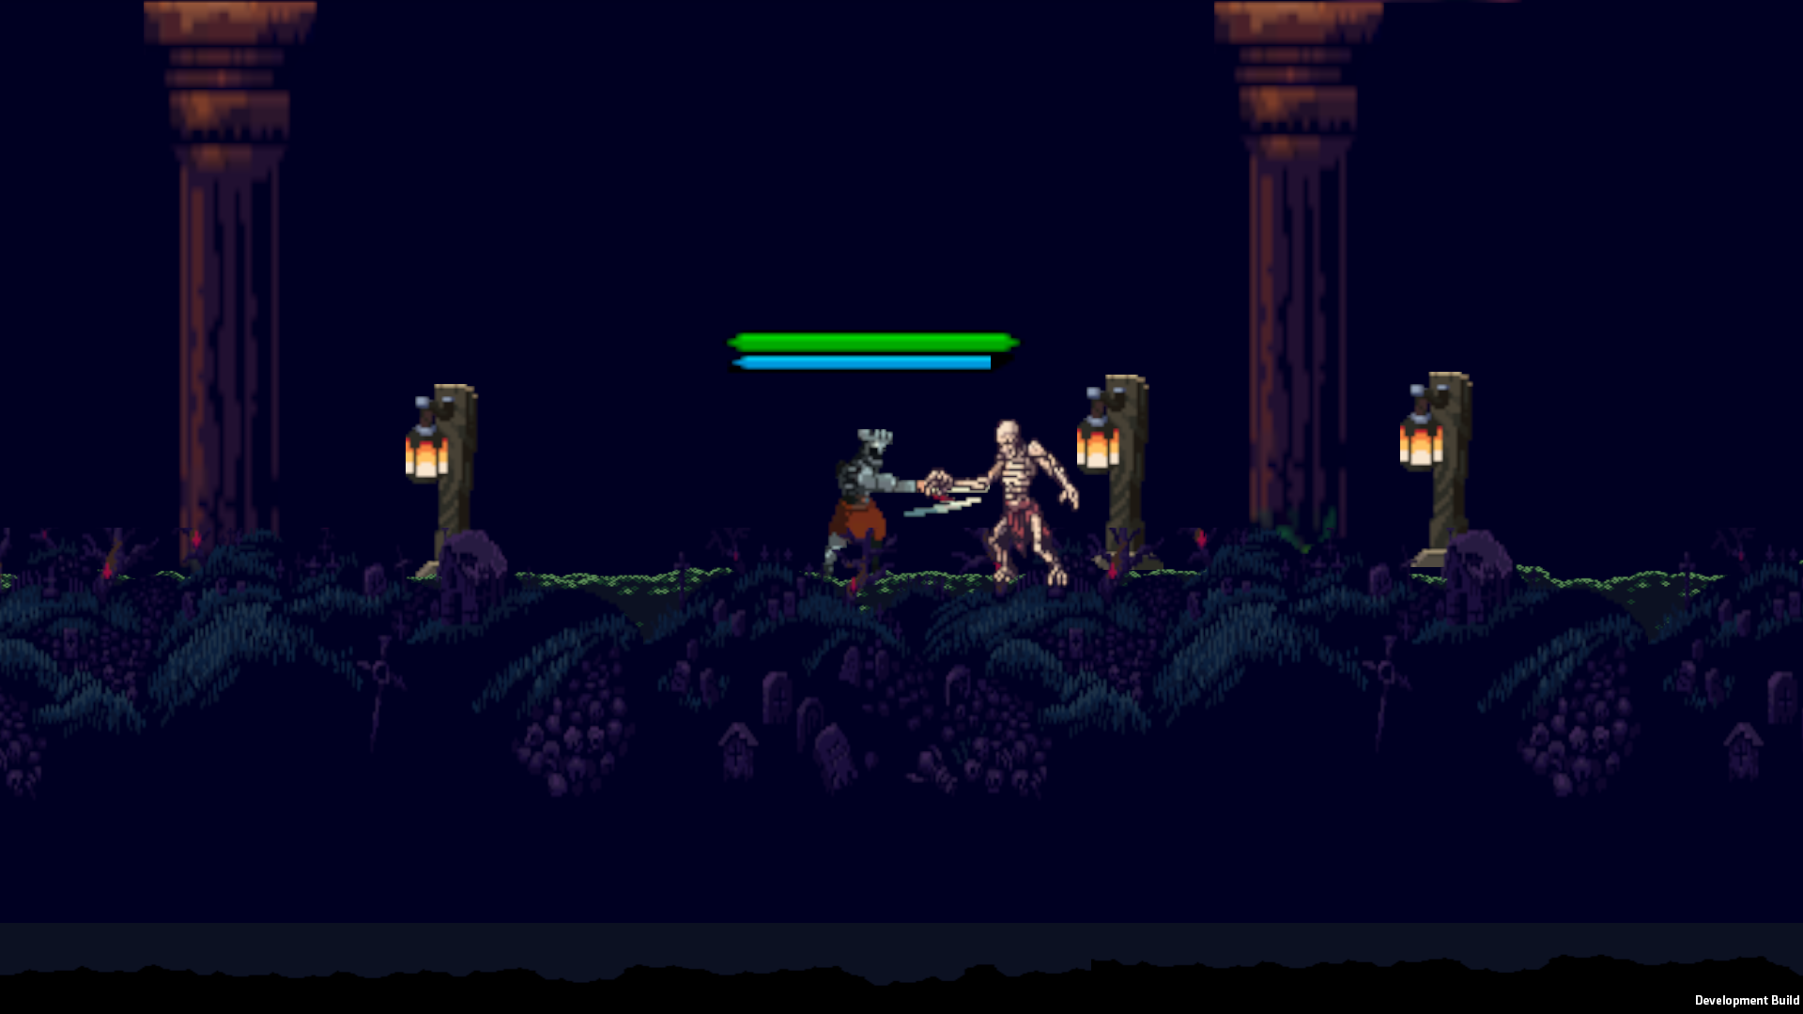

**Player get hit from skeleton:**

**Description:**

**The player receives damage from the skeleton enemy. This frame captures the hit animation response, displaying interaction between the enemy’s attack and the player’s health system.**

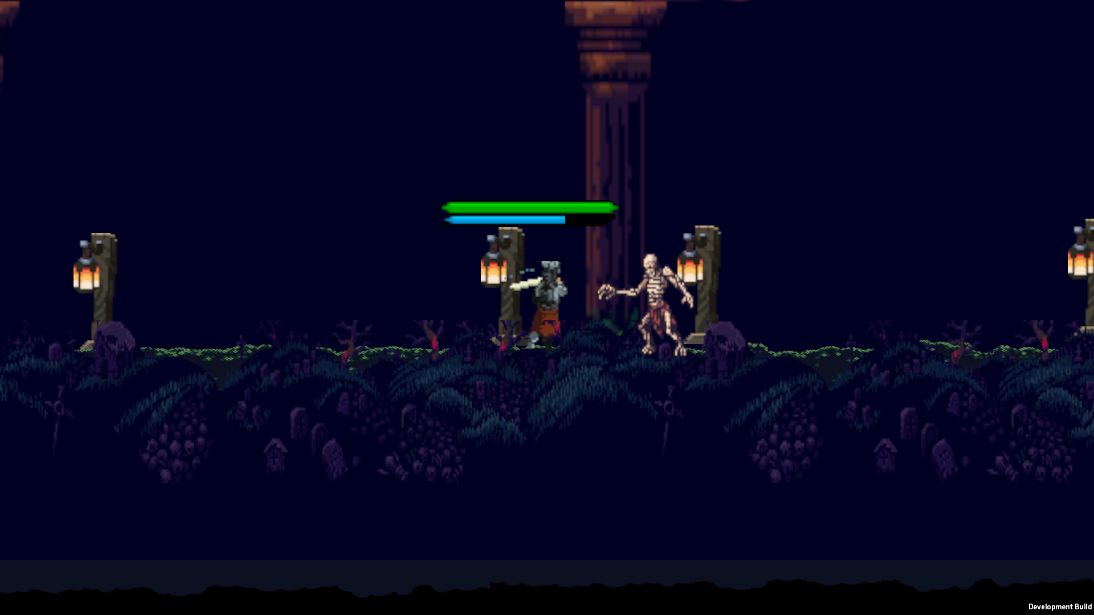

**Player use Healing colbs :**

**Description:**

**The player activates the healing mechanic by using a healing colb. A visual effect is triggered, and the health bar increases as a result. This mechanic helps sustain the player during exploration or combat.**

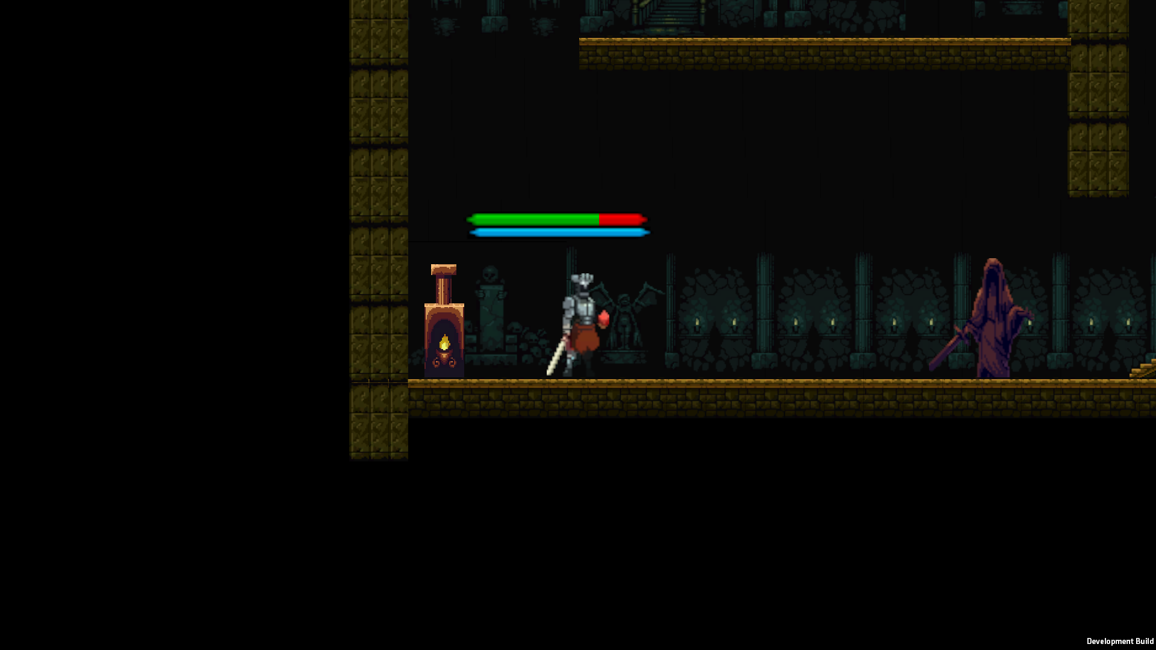

**Player prey for full restore his health , healing colbs and shield:**

**Description:**

**At a designated prayer point (like a shrine or statue), the player prays, which fully restores health, replenishes healing colbs, and reactivates the shield. This works similarly to checkpoints and serves as a recovery mechanic before entering dangerous areas.**

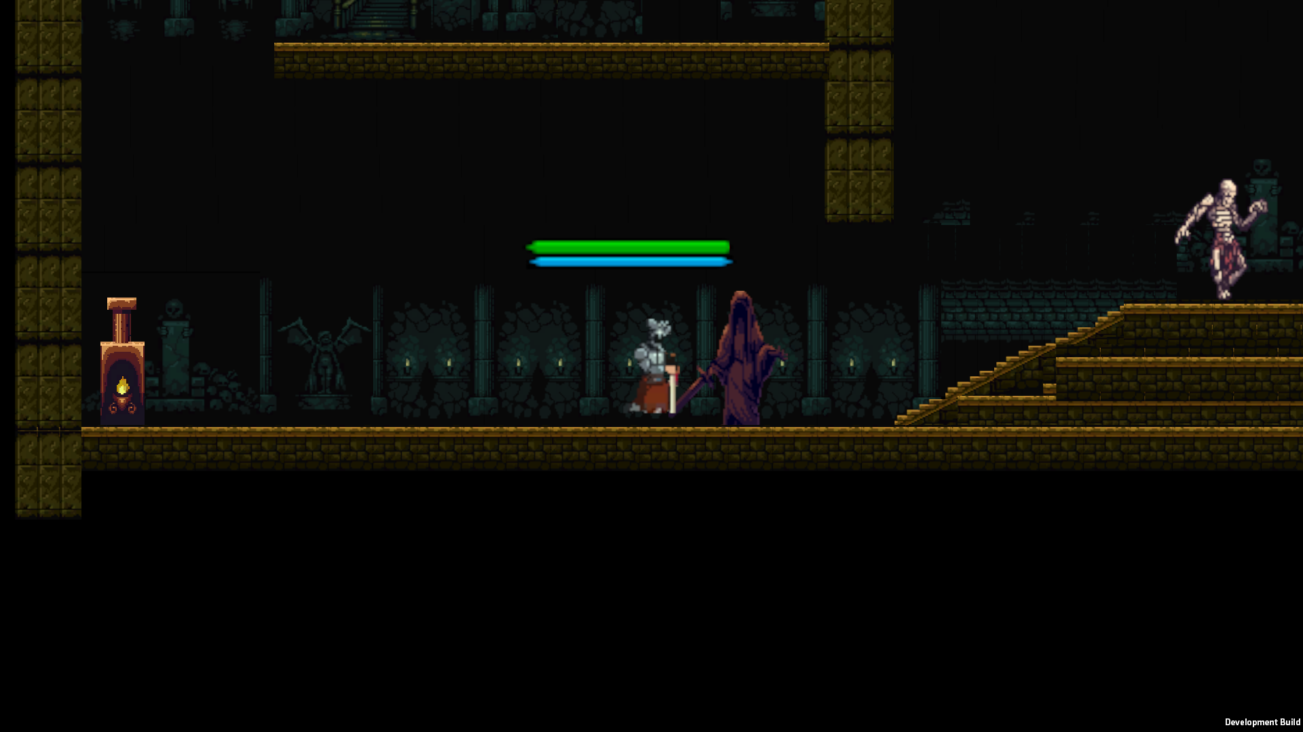

**Player fighting with skeleton on 3rd level and behind him randomly spawned statue:**

**Description:**

**The player engages in battle with a skeleton enemy on the third level. Behind the player, a statue has randomly spawned, which could be an interactive element or decor object which can also randomly spawned ,depending on the level's procedural generation.**

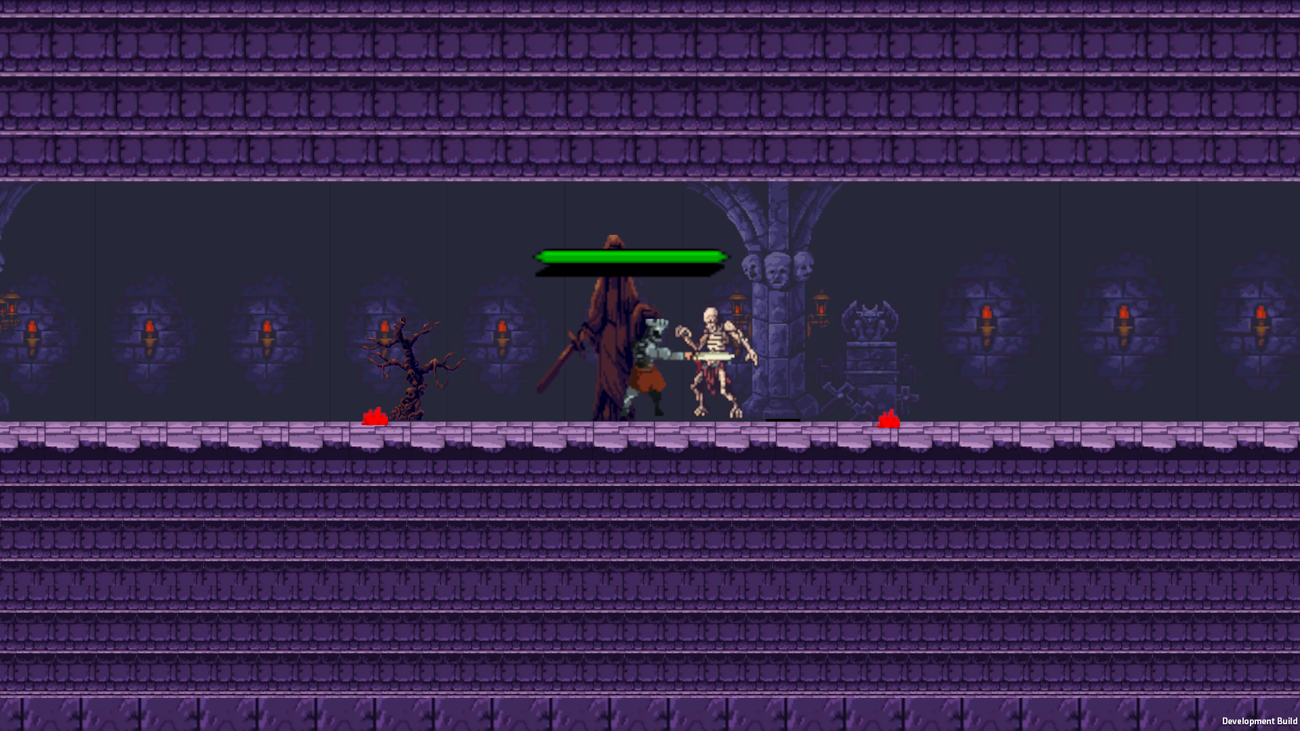

**Player uses top-down platform to get closer to boss:**

**Description:  
 The player steps onto an upward-moving platform that gradually elevates him toward the boss area. This demonstrates level progression and introduces vertical movement mechanics that add variety to navigation and design flow.**

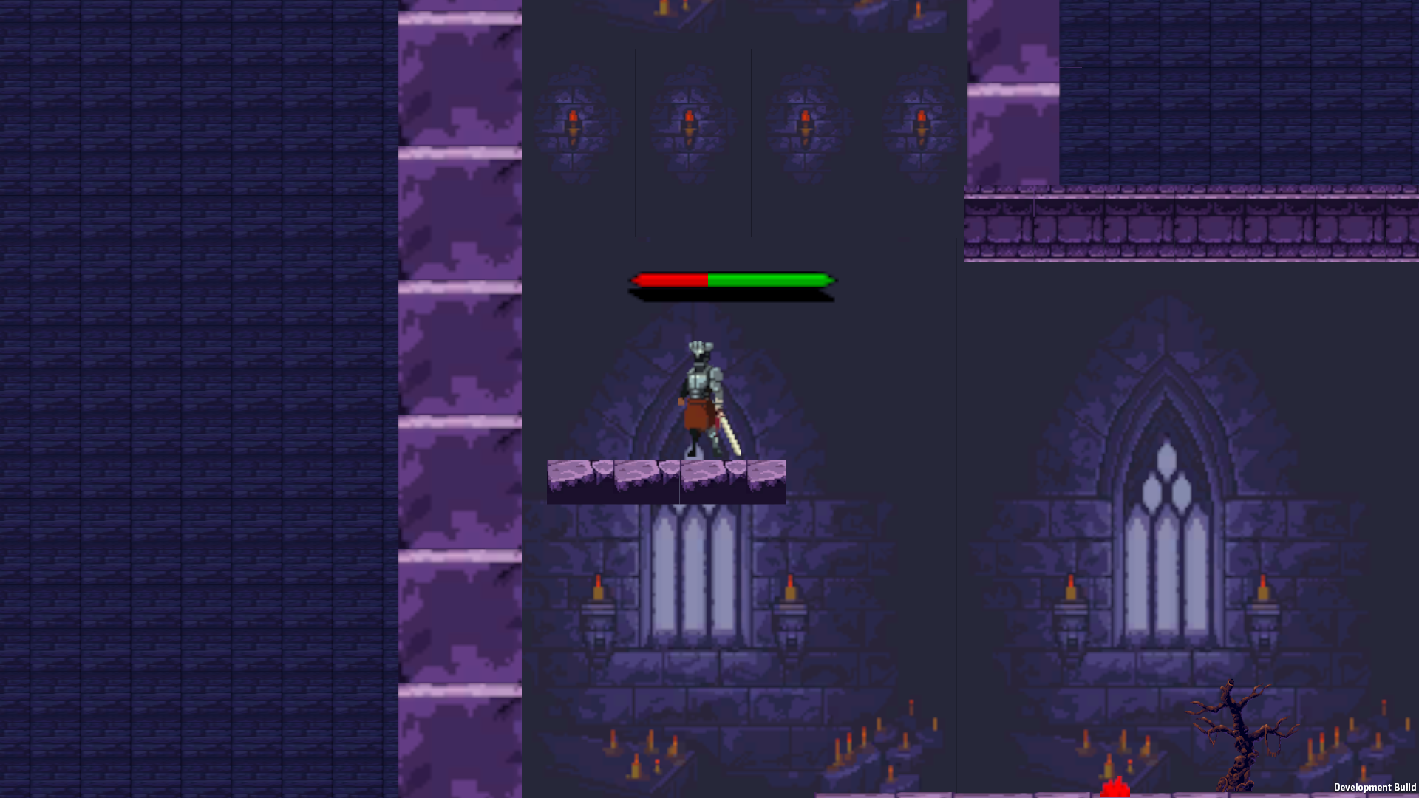

**Player get -hp by falling into spike trap:**

**Description:**

**The player missteps and lands into a spike trap. As a result, damage is inflicted and the health bar decreases. The animation or VFX of getting hurt is triggered.**

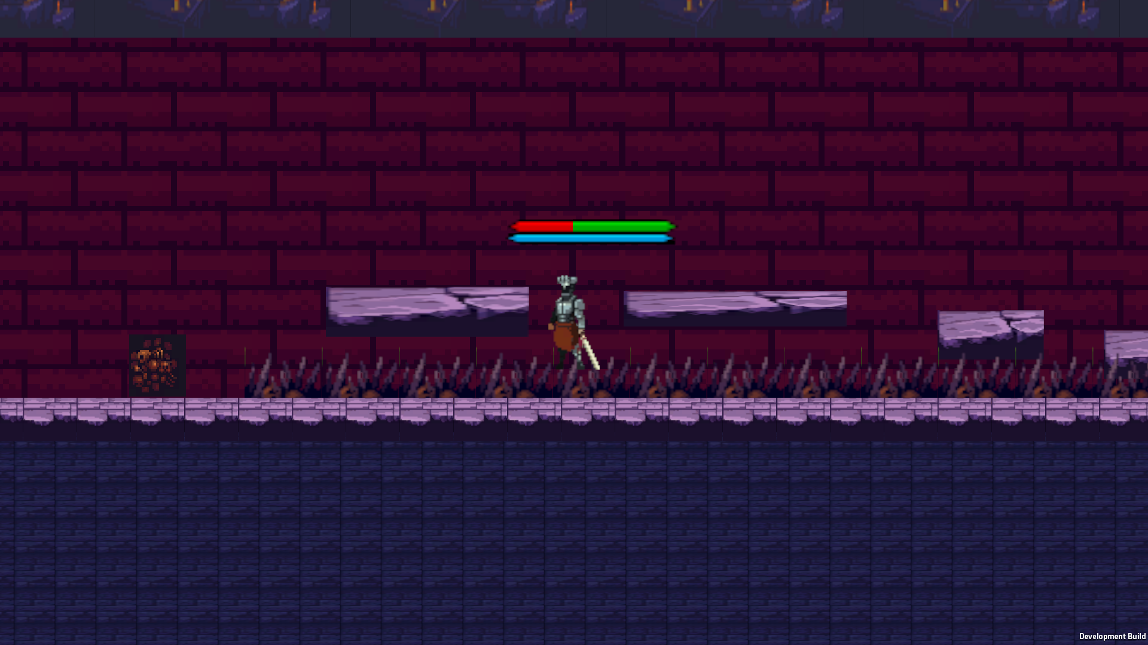

**Player to boss size comparison and both are in idle state:**

**Description:  
 This frame displays a side-by-side idle animation of the player and boss, emphasizing the size difference. It sets the stage for the boss battle and gives the player a sense of scale and upcoming challenge.**

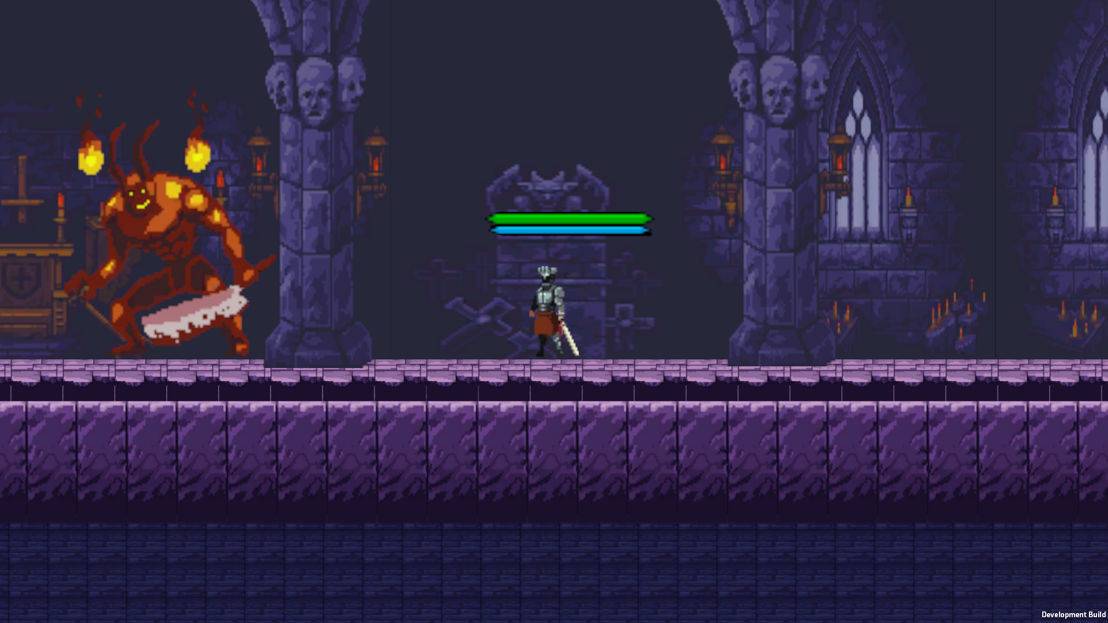

**Boss trying to fight with player:**

**Description:**

**The boss initiates an attack animation, while the player is either preparing to dodge, block, or counterattack. This shot demonstrates combat AI in action.**

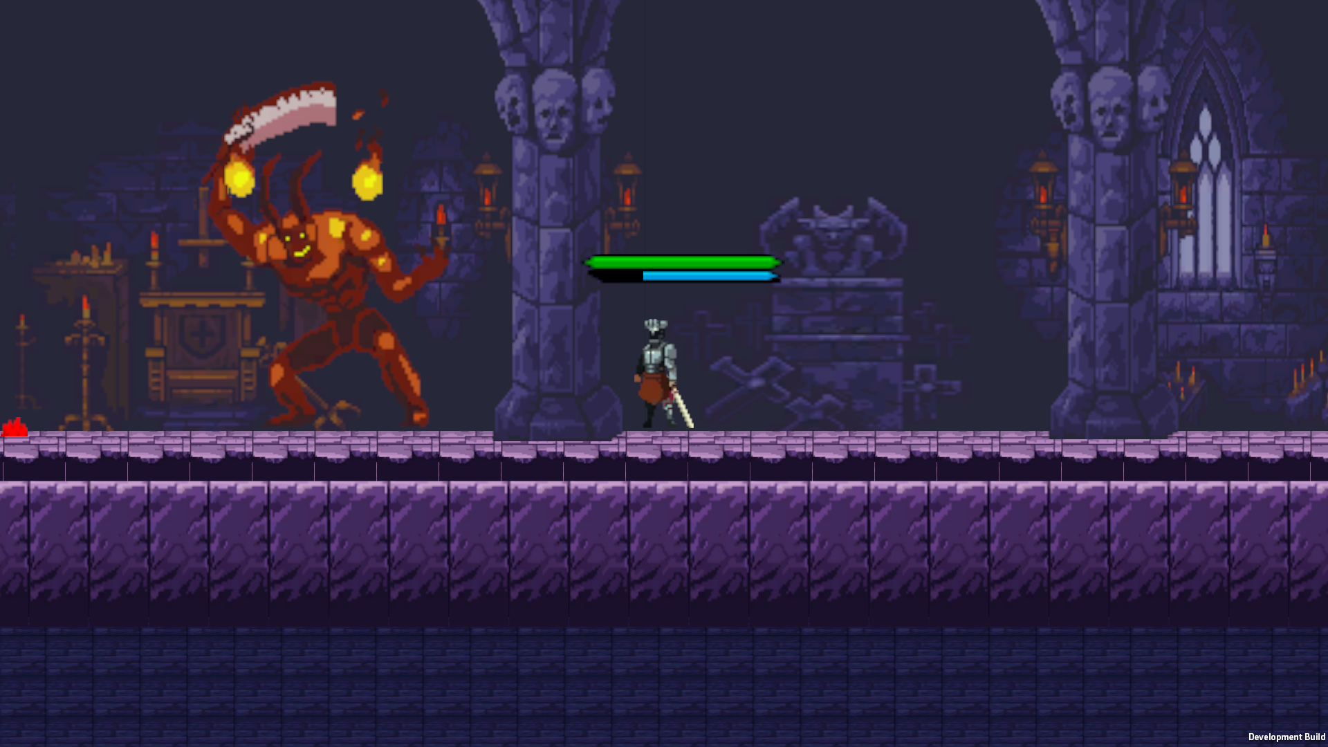

**Boss TakeHit animation and player att2 animation:**

**Description:**

**The player lands a second attack combo (Att2) on the boss, while the boss enters a hit-reaction animation. It shows the boss's ability to take damage and respond visually to it.**

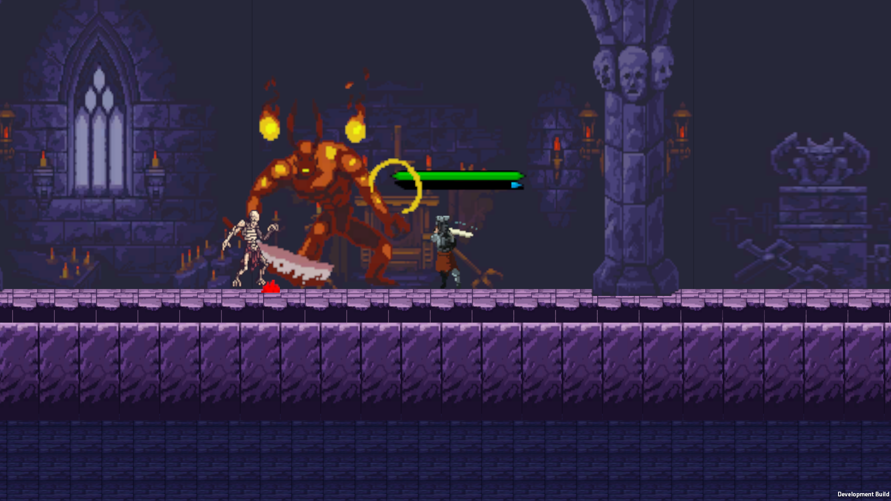

**Boss walking animation:**

**Description:  
 The boss moves across the arena using its walking animation cycle. This might be a patrol or approach behavior prior to launching an attack.**

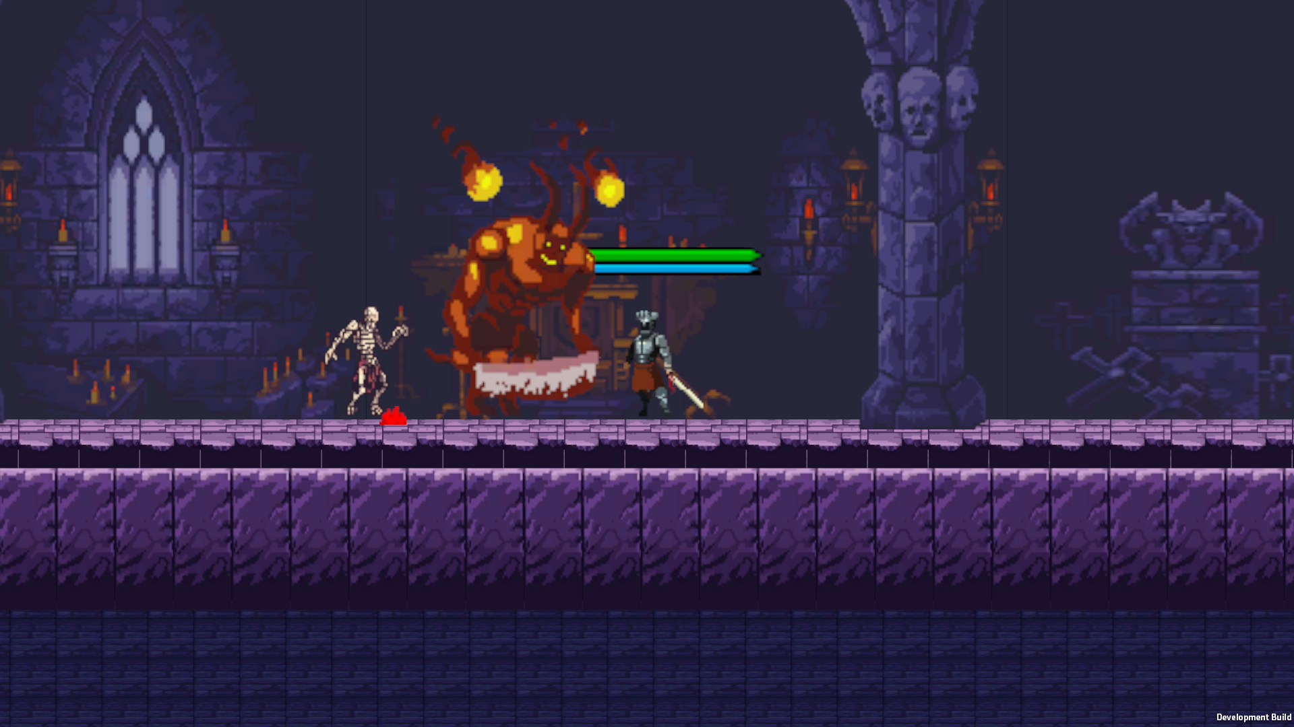

**The boss is preparing to attack the player:**

**Description:  
 The boss enters a wind-up animation, signaling an incoming attack. This gives the player time to react, dodge, or prepare a counter — reflecting a readable boss fight mechanic.**

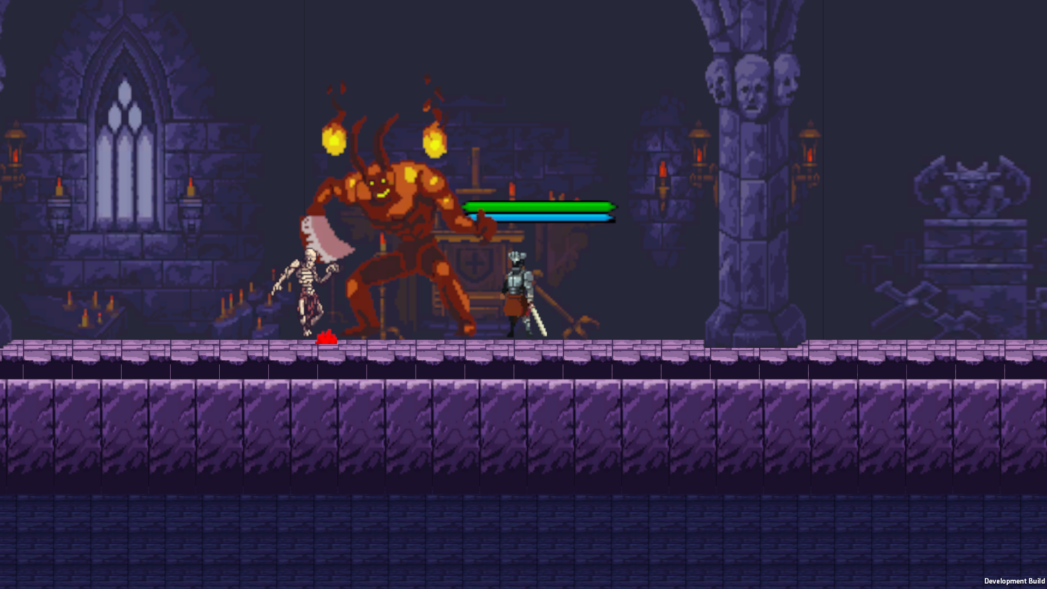

Full game main code and some explanation of how they work:

[GameManager.cs](http://gamemanager.cs):

This script controls the seat and the gap of games, transitions between the earliers and the global consciousness.

He contains the position of the game, health and the flow of the scene in the JSON-FILE, as well as the detachment of the gap that did not appear.

The Singleton system is not exposed and does not dare when scenes, perfection of constant management.

The transition to a traveling lapse of the Automatic Victory over all the enemies.

Auto-drying is an additional 10 seconds, and the scarecrow is a way out on the head menu.

[System.Serializable]

public class SaveData

{

public int hp;

public Vector3 position;

public string scene;

}

public class GameManager : MonoBehaviour

{

public static GameManager Instance;

public PlayerHealth player;

public int enemyCount = 0;

public string currentScene;

private string savePath;

private bool isLoadingFromSave = false;

private bool allowLevelTransition = true;

public bool exitedToMenu = false; // Added: if you enter the menu manually, it does not go to the level

private HashSet<string> killedEnemies = new();

private string KilledEnemiesPath => Path.Combine(Application.persistentDataPath, "killed_enemies.json");

private void Awake()

{

if (Instance == null)

{

Instance = this;

DontDestroyOnLoad(gameObject);

SceneManager.sceneLoaded += OnSceneLoaded;

}

else Destroy(gameObject);

}

private void Start()

{

savePath = Path.Combine(Application.persistentDataPath, "save.json");

currentScene = SceneManager.GetActiveScene().name;

RefreshSceneData();

}

private void OnSceneLoaded(Scene scene, LoadSceneMode mode)

{

currentScene = scene.name;

StartCoroutine(DelayedInit());

}

private IEnumerator DelayedInit()

{

yield return new WaitForSeconds(0.4f);

RefreshSceneData();

isLoadingFromSave = false;

allowLevelTransition = true;

exitedToMenu = false; // Reset the flag when the scene is loaded

}

private void RefreshSceneData()

{

player = FindObjectOfType<PlayerHealth>();

enemyCount = GameObject.FindGameObjectsWithTag("Enemy").Length;

Debug.Log("[GameManager] Enemies found: " + enemyCount);

}

public void EnemySpawned() => enemyCount++;

public void EnemyDefeated()

{

enemyCount--;

if (enemyCount <= 0 && allowLevelTransition && !exitedToMenu) // a new flag is taken into account

{

StartCoroutine(WaitBeforeNextLevel());

}

}

private IEnumerator WaitBeforeNextLevel()

{

Debug.Log("[GameManager] Victory! Transition in 2 seconds.");

allowLevelTransition = false;

yield return new WaitForSeconds(2f);

LevelManager.Instance.LoadNextLevel();

}

public void SaveGame()

{

string scene = SceneManager.GetActiveScene().name;

if (scene == "menu" || scene == "loading_sc" || scene == "catscene_end")

{

Debug.Log($"[GameManager] Scene {scene} - autosave skipped.");

return;

}

SaveData data = new()

{

hp = player ? player.CurrentHealth : 100,

position = player ? player.transform.position : Vector3.zero,

scene = currentScene

};

File.WriteAllText(savePath, JsonUtility.ToJson(data, true));

Debug.Log("[GameManager] Game saved successfully.");

}

public void MarkEnemyAsKilled(string id)

{

if (!killedEnemies.Contains(id))

{

killedEnemies.Add(id);

SaveKilledEnemies();

}

}

public bool IsEnemyAlreadyKilled(string id)

{

return killedEnemies.Contains(id);

}

private void SaveKilledEnemies()

{

File.WriteAllText(KilledEnemiesPath, JsonUtility.ToJson(new KilledEnemiesWrapper { ids = killedEnemies.ToList() }, true));

}

private void LoadKilledEnemies()

{

if (File.Exists(KilledEnemiesPath))

{

var json = File.ReadAllText(KilledEnemiesPath);

var wrapper = JsonUtility.FromJson<KilledEnemiesWrapper>(json);

killedEnemies = new HashSet<string>(wrapper.ids);

}

}

[Serializable]

private class KilledEnemiesWrapper

{

public List<string> ids;

}

public void LoadGame()

{

if (!File.Exists(savePath))

{

Debug.LogWarning("Save not found!");

return;

}

string json = File.ReadAllText(savePath);

SaveData data = JsonUtility.FromJson<SaveData>(json);

isLoadingFromSave = true;

allowLevelTransition = false;

exitedToMenu = false;

SceneManager.LoadScene(data.scene);

StartCoroutine(ApplyLoadedData(data));

}

private IEnumerator ApplyLoadedData(SaveData data)

{

yield return new WaitForSeconds(0.5f);

player = FindObjectOfType<PlayerHealth>();

if (player != null)

{

player.SetHP(data.hp);

player.transform.position = data.position;

}

else Debug.LogWarning("[GameManager] Player not found!");

yield return new WaitForSeconds(0.5f);

RefreshSceneData();

yield return new WaitForSeconds(0.3f);

isLoadingFromSave = false;

allowLevelTransition = true;

exitedToMenu = false;

}

private void OnEnable()

{

InvokeRepeating(nameof(SaveGame), 10f, 10f);

}

}

SaveSystem cs:

#### Purpose:

This system manages **deleting save files** and tracks **individual enemies** that were already killed, so they don’t respawn after loading the game.

#### How it works:

* **SaveSystem.cs**:  
  + Handles deletion of the main save file (save.json) and the list of killed enemies (killed_enemies.json).
  + Used for resetting game progress completely (e.g., when starting a new game).
* **EnemyID.cs**:  
  + Every enemy has a **unique ID**, either set manually or auto-generated.
  + On Start(), the script checks if this enemy’s ID is in the killed enemies list.
  + If it was already killed before saving, the enemy is **immediately destroyed** and won’t appear again.
  + This ensures persistent enemy deaths across play sessions.

[System.Serializable]

public class PlayerData

{

public int level;

public int hp;

public string currentScene;

}

public static class SaveSystem

{

private static string SavePath => Path.Combine(Application.persistentDataPath, "save.json");

private static string KilledEnemiesPath => Path.Combine(Application.persistentDataPath, "killed_enemies.json");

public static void DeleteSave()

{

if (File.Exists(SavePath))

{

File.Delete(SavePath);

Debug.Log("Player save deleted.");

}

if (File.Exists(KilledEnemiesPath))

{

File.Delete(KilledEnemiesPath);

Debug.Log("List of killed enemies removed.");

}

}

}

+( for work with save system + lvl manager + game manager)

[DisallowMultipleComponent]

public class EnemyID : MonoBehaviour

{

[Tooltip("Unique enemy ID. It can be set manually, or it will be generated automatically.")]

public string id;

private void Awake()

{

// ID generation only if it is not set yet

if (string.IsNullOrEmpty(id))

{

id = Guid.NewGuid().ToString();

#if UNITY_EDITOR

UnityEditor.EditorUtility.SetDirty(this); // save the ID in the inspector

#endif

}

}

private void Start()

{

// Check: if the enemy has already been killed - destroy it

if (GameManager.Instance != null && GameManager.Instance.IsEnemyAlreadyKilled(id))

{

Debug.Log($"[EnemyID] The enemy with ID {id} has already been killed. Deleting the object.");

Destroy(gameObject);

}

}

}

Player slide:

Purpose:

This script implements the **slide/dash mechanic** for the player character, enhancing mobility and dynamic combat movement.

How it works:

* When the player presses **LeftShift**, the character slides in the facing direction if they have slides available.
* The slide:  
  + Has a defined **duration** and **distance**.
  + Plays a **sliding animation** during movement.
* After using all available slides (maxSlides), a **cooldown** is triggered before resetting the slide count.
* A **visual debug line** (Gizmo) is drawn in the editor to preview the slide range.

Extra:

* Well-integrated with Rigidbody2D and Animator for responsive movement and animation syncing.
* Prevents slide spamming using a cooldown and limited slide count.

public class SlideMechanic : MonoBehaviour

{

[Header("Slide Settings")]

public float slideDuration = 0.5f;

public float slideDistance = 5f;

public float slideCooldown = 2f;

public int maxSlides = 2;

public KeyCode slideKey = KeyCode.LeftShift;

private int currentSlides;

private bool isSliding;

private bool isCooldown;

private Vector2 slideDirection;

private Rigidbody2D rb;

private Animator animator;

private void Start()

{

rb = GetComponent<Rigidbody2D>();

animator = GetComponent<Animator>();

currentSlides = maxSlides;

}

private void Update()

{

if (Input.GetKeyDown(slideKey) && !isSliding && currentSlides > 0)

{

StartCoroutine(Slide());

}

}

private IEnumerator Slide()

{

isSliding = true;

currentSlides--;

slideDirection = new Vector2(transform.localScale.x, 0).normalized;

// Start the animation of the slide

animator.SetBool("isSliding", true);

float slideSpeed = slideDistance / slideDuration;

float elapsedTime = 0f;

while (elapsedTime < slideDuration)

{

rb.velocity = slideDirection * slideSpeed;

elapsedTime += Time.deltaTime;

yield return null;

}

rb.velocity = Vector2.zero;

isSliding = false;

animator.SetBool("isSliding", false);

if (currentSlides == 0 && !isCooldown)

{

StartCoroutine(SlideCooldown());

}

}

private IEnumerator SlideCooldown()

{

isCooldown = true;

yield return new WaitForSeconds(slideCooldown);

currentSlides = maxSlides;

isCooldown = false;

}

private void OnDrawGizmos()

{

Gizmos.color = Color.cyan;

Gizmos.DrawLine(transform.position, transform.position + new Vector3(transform.localScale.x * slideDistance, 0, 0));

}

}

Player movement:

This script handles horizontal movement and multi-jump mechanics. It uses Unity's physics system to move the character based on player input (Input.GetAxis("Horizontal")) and handles flip logic to change the facing direction when moving left or right. The player can jump up to a defined number of times (maxJumps), with automatic reset upon landing. Jump cooldown and recovery are implemented using coroutines to limit abuse and enhance rhythm in movement. Animator parameters (isRunning, isGrounded, isJumping) are synced for responsive animation control. The system also supports restoring jumps over time and uses ground checks with Physics2D.OverlapCircle.

public class PlayerMovement : MonoBehaviour

{

[Header("Movement Settings")]

public float speed = 5f;

[Header("Jump Settings")]

public int maxJumps = 2;

public float jumpForce = 5f;

public float jumpCooldown = 0.2f;

public float jumpRecoveryTime = 3f;

[Header("Ground Check")]

public Transform groundCheck;

public float groundCheckRadius = 0.1f;

public LayerMask groundLayer;

[Header("Components")]

public Rigidbody2D rb;

public Animator animator;

private int currentJumps;

private bool isFacingRight = true;

private bool isGrounded;

private bool isJumping;

private bool isRecovering = false;

private bool canJump = true;

void Start()

{

currentJumps = maxJumps;

}

void Update()

{

// Check if the player is grounded

isGrounded = Physics2D.OverlapCircle(groundCheck.position, groundCheckRadius, groundLayer);

// Reset jumps if grounded and not jumping

if (isGrounded && !isJumping)

{

currentJumps = maxJumps;

}

// Horizontal movement

float horizontalMove = Input.GetAxis("Horizontal");

rb.velocity = new Vector2(horizontalMove * speed, rb.velocity.y);

// Animation control

bool isMoving = Mathf.Abs(horizontalMove) > 0.1f;

animator.SetBool("isMoving", isMoving);

animator.SetBool("isRunning", isMoving);

animator.SetBool("isGrounded", isGrounded);

// Flip the player

if (horizontalMove > 0 && !isFacingRight)

Flip();

else if (horizontalMove < 0 && isFacingRight)

Flip();

// Jump input

if (Input.GetKeyDown(KeyCode.Space) && currentJumps > 0 && canJump)

{

StartCoroutine(JumpCooldown());

Jump();

currentJumps--;

if (currentJumps == 0 && !isRecovering)

{

StartCoroutine(RestoreJumps());

}

}

}

void Flip()

{

isFacingRight = !isFacingRight;

Vector3 scale = transform.localScale;

scale.x *= -1;

transform.localScale = scale;

}

void Jump()

{

if (!isJumping)

{

rb.velocity = new Vector2(rb.velocity.x, jumpForce);

isJumping = true;

animator.SetBool("isJumping", true);

StartCoroutine(HandleLanding());

}

}

// Reset jump animation after delay if grounded

private IEnumerator HandleLanding()

{

yield return new WaitForSeconds(1f);

if (isGrounded)

{

isJumping = false;

animator.SetBool("isJumping", false);

}

}

private IEnumerator RestoreJumps()

{

isRecovering = true;

yield return new WaitForSeconds(jumpRecoveryTime);

currentJumps = maxJumps;

isRecovering = false;

}

private IEnumerator JumpCooldown()

{

canJump = false;

yield return new WaitForSeconds(jumpCooldown);

canJump = true;

}

private void OnDrawGizmos()

{

if (groundCheck != null)

{

Gizmos.color = Color.red;

Gizmos.DrawWireSphere(groundCheck.position, groundCheckRadius);

}

}

}

Player movement B:

This script handles horizontal movement and multi-jump mechanics. It uses Unity's physics system to move the character based on player input (Input.GetAxis("Horizontal")) and handles flip logic to change the facing direction when moving left or right. The player can jump up to a defined number of times (maxJumps), with automatic reset upon landing. Jump cooldown and recovery are implemented using coroutines to limit abuse and enhance rhythm in movement. Animator parameters (isRunning, isGrounded, isJumping) are synced for responsive animation control. The system also supports restoring jumps over time and uses ground checks with Physics2D.OverlapCircle.

public class b : MonoBehaviour

{

private Animator animator;

private Rigidbody2D rb;

public float moveSpeed = 5f;

public float jumpForce = 5f;

private bool isJumping = false;

void Start()

{

animator = GetComponent<Animator>();

rb = GetComponent<Rigidbody2D>();

}

void Update()

{

// Receipt of direction of movement

float moveInput = Input.GetAxis("Horizontal");

rb.velocity = new Vector2(moveInput * moveSpeed, rb.velocity.y);

// Setting the Speed ??parameter to control walking animations

animator.SetFloat("Speed", Mathf.Abs(moveInput));

// Jump

if (Input.GetKeyDown(KeyCode.Space) && !isJumping)

{

rb.velocity = new Vector2(rb.velocity.x, jumpForce);

isJumping = true;

animator.SetBool("isJumping", true);

}

// Attack

if (Input.GetMouseButtonDown(0))

{

animator.SetBool("isAttacking", true);

}

else

{

animator.SetBool("isAttacking", false);

}

}

private void OnCollisionEnter2D(Collision2D collision)

{

if (collision.gameObject.CompareTag("Ground"))

{

isJumping = false;

animator.SetBool("isJumping", false);

}

}

}

///

Player health script:

This advanced health management system includes hit points (HP), shield points, and healing logic using limited-use healing colbs. The shield regenerates over time if the player avoids damage, and healing can only be triggered under certain conditions. The script uses an interface IHealth for modular integration across different damageable characters. UI updates are reflected via Image.fillAmount components, and all actions (damage, healing, death) are linked with Animator triggers (e.g., Heal, Death, Revive). It includes methods to fully restore health, reset flask counts, apply damage, or trigger death animations and movement lock. Overall, this script is crucial for maintaining player survival, health feedback, and strategic resource management.

public class PlayerHealth : MonoBehaviour, IHealth

{

[SerializeField] private int maxHealth = 100;

[SerializeField] private int maxShield = 50;

private int currentHealth;

private int currentShield;

public float shieldRegenCooldown = 30f;

public float shieldRegenRate = 2f;

private float timeSinceLastDamage;

public bool IsDead { get; private set; } = false;

public int MaxHealth => maxHealth;

public int CurrentHealth => currentHealth;

// Treatment

public int maxHColbs = 3; // The maximum amount of treatment applied

private int remainingHColbs;

public float healPercentage = 25f; // Percentage of health recovery from maximum

public KeyCode healKey = KeyCode.H; // Button to activate treatment

public float healCooldown = 2f; // Delay between treatment activations

private float hudUpdateDelay = 2f; // HUD update delay after treatment

private bool canHeal = true;

public Image healthFill; // For visual display of health

public Image shieldFill; // For visual display of the shield

public Text hColbsText; // To display the number of remaining treated

private Animator animator;

private void Start()

{

currentHealth = maxHealth;

currentShield = maxShield;

remainingHColbs = maxHColbs;

animator = GetComponent<Animator>();

UpdateHUD();

}

private void Update()

{

if (IsDead) return;

// Регенерация щита

timeSinceLastDamage += Time.deltaTime;

if (timeSinceLastDamage >= shieldRegenCooldown && currentShield < maxShield)

{

currentShield = Mathf.Min(currentShield + Mathf.CeilToInt(shieldRegenRate * Time.deltaTime), maxShield);

UpdateHUD();

}

// Лечение

if (Input.GetKeyDown(healKey) && canHeal && remainingHColbs > 0 && IsHealthBelowThreshold(85))

{

StartCoroutine(Heal());

}

}

public void GetHit(int amount, GameObject sender)

{

if (IsDead) return;

timeSinceLastDamage = 0f;

if (currentShield > 0)

{

int remainingDamage = Mathf.Max(amount - currentShield, 0);

currentShield = Mathf.Max(currentShield - amount, 0);

currentHealth = Mathf.Max(currentHealth - remainingDamage, 0);

}

else

{

currentHealth = Mathf.Max(currentHealth - amount, 0);

}

UpdateHUD();

if (currentHealth <= 0 && !IsDead)

{

Die();

}

}

private IEnumerator Heal()

{

canHeal = false;

remainingHColbs--;

int healAmount = Mathf.CeilToInt(maxHealth * (healPercentage / 100));

currentHealth = Mathf.Min(currentHealth + healAmount, maxHealth);

// Start the treatment animation

animator.SetTrigger("Heal");

// Delay before updating the HUD

yield return new WaitForSeconds(hudUpdateDelay);

UpdateHUD();

// We set the cooldown for treatment

yield return new WaitForSeconds(healCooldown);

canHeal = true;

}

private bool IsHealthBelowThreshold(int percentage)

{

return (float)currentHealth / maxHealth * 100 < percentage;

}

private void UpdateHUD()

{

if (healthFill != null)

{

healthFill.fillAmount = (float)currentHealth / maxHealth;

}

if (shieldFill != null)

{

shieldFill.fillAmount = (float)currentShield / maxShield;

}

if (hColbsText != null)

{

hColbsText.text = $"H-Colbs: {remainingHColbs}/{maxHColbs}";

}

}

public void TakeDamage(int damage)

{

if (IsDead) return;

if (currentShield > 0)

{

int remainingDamage = Mathf.Max(damage - currentShield, 0);

currentShield = Mathf.Max(currentShield - damage, 0);

currentHealth = Mathf.Max(currentHealth - remainingDamage, 0);

}

else

{

currentHealth = Mathf.Max(currentHealth - damage, 0);

}

Debug.Log($"Player took {damage} damage. Current health: {currentHealth}");

UpdateHUD();

if (currentHealth <= 0 && !IsDead)

{

Die();

}

}

private void Die()

{

if (IsDead) return;

IsDead = true;

animator.SetTrigger("Death");

// Disable control

if (TryGetComponent(out PlayerMovement movement)) movement.enabled = false;

if (healthFill != null) healthFill.fillAmount = 0;

if (shieldFill != null) shieldFill.fillAmount = 0;

Debug.Log("Player is dead.");

}

public void Revive()

{

if (!IsDead) return;

Debug.Log("Player revived!");

IsDead = false;

currentHealth = maxHealth;

currentShield = maxShield;

remainingHColbs = maxHColbs;

UpdateHUD();

animator.ResetTrigger("Death");

animator.SetTrigger("Revive");

if (TryGetComponent(out PlayerMovement movement)) movement.enabled = true;

}

public void UseHealthPotion(int amount)

{

if (IsDead) return;

currentHealth = Mathf.Min(currentHealth + amount, maxHealth);

UpdateHUD();

}

public void RestoreHealingColbs()

{

remainingHColbs = maxHColbs; // We restore healing colbs

Debug.Log("Healing colbs restored.");

}

public void UseShieldPotion(int amount)

{

if (IsDead) return;

currentShield = Mathf.Min(currentShield + amount, maxShield);

UpdateHUD();

}

public void RestoreHealth()

{

currentHealth = maxHealth; // Complete recovery of health

currentShield = maxShield; // Full shield restoration

RestoreHealingColbs(); // Complete restoration of flasks

UpdateHUD(); // Update HUD

Debug.Log("Health, shield, and healing colbs restored.");

}

// method for full restoration of health, shield and colbs

public void FullRestore()

{

currentHealth = maxHealth;

currentShield = maxShield;

remainingHColbs = maxHColbs;

UpdateHUD();

}

public void SetHP(int newHP)

{

currentHealth = Mathf.Clamp(newHP, 0, maxHealth);

UpdateHUD();

}

public void InvokeHUDUpdate()

{

UpdateHUD();

}

}

///

Player combat script:

This script implements two melee attack types for the player: a standard attack and a sliding strike (attack 2). The first attack (Attack1) is triggered with the left mouse button and damages all enemies within a defined circular radius using Physics2D.OverlapCircleAll. It uses a cooldown to prevent spam attacks. The second attack (Attack2) is a directional dash attack triggered with the right mouse button (Mouse1). During this attack, the player slides in their facing direction for a short duration, then damages enemies in range. Both attacks are animated using Unity Animator triggers and booleans (Attack, Attack2). This script handles all combat logic, damage application, cooldowns, movement during attack, and visual feedback for responsive melee mechanics.

public class PlayerCombat : MonoBehaviour

{

[Header("Attack 1 Settings")]

public int attackDamage = 20;

public float attackRange = 1.5f;

public LayerMask enemyLayer;

public float attackCooldown = 0.5f;

[Header("Attack 2 Settings")]

public float attack2Duration = 0.5f; // Attack duration 2

public float attack2Distance = 2f; // Distance during attack 2

public KeyCode attack2Key = KeyCode.Mouse1; // Attack key 2 (right mouse button)

public int attack2Damage = 30; // Attack damage 2

private Animator animator;

private bool isAttacking = false;

private bool isAttacking2 = false; // Boolean for attack 2

private float lastAttackTime = 0;

private Rigidbody2D rb;

void Start()

{

animator = GetComponent<Animator>();

rb = GetComponent<Rigidbody2D>();

// Check for null to avoid NullReferenceException

if (animator == null || rb == null)

{

Debug.LogError("Not all components are initialized correctly.");

}

}

void Update()

{

if (Input.GetMouseButtonDown(0) && !isAttacking && Time.time >= lastAttackTime + attackCooldown)

{

StartCoroutine(Attack1());

}

if (Input.GetKeyDown(attack2Key) && !isAttacking2)

{

StartCoroutine(Attack2());

}

}

private IEnumerator Attack1()

{

isAttacking = true;

lastAttackTime = Time.time;

animator.SetBool("isAttacking", true);

animator.SetTrigger("Attack");

// We deal damage to enemies in the attack radius

Collider2D[] hitEnemies = Physics2D.OverlapCircleAll(transform.position, attackRange, enemyLayer);

foreach (Collider2D enemy in hitEnemies)

{

IHealth enemyHealth = enemy.GetComponent<IHealth>();

if (enemyHealth != null)

{

enemyHealth.GetHit(attackDamage, gameObject);

}

}

yield return new WaitForSeconds(attackCooldown);

isAttacking = false;

animator.SetBool("isAttacking", false);

}

private IEnumerator Attack2()

{

isAttacking2 = true;

animator.SetBool("isAttacking2", true); // Set the animation for attack 2

animator.SetTrigger("Attack2");

Vector2 attackDirection = new Vector2(transform.localScale.x > 0 ? 1 : -1, 0).normalized;

float attackSpeed = attack2Distance / attack2Duration;

float elapsedTime = 0f;

while (elapsedTime < attack2Duration)

{

rb.velocity = attackDirection * attackSpeed;

elapsedTime += Time.deltaTime;

yield return null;

}

rb.velocity = Vector2.zero; // We stop the movement after the attack

// We deal damage to enemies in the attack radius

Collider2D[] hitEnemies = Physics2D.OverlapCircleAll(transform.position, attackRange, enemyLayer);

foreach (Collider2D enemy in hitEnemies)

{

IHealth enemyHealth = enemy.GetComponent<IHealth>();

if (enemyHealth != null)

{

enemyHealth.GetHit(attack2Damage, gameObject);

}

}

yield return new WaitForSeconds(attackCooldown);

isAttacking2 = false; // Reset attack flag 2

animator.SetBool("isAttacking2", false); // Stop the animation for attack 2

}

void OnDrawGizmosSelected()

{

Gizmos.color = Color.red;

Gizmos.DrawWireSphere(transform.position, attackRange);

}

}

///

Background follow:

This lightweight script makes the background smoothly follow the player's horizontal position, creating a parallax scrolling effect. It stores the initial offset between the player and the background in startOffset during Start(). Then, in every Update(), it calculates the target position relative to the player and uses Vector3.Lerp to interpolate the background's position toward it. This method allows for a smooth and cinematic background motion that enhances depth and immersion in 2D side-scrolling games. Vertical and Z-axis positions are locked to preserve layout consistency.

public class BackgroundFollow : MonoBehaviour

{

public Transform player;

public float followSpeed = 2f;

private Vector3 startOffset;

void Start()

{

startOffset = transform.position - player.position;

}

void Update()

{

Vector3 targetPosition = new Vector3(player.position.x + startOffset.x, transform.position.y, transform.position.z);

transform.position = Vector3.Lerp(transform.position, targetPosition, followSpeed * Time.deltaTime);

}

}

Level manager:

LevelManager handles progression between game levels, the main menu, and the ending scene. It tracks the current level and prevents reloading once the maximum level is reached. Upon completion of a level, the LoadNextLevel() method is called, which increments the level counter and uses a coroutine (LoadSceneAfterDelay) to simulate a short loading delay before loading the next scene. This design provides a seamless and centralized way to handle scene transitions. The class also includes methods to load the menu, settings, and the end cutscene, and uses the singleton pattern (Instance) to ensure only one persistent manager exists between scenes.

public class LevelManager : MonoBehaviour

{

public static LevelManager Instance;

private int currentLevel = 1;

private int maxLevels = 3;

void Awake()

{

if (Instance == null)

{

Instance = this;

DontDestroyOnLoad(gameObject);

}

else Destroy(gameObject);

}

public void LoadNextLevel()

{

if (currentLevel < maxLevels)

{

currentLevel++;

LoadLevel(currentLevel);

}

else

{

LoadEndScene();

}

}

public void LoadLevel(int level)

{

SceneManager.LoadScene("loading_sc");

StartCoroutine(LoadSceneAfterDelay("lvl" + level));

}

private IEnumerator LoadSceneAfterDelay(string sceneName)

{

yield return new WaitForSeconds(2f);

SceneManager.LoadScene(sceneName);

}

public void LoadMainMenu()

{

SceneManager.LoadScene("menu");

}

public void LoadSettings()

{

SceneManager.LoadScene("SettingsScene");

}

public void LoadEndScene()

{

SceneManager.LoadScene("catscene_end");

}

}

Settings:

This script controls navigation from the settings menu back to the main menu. Although volume management is currently commented out, it was designed to include a slider to adjust and save the game’s audio settings using PlayerPrefs. The method BackToMainMenu() switches the active scene to "menu" using SceneManager.LoadScene, giving players a clear and simple way to exit the settings menu. This code keeps the interface modular and easy to expand upon later with audio or input configuration options.

public class SettingsMenu : MonoBehaviour

{

//public Slider volumeSlider;

// public AudioSource audioSource;

//private void Start()

//{

// Load the saved volume (default 1.0)

// float savedVolume = PlayerPrefs.GetFloat("Volume", 1.0f);

// audioSource.volume = savedVolume;

// volumeSlider.value = savedVolume;

// }

// public void SetVolume(float volume)

// {

// audioSource.volume = volume;

// PlayerPrefs.SetFloat("Volume", volume); // Save the volume

// }

public void BackToMainMenu()

{

SceneManager.LoadScene("menu");

}

}

Main menu:

This script manages the functionality of the main menu. It checks if a save file exists and enables or disables the "Load Game" button accordingly. When the player starts a new game via NewGame(), any previous save data is deleted to ensure a fresh start. LoadGame() either resumes the game from the last saved state or defaults to loading Level 1 if no save file exists. Additionally, OpenSettings() transitions to the settings scene, while QuitGame() exits the application. This script ensures a smooth and intuitive user interface for managing game sessions.

public class MainMenu : MonoBehaviour

{

public Button loadGameButton;

private void Start()

{

string path = Path.Combine(Application.persistentDataPath, "save.json");

if (loadGameButton != null)

loadGameButton.interactable = File.Exists(path);

}

public void NewGame()

{

SaveSystem.DeleteSave();

SceneManager.LoadScene("lvl1");

}

public void LoadGame()

{

string path = Path.Combine(Application.persistentDataPath, "save.json");

if (File.Exists(path))

{

GameManager.Instance.LoadGame();

}

else

{

Debug.Log("Save not found. I'm loading the first level...");

SceneManager.LoadScene("lvl1");

}

}

public void OpenSettings()

{

SceneManager.LoadScene("SettingsScene");

}

public void QuitGame()

{

Application.Quit();

}

}

Boss main scripts( health and main ai logic):

BossHealth controls the boss enemy’s health and death system, including animation triggering and visual UI feedback. When the boss is damaged via GetHit(), the health is decreased and the boss may trigger a hit animation. If health reaches zero, a structured death process begins: the game saves the boss as "killed" using a unique enemy ID, plays a death animation, and delays destruction with a coroutine. The script integrates with GameManager to decrement the enemy counter upon death, and also includes hooks via UnityEvents for modular interaction with other systems (UI updates, sound, etc.).

public class BossHealth : MonoBehaviour, IHealth

{

[SerializeField]

private int currentHealth, maxHealth;

public float deathDelay = 3f; // Delay time before removing the boss

public Slider healthBar; // Boss health bar

public UnityEvent<GameObject> OnHitWithReference, OnDeathWithReference;

private Animator animator;

private Boss boss;

private bool isDead = false;

public int MaxHealth => maxHealth;

public int CurrentHealth => currentHealth;

void Awake()

{

animator = GetComponent<Animator>();

boss = GetComponent<Boss>();

InitializeHealth(maxHealth);

// Initialize the health bar, if it is assigned

if (healthBar != null)

{

healthBar.maxValue = maxHealth;

healthBar.value = currentHealth;

}

}

public void InitializeHealth(int healthValue)

{

currentHealth = healthValue;

maxHealth = healthValue;

isDead = false;

// Update the health bar, if it is assigned

if (healthBar != null)

{

healthBar.maxValue = maxHealth;

healthBar.value = currentHealth;

}

}

public void GetHit(int amount, GameObject sender)

{

if (isDead) return;

currentHealth -= amount;

// Update the health bar, if it is assigned

if (healthBar != null)

{

healthBar.value = (float)currentHealth / maxHealth;

}

if (currentHealth > 0)

{

boss.TriggerHit(); // Call the boss's damage animation

OnHitWithReference?.Invoke(sender);

}

else

{

Die(sender);

}

}

private void Die(GameObject sender)

{

var idComponent = GetComponent<EnemyID>();

if (idComponent != null)

{

GameManager.Instance.MarkEnemyAsKilled(idComponent.id);

}

if (isDead) return;

isDead = true;

Debug.Log("Boss is dying.");

OnDeathWithReference?.Invoke(sender);

// Notify GameManager that the boss is destroyed

if (GameManager.Instance != null)

{

GameManager.Instance.EnemyDefeated();

}

if (animator == null)

{

Debug.LogWarning("Animator not found. Destroying object immediately.");

Destroy(gameObject);

return;

}

// Check for repeated animation playback

if (animator.GetCurrentAnimatorStateInfo(0).IsName("Boss_Death"))

{

Debug.LogWarning("Animation already playing. Aborting.");

return;

}

animator.SetTrigger("Boss_Death");

animator.SetBool("Dead", true);

StartCoroutine(WaitForDeathAnimation());

}

private void OnDestroy()

{

if (!isDead && GameManager.Instance != null)

{

GameManager.Instance.EnemyDefeated();

}

}

private IEnumerator WaitForDeathAnimation()

{

yield return new WaitUntil(() =>

animator.GetCurrentAnimatorStateInfo(0).IsName("Boss_Death") &&

animator.GetCurrentAnimatorStateInfo(0).normalizedTime >= 1f);

yield return new WaitForSeconds(deathDelay); // Use the delay time setting

Destroy(gameObject);

}

public bool IsDead()

{

return isDead;

}

}

This class governs the boss enemy’s artificial intelligence through a finite state machine (FSM) with clearly defined states: Idle, Walking, Attacking, TakingHit, and Dead. It uses detection logic (CheckForPlayer()) to determine when to start chasing the player, and transitions into different states using SetState(). The boss performs attacks by checking for collision within range, and reacts to incoming damage using TriggerHit(). The AI design ensures smooth behavior transitions, including player-facing, walk-to-attack movement, and proper cooldowns between actions. Death leads to destruction after animation completion, completing the encounter cycle.

public class Boss : MonoBehaviour

{

public UnityEngine.Transform rayCast;

public LayerMask raycastMask;

public float walkSpeed = 3.5f;

public float detectionRadius = 7f;

public float attackDistance = 1.5f;

public int attackDamage = 20;

[Header("Attack Timing Settings")]

public float attackPrepareTime = 0.3f;

public float attackExecutionTime = 0.5f;

public float attackCooldown = 1.2f;

[Header("Initial Facing Direction")]

public bool isFacingLeft = true;

private Animator animator;

private UnityEngine.Transform target;

private bool isAttacking;

private BossHealth bossHealth;

private bool isTakingHit = false;

private bool isDead = false;

private Coroutine attackCoroutine;

private enum BossState { Idle, Walking, Attacking, TakingHit, Dead }

private BossState currentState = BossState.Idle;

private void Awake()

{

animator = GetComponent<Animator>();

bossHealth = GetComponent<BossHealth>();

FaceDirection(isFacingLeft);

}

private void Update()

{

if (isDead || (bossHealth != null && bossHealth.IsDead()))

{

SetState(BossState.Dead);

return;

}

if (currentState == BossState.TakingHit || currentState == BossState.Dead || isAttacking)

return;

switch (currentState)

{

case BossState.Idle:

if (CheckForPlayer())

StartCoroutine(StartWalkingAfterDelay());

break;

case BossState.Walking:

WalkToPlayer();

break;

}

}

private void SetState(BossState newState)

{

if (currentState == newState) return;

Debug.Log($"State Change: {currentState} -> {newState}");

currentState = newState;

ResetAnimatorBools(); // Clear the animations before changing the state

switch (newState)

{

case BossState.Idle:

animator.SetBool("isIdle", true);

animator.SetBool("Walk", false);

break;

case BossState.Walking:

animator.SetBool("Walk", true);

animator.SetBool("isIdle", false);

break;

case BossState.Attacking:

animator.SetBool("Attack", true);

animator.SetBool("Walk", false);

animator.SetTrigger("Attack");

if (attackCoroutine == null)

attackCoroutine = StartCoroutine(PerformAttack());

break;

case BossState.TakingHit:

animator.SetTrigger("TakeHit");

break;

case BossState.Dead:

animator.SetTrigger("Boss_Death");

StartCoroutine(WaitForDeathAnimation());

break;

}

}

private void ResetAnimatorBools()

{

animator.SetBool("Walk", false);

animator.SetBool("Attack", false);

animator.SetBool("isIdle", false);

}

private IEnumerator StartWalkingAfterDelay()

{

yield return new WaitForSeconds(0.1f);

SetState(BossState.Walking);

}

private void WalkToPlayer()

{

if (target == null || Vector2.Distance(transform.position, target.position) > detectionRadius)

{

SetState(BossState.Idle);

return;

}

FaceTarget(target.position.x);

if (Vector2.Distance(transform.position, target.position) <= attackDistance)

{

StartAttack();

}

else

{

transform.position = Vector2.MoveTowards(transform.position, new Vector2(target.position.x, transform.position.y), walkSpeed * Time.deltaTime);

}

}

private void StartAttack()

{

if (isAttacking || isTakingHit || isDead || currentState == BossState.Attacking)

return;

isAttacking = true;

SetState(BossState.Attacking);

}

private IEnumerator PerformAttack()

{

yield return new WaitForSeconds(attackPrepareTime);

Collider2D hit = Physics2D.OverlapCircle(rayCast.position, attackDistance, raycastMask);

if (hit != null && hit.TryGetComponent(out IHealth playerHealth))

{

yield return new WaitForSeconds(attackExecutionTime);

if (!isDead && !isTakingHit && currentState == BossState.Attacking && Vector2.Distance(transform.position, target.position) <= attackDistance)

{

playerHealth.GetHit(attackDamage, gameObject);

Debug.Log("Attack hit the player!");

}

}

yield return new WaitForSeconds(attackCooldown);

isAttacking = false;

if (!isDead)

SetState(CheckForPlayer() ? BossState.Walking : BossState.Idle);

attackCoroutine = null;

}

public void TriggerHit()

{

if (isTakingHit || isDead)

return;

isTakingHit = true;

SetState(BossState.TakingHit);

StartCoroutine(ResetHitState());

}

private IEnumerator ResetHitState()

{

yield return new WaitForSeconds(0.5f);

isTakingHit = false;

if (!isAttacking && !isDead)

SetState(CheckForPlayer() ? BossState.Walking : BossState.Idle);

}

private IEnumerator WaitForDeathAnimation()

{

yield return new WaitForSeconds(3f);

Destroy(gameObject);

}

private bool CheckForPlayer()

{

Collider2D player = Physics2D.OverlapCircle(transform.position, detectionRadius, raycastMask);

if (player != null)

{

target = player.transform;

FaceTarget(target.position.x);

return true;

}

target = null;

return false;

}

private void FaceTarget(float targetX)

{

if ((targetX > transform.position.x && isFacingLeft) || (targetX < transform.position.x && !isFacingLeft))

{

Flip();

}

}

private void Flip()

{

isFacingLeft = !isFacingLeft;

Vector3 scale = transform.localScale;

scale.x *= -1;

transform.localScale = scale;

}

private void FaceDirection(bool faceLeft)

{

if (faceLeft != isFacingLeft)

{

Flip();

}

}

private void OnDrawGizmosSelected()

{

Gizmos.color = Color.red;

Gizmos.DrawWireSphere(transform.position, detectionRadius);

Gizmos.color = Color.blue;

Gizmos.DrawWireSphere(transform.position, attackDistance);

}

}

Healing statue script:

This script defines a special environmental object — the healing statue — that the player can interact with for buffs or recovery. When the player interacts with the statue, the StartPrayer() function initiates a coroutine that waits for 2 seconds (simulating a prayer or ritual animation), and then executes a callback function to restore player health, flasks, or other effects. The script includes visual debugging tools like a Gizmo-drawn radius for editor testing and design validation. The statue system adds non-combat interactivity to the game, aligning with Metroidvania and Souls-like influences.

public class Statue : MonoBehaviour

{

[SerializeField] private float interactionRadius = 3f; // Radius of the statue

public void StartPrayer(System.Action onPrayerComplete)

{

Debug.Log("Player interacted with the statue.");

StartCoroutine(PrayerRoutine(onPrayerComplete));

}

private System.Collections.IEnumerator PrayerRoutine(System.Action onPrayerComplete)

{

Debug.Log("Statue is performing prayer...");

yield return new WaitForSeconds(2f); // Animation delay

onPrayerComplete?.Invoke();

}

// To debug the radius in the editor

private void OnDrawGizmosSelected()

{

Gizmos.color = Color.yellow;

Gizmos.DrawWireSphere(transform.position, interactionRadius);

}

public float GetInteractionRadius()

{

return interactionRadius;

}

}

Spike trap script:

The SpikeTrap script defines a hazard object that damages the player upon entering its trigger zone. When the player enters the trap’s area, the system begins a coroutine (AttackPlayer) that deals damage at regular intervals (defined by attackInterval). The trap continues to apply damage while the player remains inside its detection range. When the player exits, the coroutine is safely stopped to prevent unnecessary processing. Debug logs provide real-time insight into when the player enters or leaves the trap. The OnDrawGizmos() method visualizes the damage area in the Unity Editor, making level design more intuitive.

public class SpikeTrap : MonoBehaviour

{

public int damage = 25;

public float attackInterval = 1.5f;

public float detectionRange = 2f; // Attack range

public Color gizmoColor = Color.red; // Color for Gizmos

private bool playerInZone = false;

private Coroutine attackCoroutine;

private void Start()

{

if (!GetComponent<Collider2D>().isTrigger)

{

Debug.LogError("The SpikeTrap object must have a collider configured as a Trigger.");

}

}

private void OnTriggerEnter2D(Collider2D other)

{

if (other.TryGetComponent(out PlayerHealth playerHealth))

{

playerInZone = true;

if (attackCoroutine == null)

{

attackCoroutine = StartCoroutine(AttackPlayer(playerHealth));

}

Debug.Log("The player entered the attack zone!");

}

}

private void OnTriggerExit2D(Collider2D other)

{

if (other.TryGetComponent<PlayerHealth>(out _))

{

playerInZone = false;

if (attackCoroutine != null)

{

StopCoroutine(attackCoroutine);

attackCoroutine = null;

}

Debug.Log("The player left the attack zone.");

}

}

private IEnumerator AttackPlayer(PlayerHealth playerHealth)

{

while (playerInZone)

{

if (playerHealth != null)

{

playerHealth.TakeDamage(damage);

Debug.Log($"Player received {damage} damage from spikes!");

}

else

{

Debug.LogWarning("PlayerHealth became null!");

yield break;

}

yield return new WaitForSeconds(attackInterval);

}

attackCoroutine = null;

}

private void OnDrawGizmos()

{

Gizmos.color = gizmoColor;

Gizmos.DrawWireSphere(transform.position, detectionRange);

}

}

Moving platform script:

MovingPlatform creates a simple oscillating platform that moves vertically between two positions — the starting point and a calculated upper target (moveDistance). The movement is handled using Vector3.MoveTowards, and the platform pauses at the top or bottom for a configurable waitTime. The direction is toggled each time the platform reaches its destination. This script adds interactive level design, enabling jumping and timing challenges. Its behavior is fully automatic and runs via an infinite coroutine started on Start().

public class MovingPlatform : MonoBehaviour

{

public float moveSpeed = 2f;

public float moveDistance = 3f;

public float waitTime = 1f;

private Vector3 startPos;

private Vector3 targetPos;

private bool movingUp = true;

private bool isWaiting = false;

void Start()

{

startPos = transform.position;

targetPos = startPos + Vector3.up * moveDistance;

StartCoroutine(MovePlatform());

}

IEnumerator MovePlatform()

{

while (true)

{

if (!isWaiting)

{

transform.position = Vector3.MoveTowards(transform.position, targetPos, moveSpeed * Time.deltaTime);

if (Vector3.Distance(transform.position, targetPos) < 0.01f)

{

isWaiting = true;

yield return new WaitForSeconds(waitTime);

movingUp = !movingUp;

targetPos = movingUp ? startPos + Vector3.up * moveDistance : startPos;

isWaiting = false;

}

}

yield return null;

}

}

}

Escape to menu script:

This script handles the player's escape-to-menu functionality via the Escape key. When triggered, it starts a coroutine that first calls GameManager.Instance.SaveGame() and flags exitedToMenu = true, ensuring no automatic level transitions occur during pause state. After a 3-second delay to guarantee the save operation completes, the game transitions to the main menu through LevelManager.Instance.LoadMainMenu(). This design provides a clean, user-friendly way to exit gameplay without risk of progress loss. It is intentionally simplified for stability and integrates seamlessly with the global game state logic.

/*public class PauseMenu : MonoBehaviour

{

public GameObject pauseUI;

private bool isPaused = false;

void Start()

{

pauseUI.SetActive(false);

Cursor.visible = true;

Cursor.lockState = CursorLockMode.None;

}

void Update()

{

if (Input.GetKeyDown(KeyCode.Escape))

{

TogglePause();

}

}

public void TogglePause()

{

isPaused = !isPaused;

pauseUI.SetActive(isPaused);

Time.timeScale = isPaused ? 0f : 1f;

Cursor.visible = true;

Cursor.lockState = CursorLockMode.None;

}

public void ResumeGame()

{

TogglePause();

}

public void ExitToMenu()

{

Time.timeScale = 1f;

GameManager.Instance.SaveGame();

LevelManager.Instance.LoadMainMenu();

}

}*/

public class PauseMenu : MonoBehaviour

{

void Update()

{

if (Input.GetKeyDown(KeyCode.Escape))

{

StartCoroutine(ExitToMenuWithDelay());

}

}

private IEnumerator ExitToMenuWithDelay()

{

if (GameManager.Instance != null)

{

GameManager.Instance.exitedToMenu = true;

GameManager.Instance.SaveGame();

Debug.Log("[PauseMenu] Save the game before exiting the menu...");

}

yield return new WaitForSeconds(3f); // Wait for Save to work for sure

Time.timeScale = 1f;

LevelManager.Instance.LoadMainMenu();

}

}

Level loader script which working with level manager and game manager:

The LevelLoader script manages asynchronous level loading with a loading screen. It uses the Singleton pattern (Instance) to ensure global access and persistence across scenes. When LoadLevel is called with a scene name, it switches to a designated “LoadingScreen” scene, waits for 2 seconds, then loads the target level asynchronously using SceneManager.LoadSceneAsync(). This creates a smooth transition experience and prepares memory between heavy scenes.

public class LevelLoader : MonoBehaviour

{

public static LevelLoader Instance;

private void Awake()

{

if (Instance == null)

{

Instance = this;

DontDestroyOnLoad(gameObject);

}

else

{

Destroy(gameObject);

}

}

public void LoadLevel(string sceneName)

{

StartCoroutine(LoadAsynchronously(sceneName));

}

private IEnumerator LoadAsynchronously(string sceneName)

{

SceneManager.LoadScene("LoadingScreen");

yield return new WaitForSeconds(2);

AsyncOperation operation = SceneManager.LoadSceneAsync(sceneName);

while (!operation.isDone)

{

yield return null;

}

}

}

Title screen script:

TitleScreenManager is responsible for transitioning from a title screen to the main menu. It waits for any key press (Input.anyKeyDown) and then loads the scene specified by mainMenuScene. This script is usually placed on a splash or intro screen and gives players control to proceed manually after startup. The LoadMainMenu() function is separated for clarity and logging.

public class TitleScreenManager : MonoBehaviour

{

public string mainMenuScene = "menu";

void Update()

{

if (Input.anyKeyDown)

{

Debug.Log("Any key pressed! Trying to load scene: " + mainMenuScene);

LoadMainMenu();

}

}

public void LoadMainMenu()

{

Debug.Log("Attempt to load scene: " + mainMenuScene);

SceneManager.LoadScene(mainMenuScene);

}

}

Main skeleton 2 scripts ( ai logic and health):

EnemyHealth manages the health, damage intake, and death of standard enemies like skeletons. It tracks currentHealth and interacts with Unity UI sliders to update the enemy’s health bar. When health drops to zero, the script triggers the death animation and notifies GameManager that the enemy was killed, optionally saving this using the enemy’s unique ID. Death is handled with animation wait logic and is followed by a delayed Destroy(gameObject) to cleanly remove the enemy.

public class EnemyHealth : MonoBehaviour, IHealth

{

[SerializeField]

private int currentHealth, maxHealth;

public float deathDelay = 3f; // Delay time before removing the enemy

public Slider healthBar; // Enemy's health bar

public UnityEvent<GameObject> OnHitWithReference, OnDeathWithReference;

private Animator animator;

private bool isDead = false;

public int MaxHealth => maxHealth;

public int CurrentHealth => currentHealth;

void Awake()

{

animator = GetComponent<Animator>();

InitializeHealth(maxHealth);

// Initialize the health bar, if it is assigned

if (healthBar != null)

{

healthBar.maxValue = maxHealth;

healthBar.value = currentHealth;

}

}

public void InitializeHealth(int healthValue)

{

currentHealth = healthValue;

maxHealth = healthValue;

isDead = false;

// Update the health bar, if it is assigned

if (healthBar != null)

{

healthBar.maxValue = maxHealth;

healthBar.value = currentHealth;

}

}

public void GetHit(int amount, GameObject sender)

{

if (isDead) return;

currentHealth -= amount;

// Update the health bar, if it is assigned

if (healthBar != null)

{

healthBar.value = (float)currentHealth / maxHealth;

}

if (currentHealth > 0)

{

OnHitWithReference?.Invoke(sender);

}

else

{

Die(sender);

}

}

private void Die(GameObject sender)

{

var idComponent = GetComponent<EnemyID>();

if (idComponent != null)

{

GameManager.Instance.MarkEnemyAsKilled(idComponent.id);

}

if (isDead) return;

isDead = true;

Debug.Log("Enemy is dying.");

OnDeathWithReference?.Invoke(sender);

// Notify GameManager that the enemy is destroyed

if (GameManager.Instance != null)

{

GameManager.Instance.EnemyDefeated();

}

if (animator == null)

{

Debug.LogWarning("Animator not found. Destroying object immediately.");

Destroy(gameObject);

return;

}

// Check for repeated animation playback

if (animator.GetCurrentAnimatorStateInfo(0).IsName("skeleton_death"))

{

Debug.LogWarning("Animation already playing. Aborting.");

return;

}

animator.SetTrigger("skeleton_death");

animator.SetBool("isDead", true);

StartCoroutine(WaitForDeathAnimation());

}

private void OnDestroy()

{

if (!isDead && GameManager.Instance != null)

{

GameManager.Instance.EnemyDefeated();

}

}

private IEnumerator WaitForDeathAnimation()

{

yield return new WaitUntil(() =>

animator.GetCurrentAnimatorStateInfo(0).IsName("skeleton_death") &&

animator.GetCurrentAnimatorStateInfo(0).normalizedTime >= 1f);

yield return new WaitForSeconds(deathDelay); // Use the delay time setting

Destroy(gameObject);

}

public bool IsDead()

{

return isDead;

}

}

Skeleton1 implements AI behavior for patrolling enemies using a state-like structure (Patrolling, Chasing, Attacking, Dead). It patrols between two points (pointA and pointB), flips direction when needed, and transitions to chasing or attacking based on proximity to the player. The AI checks for player presence via OverlapCircle and performs attacks using animation triggers and coroutines. Once health reaches zero (as reported by EnemyHealth), it plays the death animation and cleans up. This modular design allows for fluid transitions and scalable enemy behavior.

public class Skeleton1 : MonoBehaviour

{

#region Public Variables

public Transform pointA;

public Transform pointB;

public Transform rayCast;

public LayerMask raycastMask;

public float patrolSpeed = 2f;

public float chaseSpeed = 3.5f;

public float detectionRadius = 5f;

public float attackDistance = 1.5f;

public float changeTargetDistance = 0.9f;

public int attackDamage = 10;

[Header("Attack Timing Settings")]

public float attackPrepareTime = 0.3f;

public float attackExecutionTime = 0.5f;

public float attackCooldown = 1f;

[Header("Initial Facing Direction")]

public bool isFacingLeft = true;

#endregion

#region Private Variables

private Animator anim;

private Transform target;

private Transform currentTarget;

private bool isAttacking;

private EnemyHealth enemyHealth;

private bool isDead;

private enum State

{

Patrolling,

Chasing,

Attacking,

Dead

}

private State currentState = State.Patrolling;

#endregion

private void Awake()

{

anim = GetComponent<Animator>();

currentTarget = pointA;

enemyHealth = GetComponent<EnemyHealth>();

FaceDirection(isFacingLeft);

}

private void Update()

{

if (enemyHealth.IsDead())

{

if (currentState != State.Dead)

{

HandleDeath();

}

return;

}

switch (currentState)

{

case State.Patrolling:

Patrol();

break;

case State.Chasing:

ChasePlayer();

break;

case State.Attacking:

HandleAttack();

break;

}

}

private void Patrol()

{

anim.SetBool("Walk", true);

anim.SetBool("Attack", false);

transform.position = Vector2.MoveTowards(transform.position, currentTarget.position, patrolSpeed * Time.deltaTime);

if (Vector2.Distance(transform.position, currentTarget.position) <= changeTargetDistance)

{

currentTarget = (currentTarget == pointA) ? pointB : pointA;

// Replace the Flip() method with FaceDirection() to correctly change the direction of the enemy

FaceDirection(currentTarget == pointA);

}

if (CheckForPlayer())

{

currentState = State.Chasing;

}

}

private void ChasePlayer()

{

anim.SetBool("Walk", true);

anim.SetBool("Attack", false);

if (target == null || Vector2.Distance(transform.position, target.position) > detectionRadius)

{

target = null;

currentState = State.Patrolling;

return;

}

FaceTarget(target.position.x);// Correct the direction of the enemy before the attack

if (Vector2.Distance(transform.position, target.position) <= attackDistance)

{

currentState = State.Attacking;

}

else

{

transform.position = Vector2.MoveTowards(transform.position, new Vector2(target.position.x, transform.position.y), chaseSpeed * Time.deltaTime);

}

}

private void HandleAttack()

{

if (isAttacking) return;

isAttacking = true;

anim.SetBool("Walk", false);

anim.SetTrigger("Attack");

StartCoroutine(PerformAttack());

}

private IEnumerator PerformAttack()

{

yield return new WaitForSeconds(attackPrepareTime);

Collider2D hit = Physics2D.OverlapCircle(rayCast.position, attackDistance, raycastMask);

if (hit != null && hit.TryGetComponent(out IHealth playerHealth))

{

yield return new WaitForSeconds(attackExecutionTime);

playerHealth.GetHit(attackDamage, gameObject);

}

yield return new WaitForSeconds(attackCooldown);

isAttacking = false;

if (target != null && Vector2.Distance(transform.position, target.position) <= detectionRadius)

{

currentState = State.Chasing;

}

else

{

currentState = State.Patrolling;

}

}

private void HandleDeath()

{

if (isDead) return;

isDead = true;

anim.SetTrigger("skeleton_death"); // We use the skeleton_death trigger

anim.SetBool("Dead", true);

StartCoroutine(WaitForDeathAnimation());

}

private IEnumerator WaitForDeathAnimation()

{

yield return new WaitUntil(() =>

anim.GetCurrentAnimatorStateInfo(0).IsName("skeleton_death") &&

anim.GetCurrentAnimatorStateInfo(0).normalizedTime >= 1f);

yield return new WaitForSeconds(3f); // Delay before deletion

Destroy(gameObject);

}

private bool CheckForPlayer()

{

Collider2D player = Physics2D.OverlapCircle(transform.position, detectionRadius, raycastMask);

if (player != null)

{

target = player.transform;

FaceTarget(target.position.x); // Add a FaceTarget call here so that the enemy always looks at the player

return true;

}

target = null;

return false;

}

private void FaceTarget(float targetX)

{

if ((targetX > transform.position.x && isFacingLeft) ||

(targetX < transform.position.x && !isFacingLeft))

{

Flip();

}

}

private void Flip()

{

isFacingLeft = !isFacingLeft;

Vector3 scale = transform.localScale;

scale.x *= -1;

transform.localScale = scale;

}

private void FaceDirection(bool faceLeft)

{

if (faceLeft != isFacingLeft)

{

isFacingLeft = faceLeft;

Vector3 scale = transform.localScale;

scale.x *= -1;

transform.localScale = scale;

}

}

private void OnDrawGizmosSelected()

{

Gizmos.color = Color.red;

Gizmos.DrawWireSphere(transform.position, detectionRadius);

Gizmos.color = Color.blue;

Gizmos.DrawWireSphere(transform.position, attackDistance);

}

}

Parallax effect script:

This script implements a **parallax effect** for 2D background layers. It tracks the camera’s horizontal movement to shift the background at a slower rate than the foreground, creating the illusion of depth. The parallaxEffect value controls how much slower the background moves relative to the camera. The script also handles infinite looping by repositioning the background when it exits the screen, based on its length.

public class ParallaxEffect : MonoBehaviour

{

private float startPos, length;

public new GameObject camera;

public float parallaxEffect;

void Start()

{

startPos = transform.position.x;

length = GetComponent<SpriteRenderer>().bounds.size.x;

}

void Update()

{

float temp = camera.transform.position.x * (1 - parallaxEffect);

float dist = camera.transform.position.x * parallaxEffect;

transform.position = new Vector3(startPos + dist, transform.position.y, transform.position.z);

if (temp > startPos + length)

startPos += length;

else if (temp < startPos - length)

startPos -= length;

}

}

Music trigger script(this script can make radius of different sounds(not included at full game)):

MusicTrigger plays and stops a background music track when the player enters or exits a trigger zone. It relies on OnTriggerEnter and OnTriggerExit, using CompareTag("Player") to ensure only the player activates the audio. This can be used to give each level area or zone a unique soundtrack or ambient audio, although it was not included in the final full release of your game.

public class MusicTrigger : MonoBehaviour

{

public AudioSource musicSource; // Drag the audio file here from the inspector

private void OnTriggerEnter(Collider other)

{

// We check that this player has entered the zone

if (other.CompareTag("Player"))

{

musicSource.Play(); }

}

private void OnTriggerExit(Collider other)

{

// Stop the music when the player leaves the zone

if (other.CompareTag("Player"))

{

musicSource.Stop();

}

}

}

Camera follow script:

CAMscript keeps the camera position aligned with the player character. It does so by referencing the player's transform and updating the camera’s position to match the player's x and y coordinates every frame in LateUpdate(), ensuring that camera movement appears smooth and follows player motion after all other updates complete.

public class CAMscript : MonoBehaviour

{

// Start is called before the first frame update

private Transform player;

void Start()

{

player = GameObject.FindGameObjectWithTag("Player").transform;

}

// Update is called once per frame

void LateUpdate()

{

Vector3 temp = transform.position;

temp.x = player.position.x;

temp.y = player.position.y;

transform.position = temp;

}

}

IHealth interface which used in Player,Boss and skeleton health systems:

IHealth is a simple but powerful interface that standardizes how health components respond to damage. It defines one method, GetHit(int amount, GameObject sender), which is implemented by both PlayerHealth, EnemyHealth, and BossHealth. This allows for decoupled damage systems — e.g., the player’s attacks can apply damage to *any* object implementing IHealth, without knowing its internal structure.

public interface IHealth

{

void GetHit(int amount, GameObject sender);

}

Plate hud manager which is update player hud for example when player take some damage from enemies(example of this manager):

HUDManager is a placeholder example for managing on-screen UI updates. While the current version only includes a Debug.Log, it demonstrates where and how centralized UI updates should be triggered. In a complete system, this script would be extended to update health bars, shield indicators, and healing colbs UI elements in real-time when damage or healing occurs.

public class HUDManager : MonoBehaviour

{

public void UpdateHUD()

{

Debug.Log("HUD updated.");

}

}

Player pray mechanic code, which is used by statue to give a player prey and restore his health:

This script allows the player to **interact with healing statues** in the level to fully restore their health, shield, and healing colbs. When the player presses the designated prayer key (X), the script checks for nearby Statue objects using a 3D overlap sphere. If the statue is within range, the player triggers a prayer animation and calls the statue’s StartPrayer() method. Once the prayer completes, the player is restored using the FullRestore() method from PlayerHealth. Cooldown logic ensures that the prayer cannot be used repeatedly without delay.

public class PlayerPrayer : MonoBehaviour

{

[SerializeField] private KeyCode prayerKey = KeyCode.X; // Prayer key

[SerializeField] private float prayerCooldown = 5f; // Prayer cooldown

private bool canPray = true;

private PlayerHealth playerHealth; // A reference to the componentздоровья игрока

private Animator animator; // Link to the animation

private void Start()

{

playerHealth = GetComponent<PlayerHealth>();

animator = GetComponent<Animator>();

}

private void Update()

{

if (Input.GetKeyDown(prayerKey) && canPray)

{

TryPray();

}

}

private void TryPray()

{

Collider[] hitColliders = Physics.OverlapSphere(transform.position, 3f); // Check radius

foreach (var hit in hitColliders)

{

Statue statue = hit.GetComponent<Statue>();

if (statue != null)

{

float distance = Vector3.Distance(transform.position, statue.transform.position);

if (distance <= statue.GetInteractionRadius())

{

canPray = false;

animator.SetTrigger("Pray"); // Pray animation

statue.StartPrayer(OnPrayerComplete); // We start praying at the statue

return;

}

}

}

Debug.Log("No statue found in range.");

}

private void OnPrayerComplete()

{

playerHealth.FullRestore();// We completely restore the player

Debug.Log("Prayer completed: Player fully restored.");

Invoke(nameof(ResetPrayerCooldown), prayerCooldown); // Set the cooldown

}

private void ResetPrayerCooldown()

{

canPray = true;

}

public void SetPrayerKey(KeyCode newKey)

{

prayerKey = newKey;

Debug.Log($"Prayer key changed to: {newKey}");

}

}

Player respawn script which used for respawn player at chosen by me position on scene ,when player is dying:

This script defines a **simple respawn mechanic**. When the player dies (determined via PlayerHealth.IsDead), the script moves the player to a predefined respawnPoint and calls the Revive() method from PlayerHealth to fully restore them. It ensures smooth retry handling without requiring a full scene reload or reset.

public class PlayerRespawn : MonoBehaviour

{

public Transform respawnPoint; // The point where the player returns after death

private PlayerHealth playerHealth;

void Awake()

{

playerHealth = GetComponent<PlayerHealth>();

}

void Update()

{

if (playerHealth.IsDead)

{

Respawn();

}

}

private void Respawn()

{

// Move the player to the spawn point

transform.position = respawnPoint.position;

// We restore the player's state

playerHealth.Revive();

}

}

Player collider manager script, this script player is using for identification his collider on map for example at jumping or sliding :

This helper script ensures the BoxCollider2D on the player is correctly initialized. It doesn't implement complex logic but serves as a foundation for more advanced systems such as detecting head collisions, crouch zones, or adjusting hitboxes during movement like sliding or jumping.

public class PlayerColliderManager : MonoBehaviour

{

private BoxCollider2D boxCollider;

void Start()

{

boxCollider = GetComponent<BoxCollider2D>();

if (boxCollider == null)

{

Debug.LogError("BoxCollider2D is not initialized. Make sure the BoxCollider2D component is added to the object.");

}

}

}

I also have a 2nd type of enemy, a skeleton with a shield. This is not in the main game, but I have a working script: a skeleton with a shield:

This is a **more advanced variant of enemy AI**, extending the base patrol/attack logic with a **shield defense state**. The skeleton can patrol, chase the player, attack, and occasionally activate a shield based on a probability (shieldActivationChance). While the shield is active, the enemy becomes **temporarily invincible**, controlled via the ShieldedSkeletonHealth.isInvincible flag. The logic is managed via a State enum and a basic FSM (Finite State Machine) approach.

public class SkeletonWithShield : MonoBehaviour

{

#region Public Variables

public Transform pointA;

public Transform pointB;

public Transform rayCast;

public LayerMask raycastMask;

public float patrolSpeed = 2f;

public float chaseSpeed = 3.5f;

public float detectionRadius = 5f;

public float attackDistance = 1.5f;

public float changeTargetDistance = 0.9f;

public int attackDamage = 10;

public float shieldActivationChance = 0.3f;

[Header("Attack Timing Settings")]

public float attackPrepareTime = 0.3f;

public float attackExecutionTime = 0.5f;

public float attackCooldown = 1f;

[Header("Initial Facing Direction")]

public bool isFacingLeft = true;

#endregion

#region Private Variables

private Animator anim;

private Transform target;

private Transform currentTarget;

private bool isAttacking;

private bool isUsingShield; // Shield activation flag

private ShieldedSkeletonHealth enemyHealth;

private bool isDead;

private enum State

{

Patrolling,

Chasing,

Attacking,

UsingShield,

Dead

}

private State currentState = State.Patrolling;

#endregion

private void Awake()

{

anim = GetComponent<Animator>();

currentTarget = pointA;

enemyHealth = GetComponent<ShieldedSkeletonHealth>();

FaceDirection(isFacingLeft);

}

private void Update()

{

if (enemyHealth.IsDead())

{

if (currentState != State.Dead)

{

HandleDeath();

}

return;

}

switch (currentState)

{

case State.Patrolling:

Patrol();

break;

case State.Chasing:

ChasePlayer();

break;

case State.Attacking:

HandleAttack();

break;

case State.UsingShield:

UseShield();

break;

}

}

private void Patrol()

{

anim.SetBool("Walk", true);

anim.SetBool("Attack", false);

transform.position = Vector2.MoveTowards(transform.position, currentTarget.position, patrolSpeed * Time.deltaTime);

if (Vector2.Distance(transform.position, currentTarget.position) <= changeTargetDistance)

{

currentTarget = (currentTarget == pointA) ? pointB : pointA;

FaceDirection(currentTarget == pointA);

}

if (CheckForPlayer())

{

currentState = State.Chasing;

}

}

private void ChasePlayer()

{

anim.SetBool("Walk", true);

anim.SetBool("Attack", false);

if (target == null || Vector2.Distance(transform.position, target.position) > detectionRadius)

{

target = null;

currentState = State.Patrolling;

return;

}

FaceTarget(target.position.x);

if (Vector2.Distance(transform.position, target.position) <= attackDistance)

{

currentState = State.Attacking;

}

else

{

transform.position = Vector2.MoveTowards(transform.position, new Vector2(target.position.x, transform.position.y), chaseSpeed * Time.deltaTime);

}

}

private void HandleAttack()

{

if (isAttacking) return;

// Check for shield activation

if (Random.value < shieldActivationChance)

{

currentState = State.UsingShield;

return;

}

isAttacking = true;

anim.SetBool("Walk", false);

anim.SetTrigger("Attack");

StartCoroutine(PerformAttack());

}

private IEnumerator PerformAttack()

{

yield return new WaitForSeconds(attackPrepareTime);

Collider2D hit = Physics2D.OverlapCircle(rayCast.position, attackDistance, raycastMask);

if (hit != null && hit.TryGetComponent(out IHealth playerHealth))

{

yield return new WaitForSeconds(attackExecutionTime);

playerHealth.GetHit(attackDamage, gameObject);

}

yield return new WaitForSeconds(attackCooldown);

isAttacking = false;

if (target != null && Vector2.Distance(transform.position, target.position) <= detectionRadius)

{

currentState = State.Chasing;

}

else

{

currentState = State.Patrolling;

}

}

private void HandleDeath()

{

if (isDead) return;

isDead = true;

anim.SetTrigger("skeleton_death");

anim.SetBool("Dead", true);

StartCoroutine(WaitForDeathAnimation());

}

private IEnumerator WaitForDeathAnimation()

{

yield return new WaitUntil(() =>

anim.GetCurrentAnimatorStateInfo(0).IsName("skeleton_death") &&

anim.GetCurrentAnimatorStateInfo(0).normalizedTime >= 1f);

yield return new WaitForSeconds(3f); // Delay before deletion

Destroy(gameObject);

}

private bool CheckForPlayer()

{

Collider2D player = Physics2D.OverlapCircle(transform.position, detectionRadius, raycastMask);

if (player != null)

{

target = player.transform;

FaceTarget(target.position.x);

return true;

}

target = null;

return false;

}

private void UseShield()

{

if (isUsingShield) return;

isUsingShield = true;

anim.SetTrigger("UseShield"); // Animation of shield use

Debug.Log("Shield activated!");

// Temporarily make the skeleton invulnerable

enemyHealth.isInvincible = true;

StartCoroutine(DeactivateShield());

}

private IEnumerator DeactivateShield()

{

yield return new WaitForSeconds(1f); // Shield duration

enemyHealth.isInvincible = false;

isUsingShield = false;

Debug.Log("Shield deactivated!");

currentState = (target != null && Vector2.Distance(transform.position, target.position) <= detectionRadius) ? State.Chasing : State.Patrolling;

}

private void FaceTarget(float targetX)

{

if ((targetX > transform.position.x && isFacingLeft) ||

(targetX < transform.position.x && !isFacingLeft))

{

Flip();

}

}

private void Flip()

{

isFacingLeft = !isFacingLeft;

Vector3 scale = transform.localScale;

scale.x *= -1;

transform.localScale = scale;

}

private void FaceDirection(bool faceLeft)

{

if (faceLeft != isFacingLeft)

{

isFacingLeft = faceLeft;

Vector3 scale = transform.localScale;

scale.x *= -1;

transform.localScale = scale;

}

}

private void OnDrawGizmosSelected()

{

Gizmos.color = Color.red;

Gizmos.DrawWireSphere(transform.position, detectionRadius);

Gizmos.color = Color.blue;

Gizmos.DrawWireSphere(transform.position, attackDistance);

}

}

This script manages the health logic for shielded skeletons. It implements the IHealth interface and includes full damage and death handling. If the skeleton is in an invincible shielded state, incoming damage is ignored. Otherwise, damage is applied, hit animations are triggered, and death logic is invoked when HP reaches zero. The class also integrates with the GameManager and optionally updates a health bar UI.

public class ShieldedSkeletonHealth : MonoBehaviour, IHealth

{

[SerializeField]

private int currentHealth = 100;

[SerializeField]

private int maxHealth = 100;

public float deathDelay = 3f;

public Slider healthBar;

public UnityEvent<GameObject> OnHitWithReference, OnDeathWithReference;

private Animator animator;

private bool isDead = false;

public bool isInvincible = false;

public int MaxHealth => maxHealth;

public int CurrentHealth => currentHealth;

private void Awake()

{

animator = GetComponent<Animator>();

InitializeHealth(maxHealth);

// Initialize the health bar, if it is assigned

if (healthBar != null)

{

healthBar.maxValue = maxHealth;

healthBar.value = currentHealth;

}

}

public void InitializeHealth(int healthValue)

{

currentHealth = healthValue;

maxHealth = healthValue;

isDead = false;

// Update the health bar, if it is assigned

if (healthBar != null)

{

healthBar.maxValue = maxHealth;

healthBar.value = currentHealth;

}

}

public void GetHit(int amount, GameObject sender)

{

if (isDead || isInvincible) return;

currentHealth -= amount;

Debug.Log("Shielded skeleton took damage: " + amount);

animator.SetTrigger("TakeHit");

// Update the health bar, if it is assigned

if (healthBar != null)

{

healthBar.value = currentHealth;

}

if (currentHealth > 0)

{

OnHitWithReference?.Invoke(sender); // Call the hit event

}

else

{

Die(sender);

}

}

private void Die(GameObject sender)

{

if (isDead) return;

isDead = true;

Debug.Log("Shielded skeleton is dying.");

OnDeathWithReference?.Invoke(sender); // Call the death event

if (animator == null)

{

Debug.LogWarning("Animator not found. Destroying object immediately.");

Destroy(gameObject);

return;

}

// Check for repeated animation playback

if (animator.GetCurrentAnimatorStateInfo(0).IsName("skeleton_death"))

{

Debug.LogWarning("Animation already playing. Aborting.");

return;

}

animator.SetTrigger("skeleton_death"); // Используем триггер skeleton_death

animator.SetBool("isDead", true);

StartCoroutine(WaitForDeathAnimation());

}

private IEnumerator WaitForDeathAnimation()

{

yield return new WaitUntil(() =>

animator.GetCurrentAnimatorStateInfo(0).IsName("skeleton_death") &&

animator.GetCurrentAnimatorStateInfo(0).normalizedTime >= 1f);

yield return new WaitForSeconds(deathDelay);

Destroy(gameObject);

}

public bool IsDead()

{

return isDead;

}

}

// Procedural Generation script:

Procedural Spawning System (Levels 2–3)

The procedural spawning system increases replayability by randomly placing enemies, decorations, and healing items in pre-marked points.

**Main logic:**

* Marked spawn points on scene (via empty GameObjects)
* Prefab array for enemy types
* Random.value to define spawn probability (e.g., 60%)
* Optional assignment of EnemyID for save system tracking
* Seamless integration with Unity’s Instantiate system

**Code sample:** ProceduralSpawner.cs — controls spawning logic  
 EnemyID.cs — ensures enemies persist or disappear based on save state  
 ItemSpawner.cs — manages rare item/decoration activation

**Benefits:**

* Scalable system (just add spawn points)
* Replayable levels
* Easy to tweak balance (just adjust spawnChance)
* Expandable into ScriptableObject + Seed-based logic

using UnityEngine;

using System.Collections.Generic;

public class ProceduralSpawner : MonoBehaviour

{

[Header("Spawn settings")]

[SerializeField] private List<Transform> spawnPoints;

[SerializeField] private GameObject[] enemyPrefabs;

[Range(0f, 1f)]

[SerializeField] private float spawnChance = 0.6f;

private void Start()

{

SpawnEnemiesProcedurally();

}

private void SpawnEnemiesProcedurally()

{

foreach (Transform point in spawnPoints)

{

if (Random.value < spawnChance)

{

GameObject prefab = enemyPrefabs[Random.Range(0, enemyPrefabs.Length)];

GameObject instance = Instantiate(prefab, point.position, Quaternion.identity);

// Optionally assign an ID if needed

var idComponent = instance.GetComponent<EnemyID>();

if (idComponent != null)

Debug.Log($"Spawned enemy with ID: {idComponent.id}");

}

}

}

}